

Q1 2026 Large Load Economic Development Report

May 15, 2026

Docket No. 56002

Introduction
Georgia Power has a responsibility to serve the needs of its customers — today and for generations to come. Our long-term integrated resource planning processes, along with the Georgia Public Service Commission’s triennial Integrated Resource Plan (“IRP”) proceedings, serve as the foundation of our ability to provide clean, safe, reliable, and affordable energy to Georgians and to serve the state’s growing economy. Georgia is the number one state in which to do business due in large part to the effectiveness of this planning process that helps ensure we can meet energy demands today and in the future.
Since the Company’s last large load quarterly report in February, Georgia’s economy has continued to prosper. And as the state’s economic prospects remain bright, the trends leading up to the 2023 IRP Update filing and as presented in the 2025 IRP and 2029-2031 All-Source RFP and 2028-2031 Supplemental Resources Certification proceedings remain largely consistent, having now continued for more than two years.
The latest data continue to support Georgia Power’s projection of continued and robust economic growth in Georgia and the timing of new large load customers. This report highlights the following developments:
- The size of commitments (Contracts for Electric Service plus Requests for Service) from large load customers for reliable service from Georgia Power increased.
  - As of March 31, 2026, the portfolio of large load customers committed to receiving service from Georgia Power has grown by 500 MW, reaching a total of 12,400 MW across 31 customers. By the winter of 2028/2029, these customers will represent a load of 7,800 MW.
- Large load customers continue to materialize and progress with construction.
  - The amount of load that has broken ground continues to rise this quarter, now representing 8,500 MW out of 12,400 MW of customer commitments through the mid-2030s.
  - Table 1 in this report provides a summary of the construction status of the 31 large load projects that, at a minimum, have executed a Request for Electric Service (“RFS”) as of March 31, 2026. Twenty-one of these projects have broken ground, including ten that are currently online. The remaining ten commitments are pending construction.
- The pipeline of potential economic development projects increased significantly.
  - As of March 31, 2026, the total pipeline of economic development projects through the mid-2030s has increased by 7,100 MW to 76,200 MW. Of this, 73,100 MW represents large load economic development projects.
  - For the near-term (winter of 2028/2029), the large load economic development pipeline has increased by 2,100 MW to 23,600 MW.

This Q1 2026 Large Load Economic Development Report is provided in accordance with the Order Adopting Stipulated Agreement issued by the Commission in approving the Stipulation in Georgia Power’s 2023 IRP Update in Docket No. 55378 and Order Adopting Stipulation in Georgia Power’s 2025 IRP in Docket No. 56002. To keep the Commission informed during this period of extraordinary projected economic growth, Item 2 from the 2023 IRP Update Stipulation requires the Company to file quarterly reports that include information identified in Attachment A of the Stipulation and any other pertinent information about large load economic development activity in the 2023 IRP Update Load Forecast and any changes since the previous update. Details about the existing, new, and former projects in the pipeline are provided in the attachment to this report. In addition, as agreed to in the 2025 IRP Stipulation, the Company has included the entry date and announced load for any new project entering the large load pipeline and identified the new large load projects that have entered into a Contract for Electric Service.

Changes in the Economic Development Pipeline
Since the fourth quarter 2025 report, as of March 31, 2026, the total pipeline of economic development projects through the mid-2030s has increased from 69,100 MW to 76,200 MW – an increase of 7,100 MW. Of the 76,200 MW in the total pipeline, 73,100 MW represent large load economic development projects. The large load projects have increased by a net 7,300 MW, resulting from the following changes since the last report:
- 12,600 MW that entered the pipeline;
- A net decrease of 2,500 MW for projects in the pipeline that modified their projected load; and
- 2,900 MW that exited the pipeline.
Since our last report, in the near-term (winter of 2028/2029), the total pipeline of projects has increased by 2,100 MW to 26,200 MW, and the large load economic development pipeline has increased by 2,100 MW to 23,600 MW, driven primarily by new projects entering the pipeline. Further details about the existing, new, and former projects in the pipeline are provided in the attachment to this report.

Changes in Commitments from Large Load Customers
Just as the total and large load economic development pipelines have increased, the number of commitments to Georgia Power for electric service from large load customers has grown. This increase in commitments brings the level of total commitments to 12,400 MW, reflecting an increase of 500 MW. Since the last report, an additional customer has broken ground, reflecting an increase in the long-term load from 8,000 MW in Q4 2025 to 8,500 MW in Q1 2026.
Table 1 below provides a summary of the construction status of the 31 committed large load projects, all of which have executed an RFS with Georgia Power. Twenty-one of these projects have broken ground, and ten are pending construction. This evidence indicates that these large load customers are materializing and making progress without material delays. In the near term, projects that have broken ground now represent 6,800 MW of the total 7,800 MW of customer commitments for the winter of 2028/2029.
Table 1. Summary of Committed Customers
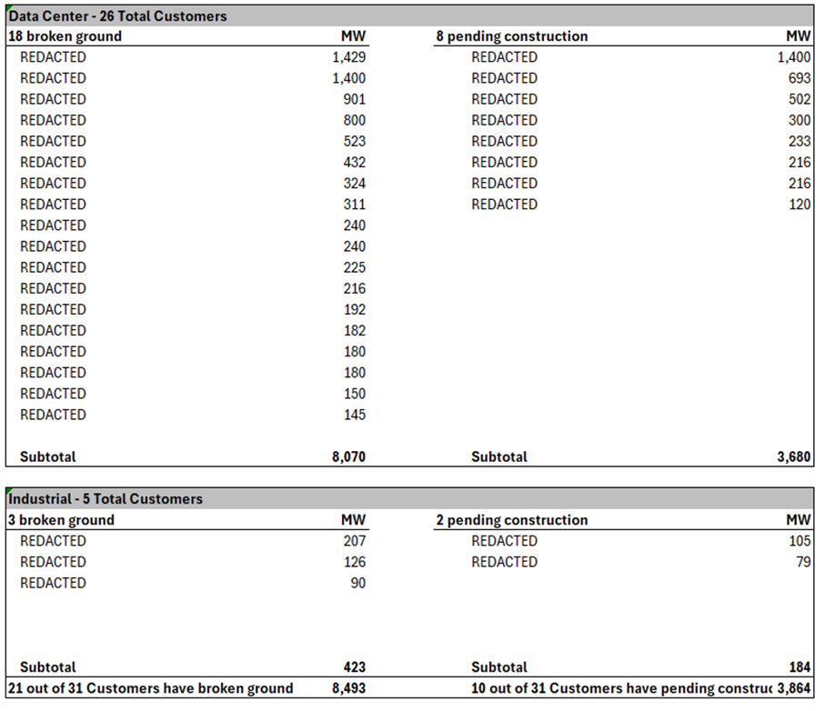

Table 2 below provides a summary of the changes in the economic development pipeline, commitments from large load customers, and announced load ramps for projects that have broken ground.
Table 2. Summary of Pipeline Changes (approximate MW)
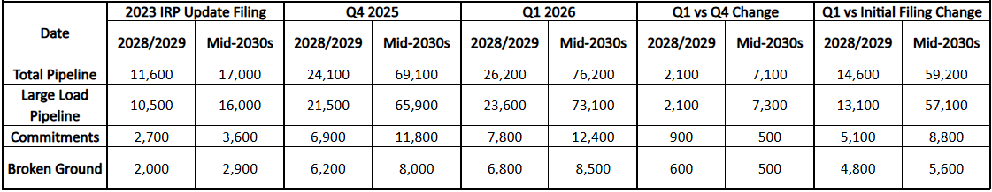

Conclusion
Since February 2026:
- Customer commitments increased by 500 MW to 12,400 MW, and near-term commitments increased 900 MW to 7,800 MW;
- Projects that have broken ground increased, now representing approximately 8,500 MW;
- The total economic development pipeline has increased from approximately 69,100 MW to approximately 76,200 MW through the mid-2030s, representing an increase of 7,100 MW; and
- Near-term 2028/2029 large loads have increased by 2,100 MW.
Since the filing of the 2023 IRP Update in October 2023:
- Customer commitments expanded from 3,600 MW to 12,400 MW, representing an increase of 8,800 MW;
- The total economic development pipeline has expanded from approximately 17,000 MW to approximately 76,200 MW through the mid-2030s, representing an increase of 59,200 MW; and
- Near-term 2028/2029 large loads have increased by approximately 13,100 MW.

This information evidences that Georgia Power’s load forecast is materializing and that the constructive outcomes of the 2023 IRP Update, 2025 IRP, and 2029-2031 All-Source RFP and 2028-2031 Supplemental Resources Certifications are supportive of economic growth in Georgia.
The Company will continue to monitor economic growth projections and will keep the Commission apprised of large load activity consistent with the requirements of the Commission’s Order Adopting Stipulation in the 2025 IRP.

The values in this report are based on activity through 3/31/2026. There were commitments added totaling 3,200 MW in April of 2026 that are not included in these values, which will be included in the second quarter report.
Large load economic development projects represent those above the Company’s organic load growth thresholds for commercial and industrial load.

