BEFORE THE GEORGIA PUBLIC SERVICE COMMISSION

IN RE: ATLANTA GAS LIGHT COMPANY’S ) DOCKET NO. 43510

PETITION TO APPROVE )

2022 UNIVERSAL SERVICE FUND )

FACILITIES EXPANSION PLAN )

STAFF’S EIGHTEENTH SET OF DATA REQUESTS TO
ATLANTA GAS LIGHT COMPANY

TO: BLAKE O’FARROW
DIRECTOR, EXTERNAL AFFAIRS
ATLANTA GAS LIGHT COMPANY
TEN PEACHTREE PLACE NE, BIN GAS 114
ATLANTA, GEORGIA 30309

COMES NOW the Georgia Public Service Commission Staff (“Staff”) and, pursuant to the authority vested in it by the Georgia Public Service Commission (“Commission”) pursuant to O.C.G.A. § 46-2-57, herein propounds the following interrogatories and requests for production of documents (collectively, “data requests”), to be answered under oath by Atlanta Gas Light Company, (“AGLC” or “Company”) or its designated representatives. AGL has Thirty (30) days to respond to data requests. The Company shall file with the Executive Secretary’s Office using the Alternative E-filing instructions. Public and Trade Secret responses shall be Accompanied therewith shall be an electronic version in Microsoft Word® format for text documents and Excel® for spreadsheets.
Please provide responses on or before 4:00 p.m. on April 6, 2026.
INSTRUCTIONS
- These requests shall be deemed to be continuing. The Respondent is obliged to change, supplement, and correct all answers to requests to conform to available information, including such information as first comes available to the Respondent after the answers are hereto filed.
- The answers provided should first restate the question asked and also identify the person(s) supplying the information.
- All information is to be divulged that is within the knowledge, possession, control, or custody of the Respondent or may be reasonably ascertained thereby.
- As used herein the “document” included, but is not limited to, the original and all copies (regardless of origin and whether or not including additional writing thereon or attached thereto) of memoranda, reports, books, manuals, instructions, directives, records, forms, notes, letters, notices, confirmations, telephone calls, meetings or other communications, bulletins, transcripts, diaries, analyses, summaries, correspondence and enclosures, circulars, opinions, studies, investigations, questionnaires and surveys, work sheets, and all drafts, preliminary versions, alterations, modifications, revisions, changes, amendments and written comments concerning the foregoing, in whatever form, stored or contained in or on whatever medium including computerized memory or magnetic media.

Information Request
Docket No. 43510

Amended 2026 Plan (Filed February 13, 2026)
STF-18-1 Regarding the Gilmer County Project, the Minimum Filing Requirements (“MFR”), MFR-1 provided a technical description of each project and MFR-4 provided maps.

MFR-1 described this project potentially providing natural gas service to four (4) poultry houses that are part of the Old Clear Creek Poultry Farm. The project called for 1,665 feet of 6” plastic main (MAOP 60 psi) along Parker Road to the intersection of Parker Road and Old Clear Creek Road, approximately 3,500 feet of 4” plastic main (MAOP 60 psi) south along Old Clear Creek Road, and approximately 560 feet of 2” plastic service line to serve the facilities. In total, the project would consist of 5,165 of approach main and 560 feet of service line.
When reviewing the MFR-4 map, it shows the service line extending to one
poultry house on the property of six (6) poultry houses. See Exhibit-1 below.

Exhibit-1: MFR-4 Map Gilmer County Project
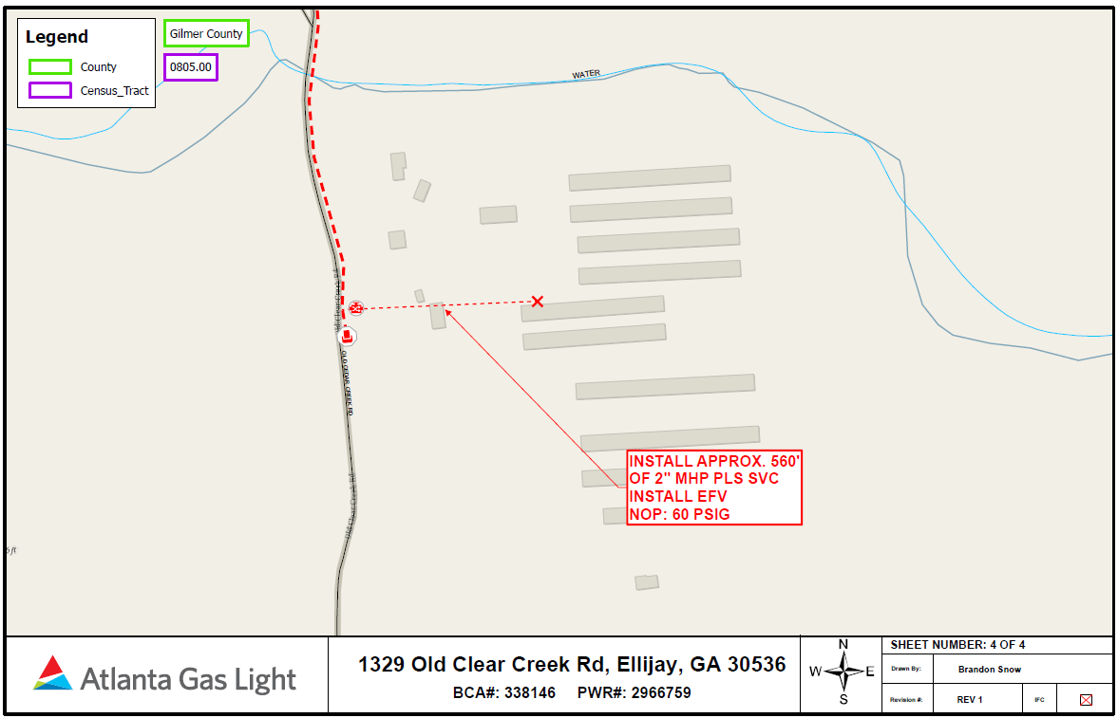

When the Staff reviews the property on QPublic.net, see Exhibit-2 below, the property is owned by Old Clear Creek Poultry Farm, but the address is 1185 Old Clear Creek Rd. The MFR-4 map shows the address 1329 Old Clear Creek Rd, which is the adjacent property below Old Clear Creek Farm, and it is owned by Norman and Kimberly Rickett. The Staff notes that the Rickett’s property has four (4) poultry houses as descripted in AGL’s MFR-1.

Exhibit-2: QPublic.net Map
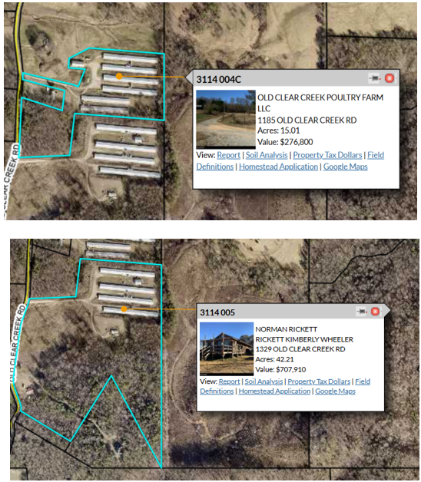

Please answer the following:

- Please update MFR-1 and MFR-4 as needed to provide the correct information of the property were natural gas service will is proposed.

- Please provide a Rule-8 line extension analysis developing estimated revenues, unit costs, allowable investment, and cost to serve, and the CIAC required by the customer. Use the process found in Staff-Attachment-1, Oconee County Project.

- As part of MFR-1 and MFR-5, AGL stated that 20 to 25 jobs will be created as a result of this line-extension. Since this is an existing poultry farm, how does switching from propane to natural gas create these new jobs?

- With the creation of these new jobs, what is the increased tax base?

- MFR-1 stated that the increase natural gas load will be 5.2 dekatherms a day. Would the annual estimated increase in gas load result in 1,898 dekatherms a year?

- Regarding 1329 Old Clear Creek Rd and 1185 Old Clear Creek Rd, is there a family or business relationship between the owners of the two addresses?

STF-18-2 For the past ten (10) years, 2015 – 2025, how many poultry farms, or poultry houses, has AGL served with natural gas service with the following breakdown:

- USF: # of Customers____ Location:_______ Cost:________

- Rule-8: # of Customers____ Location:_______ Cost:________

- ECON-1: # of Customers____ Location: _______ Cost:________

- CGP: # of Customers____ Location: _______ Cost:________

STF-18-3 Regarding MFR-6 for the Gilmer County Project, please answer the following:

- AGL listed a meter set cost of $8,794. Reviewing past USF and ECON-1 project filings, larger Commercial customers, when provided, had comparable costs for meter sets. Though some larger Commercial customers had lower estimates. Why would a meter set for a small poultry farm have similar costs for meter set as larger Commercial customers? Do meter sets have a range of costs based on estimated gas load?

- MFR-6 shows a contingency of 10%, but MFR-7 shows a contingency of 50%/30%. Which is the correct estimate?

- Regarding MFR-6 Cost to Serve for the Gilmer County Project, AGL used income tax and finance ratios consistent with 2025. On January 30, 2026, AGL filed updated ratios for 2026. Likewise, the Staff found that the Gilmer County Project engineering estimates were rounded and didn’t provide exact dollar amounts. As found in Exhibit-3 below, does AGL agree with Staff’s updated Cost to Serve dollar amount for the Gilmer County Project?

Exhibit-3: Staff Updated Cost to Serve – Gilmer County Project
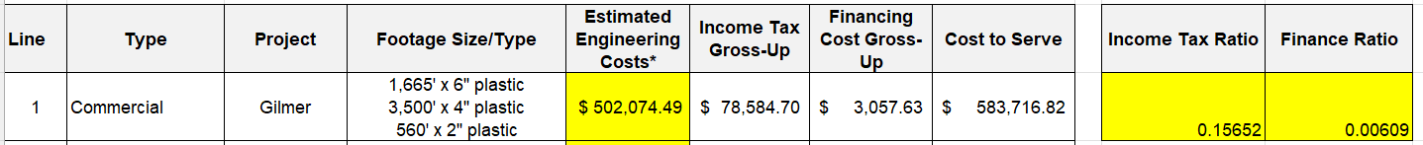

STF-18-4 Related to the Coweta County project, please answer the following:

- MFR-6 shows a contingency of 10%, but MFR-7 shows a contingency of 50%/30%. Which is the correct estimate?

- Regarding MFR-6 Cost to Serve for the Coweta County Project, AGL used income tax and finance ratios consistent with 2025. On January 30, 2026, AGL filed updated ratios for 2026. Likewise, the Staff found that the Cowtea County Project engineering estimates were rounded and didn’t provide exact dollar amounts. As found in Exhibit-4, does AGL agree with Staff’s updated Cost to Serve dollar amount for the Coweta County Project?

Exhibit-4: Staff’s Updated Cost to Serve – Coweta County Project
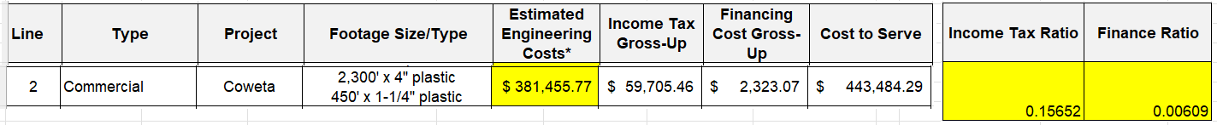

STF-18-5 Regarding AGL’s petition, it had a footnote that stated the following:

Please answer the following:

- Please provide the name of the AGL employee that requested natural gas service.

- At the time the Field Serve Representative was contacted by, and met with this potential customer, did the rep become aware this person was an employee of AGL?

- At what point in the process was it determined that the person requesting natural gas service was an AGL employee?

- Did AGL conduct an internal legal review to determine if there was a conflict of interest in providing a line-extension to an AGL employee?

STF-18-6 Currently, does the poultry houses along Clear Creek Rd and Parker Rd along route of the existing main have natural gas service. If so, what addresses currently have natural gas service?

STF-18-7 Has AGL contacted owners of poultry farms along Parker Rd and Old Clear Creek Rd proposed route to determine if they desire natural gas service, in additional this proposed customer?

