COMMISSIONERS:  JASON SHAW, Chairman  FITZ JOHNSON, Vice-Chairman  TIM G. ECHOLS  LAUREN “BUBBA” McDONALD  TRICIA PRIDEMORE | 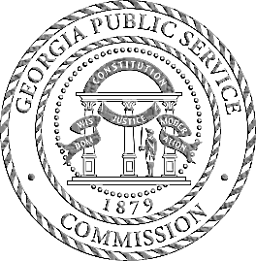 | REECE McALISTER  EXECUTIVE DIRECTOR  SALLIE TANNER  EXECUTIVE SECRETARY

Georgia Public Service Commission
(404) 656-4501  (800) 282-5813 | 244 WASHINGTON STREET, SW  ATLANTA, GEORGIA 30334-5701 | FAX: (404) 656-2341  psc.ga.gov

DOCKET NO. 43510

IN RE: ATLANTA GAS LIGHT COMPANY’S UNIVERSAL SERVICE FUND FACILITIES EXPANSION PLAN

FINAL ORDER APPROVING ATLANTA GAS LIGHT COMPANY’S PETITION TO APPROVE THE 2026 UNIVERSAL SERVICE FUND FACILITIES EXPANSION PLAN

- Background

Commission Rule 515-7-5-.02 states that, consistent with O.C.G.A. §46-4-161, the Commission is authorized to create and establish regulations to administer a universal service fund for each gas company that elects to become subject to the provisions of Article 5 of Chapter 4 of Title 46 of the Official Code of Georgia Annotated, and which satisfies the requirements of O.C.G.A. §46-4-154. With respect to each such gas company, which is also termed an "Electing Distribution Company" (“EDC”) under the Natural Gas Competition and Deregulation Act, the Commission is charged with making a determination prior to the commencement of the electing distribution company's fiscal year as to the amount of funding that is appropriate for that year. Commission Rule 515-7-5-.03 states that, a universal service fund shall be created for each electing distribution company for the purposes set forth in O.C.G.A. §46-4-161(a). These purposes include assuring that gas is available for sale by marketers to firm retail customers within a territory certificated to each such marketer; enabling the electing distribution company to extend and expand its facilities and service in the public interest; assisting low-income residential consumers in times of emergency as determined by the Commission; and consumers of the regulated provider of natural gas in accordance with Code Section 46-4-166. Commission Rule 515-7-5-.07 outlines procedures related to applications for disbursement from the Universal Service Fund for an electing distribution company.

- Atlanta Gas Light Company’s 2026 Universal Service Fund
Facilities Expansion Plan

Commission Rule 515-7-5-.07(1) and (2) outlines the process requirements for an EDC to file a USF Annual Plan. On November 25, 2025, Atlanta Gas Light Company (“AGL”) filed the Universal Service Fund Facilities Expansion Plan (“USF 2026 Plan”) with two proposed projects. This included the Bartow County Project and the Lanier County Project. . Additionally, on December 1, 2025, AGL made a supplemental filing to update MFR-1. As required by Commission Rule 515-7-5-.07(2)(a)-(g), AGL filed seven (7) required Minimum Filing Requirements (“MFR”). The MFRs included the following:
MFR-1: Written description of each project
MFR-2: AGL capital budget
MFR-3: Stakeholder process
MFR-4: Maps of each project
MFR-5: Basic economic development data
MFR-6: Project Financial Analysis
MFR-7: Project Technical Analysis

- MFR-1 Project Description

Bartow County Project
This project is for the Eco Materials Technology located at 2650 Old State Highway, Taylorsville, Georgia 30178. AGL proposes to serve an electricity generation waste recycling operation. The customer removes residue from waste ponds and uses the residue to produce tires and asphalt binders, among other things. This is an existing AGL customer that is expanding the use of natural gas from approximately 216 CFH to 3,500+ CFH by adding a commercial dryer to process the product. This expansion is expected to result in the addition of three to four incremental jobs to the area. AGL proposes to upsize approximately 1,625 feet of 2” MHP steel pipe with 4” plastic pipe originating on Old State Highway 113 northeast of the facility to reach the facility. An approximately 45-foot 1-1/4” plastic service line is required to replace an existing 7-foot service line to provide sufficient gas supply for the expansion.
Lanier County
This project is for the City of Lakeland. The project proposes to serve the city workshop and city wellhouse for the city of Lakeland, Georgia. Both of these facilities desire to install natural gas fired backup generators for use during primary electric service power loss. For the workshop, AGL proposes to tie-into existing 2” plastic pipe on S Williams Street at the intersection of S Williams Street and E Footman Avenue, install approximately 1,120 feet of 2” plastic pipe (MAOP 60 psi) along E Footman Avenue and S Valdosta Road to reach the workshop. The workshop will also require an approximate 300 foot 1-1/4” plastic service line. For the wellhouse, AGL proposes to tie-into existing 2” plastic (MAOP 60 psi) on N Pine Street and install an approximate 35 foot 1-1/4” plastic service line.

- MFR-2 Capital Budgets
AGL filed all data related to their capital budgets approved in the 2025-2034 i-CDP as a trade secret to include the 5% cap portion. See below.

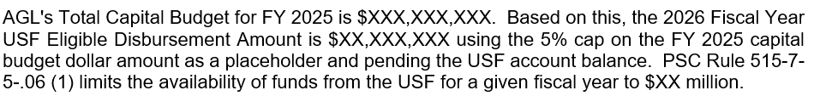

- MFR-3 Stakeholder Process
AGL filed a survey response as a trade secret. There were 39 respondents.

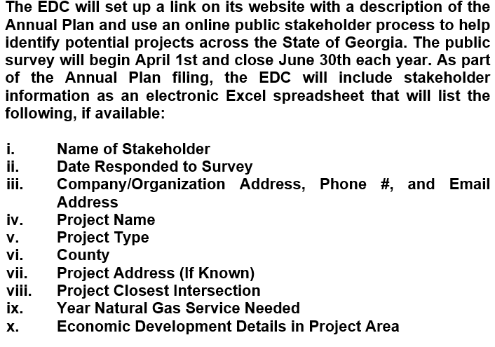
- MFR-4 Maps

AGL filed a map, but it did not have sufficient details.
- MFR-5 Basic Economic Development Data

AGL provided the basic economic impact data below.

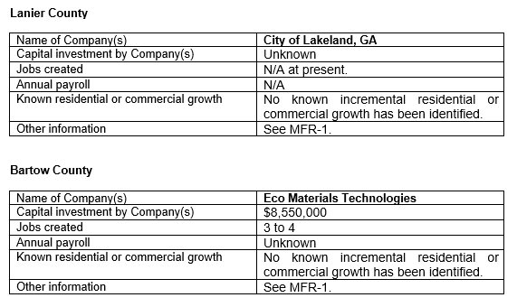
- MFR-6 Financial Technical Analysis

In MFR-6, AGL provided the Cost to Serve, for the Lanier County Project at $186,125 and the Bartow County Project at $255,922. This includes income tax and finance cost gross ups. See Table-1 below.

Table-1: MFR-6 Cost to Serve
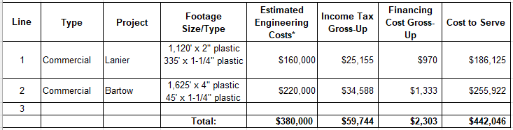
- MFR-7 Project Technical Analysis

In MFR-7, AGL provided technical details about each line-extension project, including the gas load, PSI, pipe length details, wall thickness, and other details.

- Staff Analysis

- Project Review
The Staff reviewed the MFRs provided by AGL, and the filing was whole and complete. Further, the Staff reviewed Google Maps and QPublic.net to obtain a better understanding of the project areas and companies involved.

- USF Available Funds & Cost to Serve
As shown in Table-2 below, the 2026 beginning balance is $25 million. In 2025, the Commission committed $10.8 million for the Emanuel County Project and $3 million for USF low-income assistance from the 2026 $25 million restriction’s balance. The Staff has projected that the USF 2026 Regulated Provider disbursements will be approximately $542,132. Currently, there is $14.3 million encumbered against the 2026 $25 million restriction, leaving $10.6 million unencumbered and available for additional USF projects and low-income assistance. Likewise, if the Commission approves the three proposed USF projects in DN 43510 and DN 41560, the January 1, 2026 unencumbered balance will be $10.1 million. The proposed projects have no impact on AGL’s 5% capital budget cap.

Table-2: 2026 $25 Million Restriction
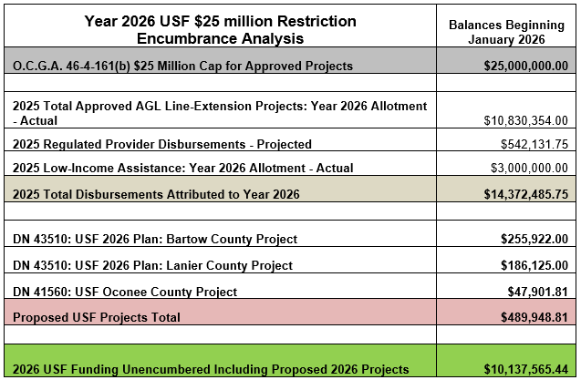

- Commission Decision

During the December 16, 2025, Administrative Session, the Commission approved AGL’s USF 2026 Plan for the Lanier County Project with USF funding of $186,125 and the Bartow County Project with USF funding of $255,922.

* * * * *

- Ordering Paragraphs

WHEREFORE IT IS ORDERED, that the Commission approves AGL’s USF 2026 Plan for the Bartow County Project with an estimated cost of $255,922 and the Lanier County Project with an estimated cost of $186,125.
ORDERED FURTHER, that all findings, conclusions, statements, and directives made by the Commission and contained in the foregoing sections of this Order are hereby adopted as findings of fact, conclusions of law, statements of regulatory policy, and orders of this Commission.

ORDERED FURTHER, that a motion for reconsideration, rehearing, or oral argument or any other motion shall not stay the effective date of this Order, unless otherwise ordered by the Commission.

ORDERED FURTHER, that jurisdiction over this matter is expressly retained for the purpose of entering such further Order or Orders as the Commission may deem just and proper.

The above by action of the Commission in Administrative Session on the 16th day of December 2025.

Sallie Tanner Jason Shaw
Executive Secretary Chairman

Date Date

