COMMISSIONERS:  JASON SHAW, Chairman  TIM G. ECHOLS, Vice-Chairman  FITZ JOHNSON  LAUREN “BUBBA” McDONALD  TRICIA PRIDEMORE |  | REECE McALISTER  EXECUTIVE DIRECTOR  SALLIE TANNER  EXECUTIVE SECRETARY

Georgia Public Service Commission
(404) 656-4501  (800) 282-5813 | 244 WASHINGTON STREET, SW  ATLANTA, GEORGIA 30334-5701 | FAX: (404) 656-2341  psc.ga.gov

DOCKET NO. 41559

ORDER APPROVING ATLANTA GAS LIGHT COMPANY’S PETITION TO APPROVE GLYNN COUNTY PROJECT – BRUNSWICK

- Background

On October 10, 2017, the Commission approved Atlanta Gas Light Company’s (“AGL” or “Company”) Economic Development Tariff (“ECON-1 Tariff”) as part of efficiency changes to AGL’s customer growth initiatives. The ECON-1 Tariff, Section 27, was approved for large economic development projects with economic development parameters based on customer class, capital investment, new jobs created, and new gas load. The initial Tariff allowed up to $15 million per year for ECON-1 Tariff projects. On August 28, 2023, the Commission approved changes to the ECON-1 Tariff that increased the annual limit to $25 million per year. ECON-1 projects were approved to be recovered through a surcharge mechanism similar to the i-CDP’s SRR rider, a known and approved recovery mechanism, to recover the ECON-1 rate base.

- Glynn County Project – Brunswick

On October 31, 2025, AGL filed a Petition (Docket No. 41559, Document No 224381) seeking approval of a proposed ECON-1 Project in Glynn County to serve developments that meet the requirements of the R-1 and G-11 rate class of AGL’s ECON-1 Tariff. The Glynn County Project consists of DR Horton’s Altama development and Forino Homes’ Grand Dunes development, R-1 customers, and Hill Pointe’s TradeWinds industrial park, a G-11 customer in Brunswick, Georgia.

The DR Horton’s Altama development will eventually include over 1,900 homes. The first phase of the Altama development is planned to connect over 160 homes that will utilize space heating, water heating, and cooking. Additionally, there is a 130-acre commercial development to the east of the Altama development that will include yet-to-be determined retail establishments that may also be served by this extension. DR Horton is committed to contracting natural gas service to all of the approximate 1,900 residences in the Altama development.

The Forino Homes Grand Dunes development will eventually include over 900 homes. Forino Homes is committed to contracting natural gas service for all of the approximate 900 residences in the development for space heating, water heating, and cooking. In addition, there is an elementary school planned adjacent to the Grand Dunes development along Golden Isles Parkway that could be served by this extension in the future.

The Hill Pointe TradeWinds industrial park will include a warehousing facility that is currently using liquid propane gas and has committed to convert to natural gas for space heating. In addition, there will be a 350,000 square foot warehouse will be completed later this year that will utilize natural gas. Finally, there is an Amazon facility under construction and additional lots within the TradeWinds industrial park that may utilize natural gas in the future.

DR Horton’s Altama development and the Forino Homes Grand Dunes development’s estimated total customer capital investment amount is $270,000,000. These developments are customers in the R-1 rate class therefore, the addition of local jobs to the local community is not applicable. DR Horton’s Altama development and the Forino Homes Grand Dunes development’s facilities reasonably anticipate that the tax base for its project will be $5,600,000. DR Horton’s Altama development and the Forino Homes Grand Dunes development’s facilities will add a total connected load on a Firm basis of approximately 630 dekatherms per year.

Hill Pointe TradeWinds industrial park’s estimated total customer capital investment amount is $40,200,000. It is expected that the Hill Pointe TradeWinds industrial park facilities will add approximately 50 jobs to the local community. The Hill Pointe TradeWinds industrial park’s facilities reasonably anticipate that the tax base for its project will be $3,000,000. The Hill Pointe TradeWinds industrial park facilities will add a total connected load on a Firm basis of approximately 2,250 dekatherms per year.

In order to serve DR Horton’s Altama development, AGL proposes to tie-into existing 12” steel at the intersection of AGL’s right-of-way and Crispen Road and install approximately 36,200 feet of 8” steel (MOAP 300 psi) along Cate Coad and Golden Isles Parkway to the intersection of Golden Isles Parkway and north along SR 99 to reach the Altama development and future commercial entities. AGL proposes to install a regulator station at the entrance of the Altama development and approximately 15,000 feet of 4” plastic (MOAP 60 psi) and 45,000 feet of 2” plastic (MOAP 60 psi) to serve the residences in the Altama development.

In order to serve the Forino Homes Grand Dunes development, AGL proposes to tie-into the new 8” steel at the intersection of Golden Isles Parkway and SR 99 and install approximately 13,450 feet of 6” steel (MOAP 300 psi) along Golden Isles Parkway and Green Swamp Road to reach the development. AGL proposes to install a regulator station south of the intersection of Green Swamp Road and Golden Isles Parkway and approximately 6,000 feet of 4” plastic (MOAP 60 psi) and 13,000 feet of 2” plastic (MOAP 60 psi) to serve the residences in the west section of the Grand Dunes development. AGL proposes to install a regulator station north of the intersection of Golden Isles Parkway and Green Swamp Road and install approximately 5,100 feet of 4” plastic (MOAP 60 psi) and 15,100 feet of 2” plastic (MOAP 60 psi) to serve the residences in the east section of the Grand Dunes development.

In order to serve the Hill Pointe TradeWinds industrial park’s proposed industrial clients, the 8” steel described above serving the DR Horton’s Altama development will also serve the industrial park.

AGL is certificated to serve the relevant area of Glynn County.

An analysis of this project under Rule 8 (Nonresidential Main and Service Extension) of the AGL Tariff indicates that the Customers would owe a contribution in aid of construction in excess of $400,000 for the DR Horton/Forino Homes.

An analysis of this project under Rule 8 (Nonresidential Main and Service Extension) of the AGL Tariff indicates that the Customers would owe a contribution in aid of construction in excess of $400,000 the Hill Pointe.

- Staff's Analysis Project Analysis

The Staff reviewed the filing and confirmed that the required Minimum Filing Requirement (“MFR”) information was provided as part of ECON-1 Tariff Section 3(C)(i-iv), and it was found to be whole and complete. Please see Table 1 below:

Table 1: AGL’s ECON-1 Tariff Section 3(C)(i-iv)

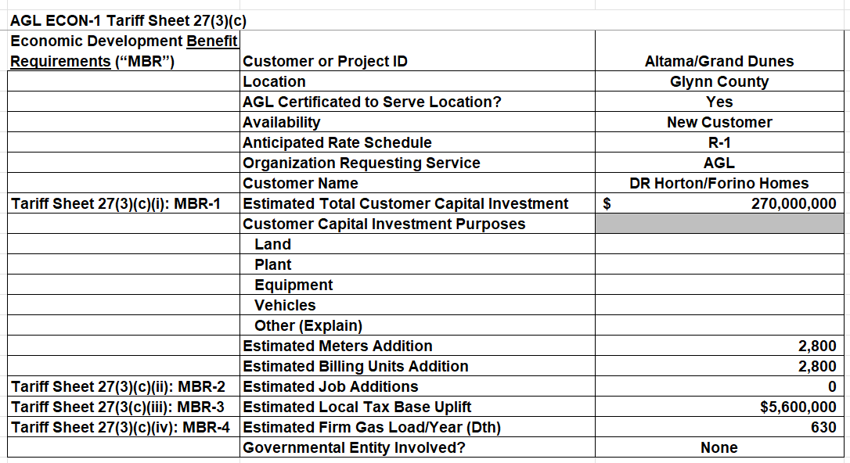

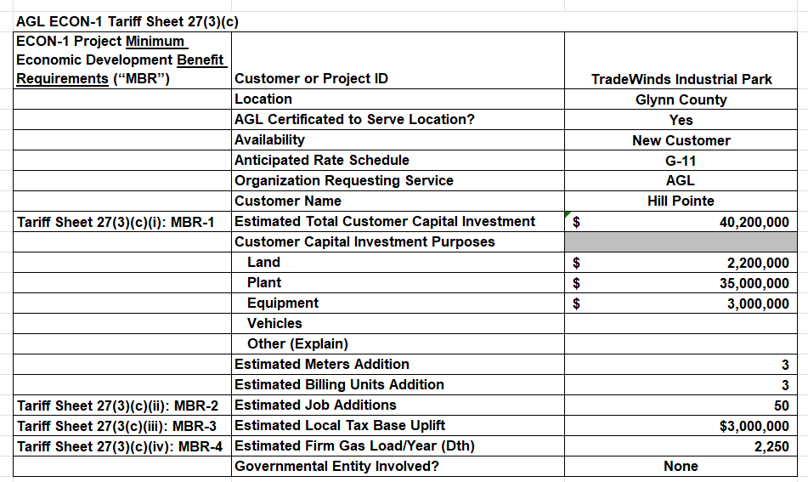

In Tariff Section 4(a-d), AGL was required to provide a technical description of the project, a statement affirming that the project meets the ECON-1 requirements, detailed engineering cost estimates, and a map of the project area. AGL provided this information. Please see Table 2 below:

Table 2: AGL’s ECON-1 Tariff Section 4(a – d)

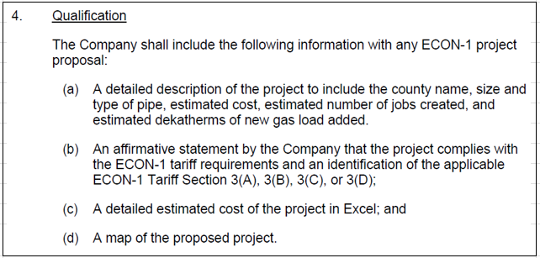

The map can be seen as Map 1 below.

Map 1

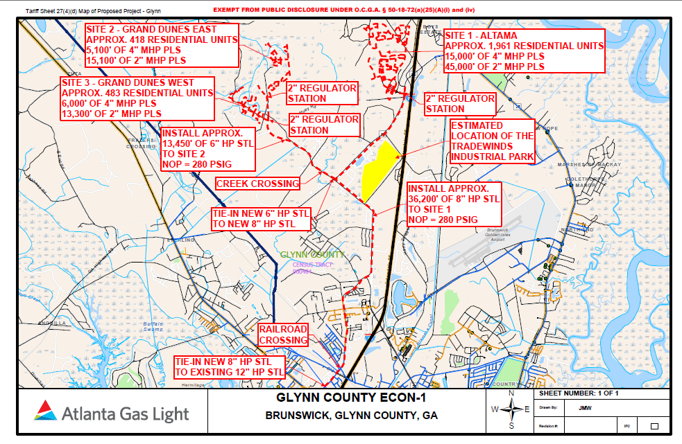

Although the AGL petition provided the required MFRs, the Staff requested supplemental information from the Company.

- Supplemental Information Provided by AGL

The Staff reached out to AGL for clarification regarding the information included in the filing. AGL filed a supplemental filing addressing our concerns.

Table 3: Georgia Secretary of State Information

DR Horton:

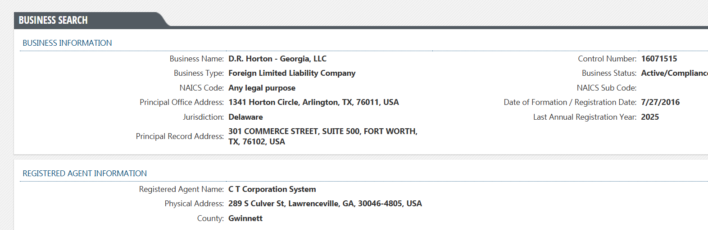

Forino Co., L.P.:

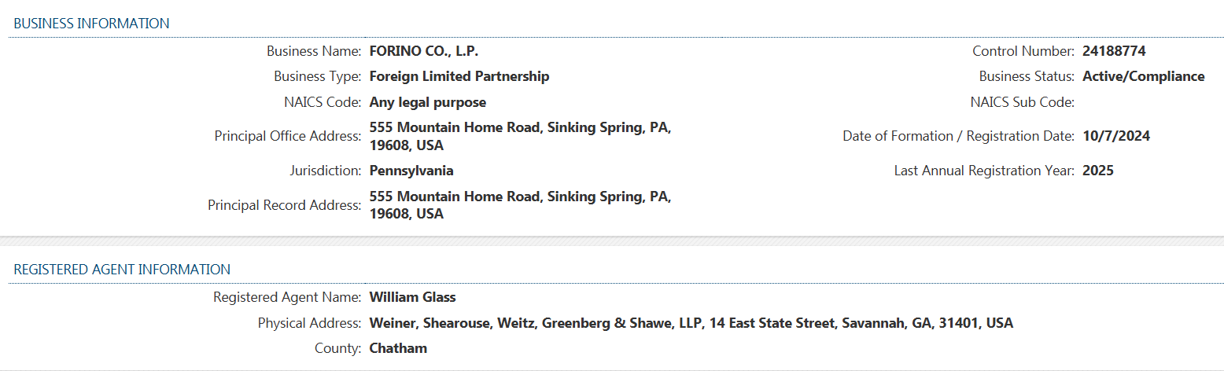

Hillpointe Residential LLC:
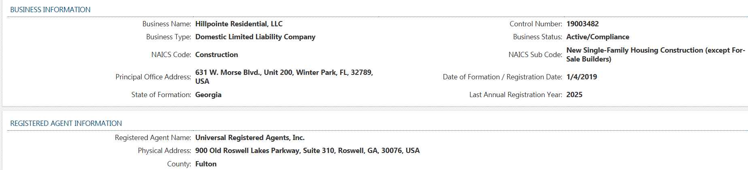

- ECON-1 Recovery Rider Analysis

As seen in Table 4 below, the 2025 beginning balance for funding projects is $25 million. This Project is the third project approved for the year 2025. If this Project were approved with an estimated cost of $23,570.000, the balance funds for 2025 would be $0. With Commission approval, there are no issues with funding this project.

Table 4: 2025 ECON-1 Tariff Available Funds

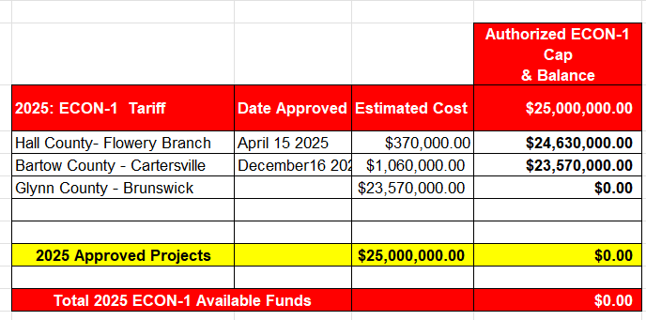

Per the petition, AGL estimates that this project can be completed at an estimated cost of approximately $29,978,240. AGL would like to allocate this project against 2025 ECON-1 available funds. The balance in the 2025 ECON-1 Fund is $23,570.000. The remaining $6,408,240 will be applied toward the 2026 ECON-1 cap. The 2026 ECON-1 cap is $25 million; thus 2026 ECON-1 allocation will have $18, 591,760 funds available for projects.

Commission Decision

During the December 16th, 2025 Administrative Session, the Commission approved the Glynn County Project for DR Horton’s Altama development, Forino Homes’ Grand Dunes development, and Hill Pointe’s TradeWinds industrial park in Brunswick, Georgia, with an estimated cost of $29,978,240. $23,570.000 of the estimated cost will be allocated towards the 2025 ECON-1 Tariff projects. The outstanding $6,408,240 requested allocated to the 2026 ECON-1 Tariff projects.

The Glynn County Project consists of DR Horton’s Altama development, Forino Homes’ Grand Dunes development, and Hill Pointe’s TradeWinds industrial park in Brunswick, Georgia.

* * * * *

- Ordering Paragraphs

WHEREFORE IT IS ORDERED, that the Commission approves AGL’s petition in Docket No. 41559 as filed with an estimated cost of $29,978,240.

ORDERED FURTHER, $23,570.000 of the estimated cost will be allocated towards the 2025 Econ-1 Tariff projects with the outstanding $6,408,240 requested allocated to the 2026 Econ- Tariff projects

ORDERED FURTHER, that all findings, conclusions, statements, and directives made by the Commission and contained in the foregoing sections of this Order are hereby adopted as findings of fact, conclusions of law, statements of regulatory policy, and orders of this Commission.

ORDERED FURTHER, that a motion for reconsideration, rehearing, oral argument, or any other motion shall not stay the effective date of this Order, unless otherwise ordered by the Commission.

ORDERED FURTHER, that jurisdiction over this matter is expressly retained for the purpose of entering such further Order or Orders as the Commission may deem just and proper.

The above by action of the Commission in Administrative Session on the 16th day of December 2025.

Sallie Tanner Jason Shaw
Executive Secretary Chairman

Date Date

