COMMISSIONERS:  JASON SHAW, Chairman  FITZ JOHNSON, Vice-Chairman  TIM G. ECHOLS  LAUREN “BUBBA” McDONALD  TRICIA PRIDEMORE |  | REECE McALISTER  EXECUTIVE DIRECTOR  SALLIE TANNER  EXECUTIVE SECRETARY

Georgia Public Service Commission
(404) 656-4501  (800) 282-5813 | 244 WASHINGTON STREET, SW  ATLANTA, GEORGIA 30334-5701 | FAX: (404) 656-2341  psc.ga.gov

DOCKET NO. 43820

IN RE: ATLANTA GAS LIGHT COMPANY’S ANNUAL DEPARTMENT OF TRANSPORTATION (DOT) PROJECT YEAR 2026 RIDER ADJUSTMENT FILING

FINAL ORDER APPROVING ATLANTA GAS LIGHT COMPANY’S PETITION TO APPROVE THE 2026 DEPARTMENT OF TRANSPORTATION (“DOT”) RIDER ADJUSTMENT

- Background/Recovery Mechanism

On July 2, 2024, the Commission approved Atlanta Gas Light Company’s (“AGLC”) 2025 – 2034 Integrated Capacity and Delivery Plan (“i-CDP”) in Docket No. 43820. The i-CDP is a comprehensive planning tool that provides a ten-year forecast of interstate, intrastate, and distribution capacity asset requirements. As part of this plan, the Commission approved the Department of Transportation (“DOT”) Rider. AGL is required to relocate its facilities in road rights-of-way when the state, county, or municipal entity makes significant changes to its roadways. The DOT Rider, Section 28 of AGL’s tariff, is designed to provide recovery related to the relocation of AGL facilities due to these roadway projects.

By September 1st of each calendar year, AGL must file a petition with the Commission to support an adjustment of the DOT Rider rate to become effective the following January 1st. The filing must include the following:

  - A pleading discussing the purpose of the filing.
  - A proposed DOT Project Rider rate for the following year.
  - A map showing locations of likely DOT related projects.
  - A list of known or ongoing DOT related projects.
  - As an electronic Excel spreadsheet, a proposed capital budget for the following calendar year that will include Allowance for Funds Used During Construction (“AFUDC”) and Overheads.
  - An updated electronic Excel spreadsheet DOT Project Rider recovery model.

The DOT Rider rate is a monthly charge and will be recovered for each rate class as follows:

- R-1, G-10, AG-1, and S-51 Customers shall be charged an amount equal to the approved DOT Rider rate.

- G-11 Customers shall be charged an amount equal to three times the approved DOT Rider rate.

- G-12 Customers shall be charged an amount equal to 25 times the approved DOT Rider rate.

AGL will file with the Commission a DOT Rider quarterly report for approved DOT capital budgets. The quarterly report will include the following reporting as an electronic Excel spreadsheet with the following worksheets:

- DOT Rider Capital Budget Reporting: The comprehensive capital budget reporting shall be for Commission approved capital budgets.
- DOT Project Costing Ledger: The project costing ledger shall include all the details for the ongoing project activities.
- DOT Rider Rate Model: An updated comprehensive rate model shall be provided each quarter.

Each quarter, the Staff reviews AGL’s quarterly DOT reports. The Staff reviews the rider model and the capital budget reporting to determine if AGL is in compliance with Commission i-CDP orders and in compliance with its DOT tariff. On a routine basis, the Staff will communicate with AGL to resolve issues.

- AGL 2026 Annual DOT Rider Filing

On September 2, 2025, AGL filed the 2026 Annual DOT Rider request. The filing contained a map of the known AGL DOT projects, a list of the known DOT projects, the capital budget, and the DOT Rider model. As provided in Table-1 below, the rider rate for Residential R-1, Multi-Family G-10, Agriculture AG-1, and Seasonal Gas Service S-51 is proposed at $0.57 per customer per month. The General Delivery Service G-11 Class rate will be three times the Residential rate, or $1.71 per customer per month. The High Demand G-12 gas users will have a rate twenty-five times the Residential rate, or $14.25 per customer per month.

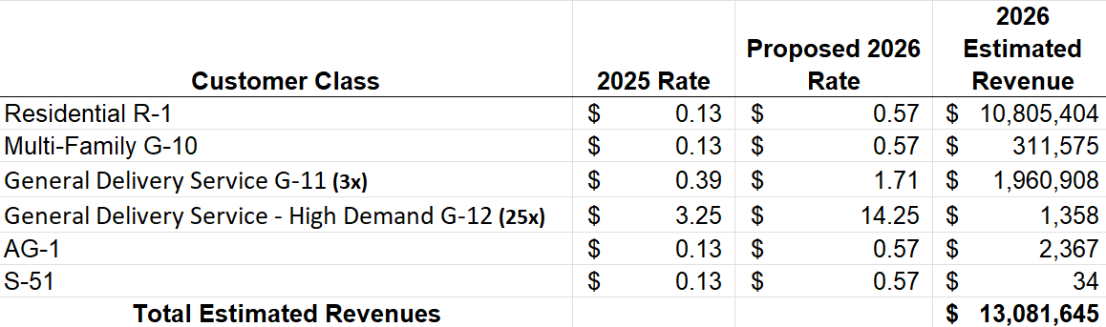
Table-1: 2026 DOT Rates & Revenues

- Staff's Analysis

The Staff began its review and due diligence of the contents of the filing, ensuring that the company provided all information required in its tariff. While reviewing, Staff noticed a lack of detail in the petition. As a result, Staff contacted AGL, requesting that the company refile to specify whether the surcharge mentioned in the petition is a monthly or annual rate. Additionally, Staff requested that the company provide the adjusted surcharge for each rate class and provide whether it is the monthly or annual rate. On October 3rd, AGL filed the requested information. Staff reviewed the model and its contents for accuracy and ensured the contents were in accordance with Tariff Section 28(2) (A) – (F). Additionally, Staff analyzed the proposed rate changes and the 2026 DOT capital budget, comparing both the rates and capital budget to past annual and quarterly filings.

Table-2: 2025 and 2026 DOT Rate Comparison

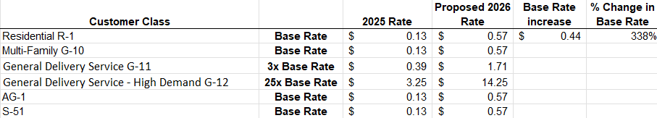

Staff’s review led to an inquiry with AGL requesting an explanation of the high level of the proposed rate increase. Staff also requested that the AFUDC and Overhead costs related to the 2026 DOT projects be provided. On October 13th, the company provided responses and Staff reviewed them.

Among AGL’s responses was an explanation of the 338% increase from the current rate to the proposed rate increase (Table-2). The drivers of the 2026 rate increase were threefold: (1) recovery of the 2025 under-recovered balance, (2) recovery of the revenue requirement related to the 2025 Plant in service (“Plant”) and Cost of Removals (“Removals”), and (3) the projected 2026 Plant and Removal amounts. Additionally, budgeted costs for 2025 and 2026 Plant and Removals have increased compared to projections in the 2025 – 2034 i-CDP, increasing the revenue requirement and the rider rate.

The 2025 DOT rates did not recover the full revenue requirement. The revenue requirement for 2025 was $3.8 million; however, the company collected approximately $3 million from customers, leaving an $838,000 under-recovery balance. Increasing rates by $0.03 would allow the company to recover the 2025 under-recovery balance.

The recovery of the revenue requirement related to 2025 Plant and Removals will increase rates by $0.20. If there were no spending in 2026, the 2026 revenue requirement would still increase due to carrying charges and depreciation expenses related to 2025 Plant and Removals. A $0.20 rate increase will allow the company to recover these costs.

Lastly, the projected 2026 Plant and Removals amounts will increase rates by $0.21. The proposed monthly rider rate is a $0.44 increase from the 2025 monthly rider rate, as seen in Table-2 above. The increase of $0.44 is composed of a $0.03 increase for the recovery of the 2025 under-recovery balance, a $0.20 increase for 2025 Plant recovery, and a $0.21 increase for projected 2026 Plant. This results in an over-recovery of approximately $218,211 in 2026.

Staff found the revised filing to be whole and complete, with no material issues

- Commission Decision

During the December 16, 2025 Administrative Session, the Commission approved AGL’s proposed 2026 DOT Rider Adjustment. The rate will be effective January 1, 2026, and the quarterly reports will be due forty-five (45) days after the end of each quarter.

* * * * *

- Ordering Paragraphs

WHEREFORE IT IS ORDERED, that the Commission approves AGL’s proposed 2026 DOT Rider Adjustment with new rates effective January 1, 2026.

ORDERED FURTHER, that all findings, conclusions, statements, and directives made by the Commission and contained in the foregoing sections of this Order are hereby adopted as findings of fact, conclusions of law, statements of regulatory policy, and orders of this Commission.

ORDERED FURTHER, that a motion for reconsideration, rehearing, oral argument, or any other motion shall not stay the effective date of this Order, unless otherwise ordered by the Commission.

ORDERED FURTHER, that jurisdiction over this matter is expressly retained for the purpose of entering such further Order or Orders as the Commission may deem just and proper.

The above by action of the Commission in Administrative Session on the 16th day of December 2025.

Sallie Tanner Jason Shaw
Executive Secretary Chairman

Date Date

