COMMISSIONERS:  JASON SHAW, Chairman  FITZ JOHNSON, Vice-Chairman  TIM ECHOLS  LAUREN “BUBBA” McDONALD  TRICIA PRIDEMORE |  | REECE McALISTER  EXECUTIVE DIRECTOR  SALLIE TANNER  EXECUTIVE SECRETARY

Georgia Public Service Commission
(404) 656-4501  (800) 282-5813 | 244 WASHINGTON STREET, SW  ATLANTA, GEORGIA 30334-5701 | FAX: (404) 656-2341  psc.ga.gov

IN RE: DOCKET NO. 42959: LIBERTY UTILITIES (PEACH STATE NATURAL GAS) CORP.’s GEORGIA RATE ADJUSTMENT MECHANISM

FINAL ORDER
APPROVING LIBERTY UTILITIES REVISED ALTERNATIVE 2026 GRAM FILING

- Background
On December 27, 2011, the Commission approved a Stipulated Agreement between Staff and Atmos Energy for an alternative form of ratemaking in accordance with O.C.G.A. 46-2-23.1. The process is called the Georgia Rate Adjustment Mechanism or GRAM. On February 26, 2013, Liberty purchased the Atmos Energy assets in Georgia and was ordered to continue to use the GRAM process. The asset purchase was final on April 1, 2013. On May 3, 2016, the Commission approved a new GRAM stipulated agreement between the Staff and Liberty that continued to incorporate the annual filing with a detailed revenue requirement and rate design model with eleven schedules and supporting workpapers. On July 30, 2020, the Commission approved a GRAM Stipulated Agreement between Staff and Liberty for a continuation of an alternative form of ratemaking in Docket No 42959 as part of Liberty’s 2020 rate case. Since then, there have been numerous stipulated agreements between the Staff and Liberty (“Parties”) that have modified the GRAM filing from the 2020 GRAM stipulation.

Pursuant to the July 30, 2020, rate case Order, on November 3, 2025, Liberty made its required GRAM filing, which it identified as its Required 2026 GRAM, and included all information necessary for inclusion in its Annual GRAM Filing. As initially filed, the Required 2026 GRAM would have resulted in significant customer rate impacts due in large part to the costs of its Gainesville Transmission Line project (“GTL”), identified in the 2025 GRAM Final Order, along with other system improvements that are necessary to meet customer needs on the coldest days of the year. The GTL represents an unprecedented capital investment and commitment to customers, now estimated to be approximately $120 million, with all three sections of the GTL scheduled to be in service by the end of 2027.

To mitigate customer rate impacts of such a large capital investment, consistent with the principles of rate gradualism, Liberty also filed a Petition to Approve the System Integrity Rider (“SIR”) Tariff (“Petition”) and proposed an Alternative 2026 GRAM. Liberty requested that the Commission approve the new SIR rider to capture the remaining GTL investments, along with certain other 2026 distribution integrity management program (“DIMP”) project costs, over a different recovery schedule than would otherwise apply.

- Staff’s Analysis
The Staff conducted a thorough review of the filing, which included 11 schedules and 47 supporting workpapers. During this review, Staff identified issues that were addressed through four data requests. Staff filed from the 29th set through the 32nd set of data requests to obtain additional information from Liberty on both its Required 2026 Annual GRAM Filing, as well as the Alternative 2026 GRAM proposal. Liberty filed responses to such discovery and provided information to the Staff on an informal basis.

On December 5, 2025, the Staff held a meeting with Liberty to discuss their outstanding issues. As a result of this meeting, the Staff and Liberty reached several agreements; however, there were some issues that the Parties could not reach agreement on. As part of the agreed-on items, Liberty made certain modifications and adjustments to its Alternative 2026 GRAM, as further described below. Also, as part of this agreement, Staff may continue to review the Revised Alternative 2026 GRAM to administratively make any corrections of errors that may be identified for an additional 60-days following a Final Order approving the Revised Alternative 2026 GRAM.

As a result of the December 5, 2025, meeting between the Parties, the following agreed-to modifications are included in the Revised Alternative 2026 GRAM Filing filed on December 9, 2025, with the changes from the November 3, 2026, filing summarized below, as specifically provided:

- Regarding Work Paper (“WP”) 2-5, Investment Value of Gas Inventory, the September 2025 Unit Cost value was adjusted from $3,557 to $3,190, which was calculated by taking the average of the Gainesville and Columbus prices ($3.2719 + $3.1087 / 2). See, STF-29-31. This change from the as filed Alternative 2026 GRAM does affect the revenue deficiency.

- On WP 2-5, the July – September Unit Costs were corrected to reflect the NYMEX prices in Exhibit III, page 6 of the 2023-2024 Gas Supply Plan. See, STF-29-32. This change from the as filed Alternative 2026 GRAM does affect the revenue deficiency.

- On WP 2-5, the notes were updated to reflect the correct cross-references. See, STF-29-33. This change from the as filed Alternative 2026 GRAM does not affect the revenue deficiency.

- WP 2-10, Deferred Rate Case Costs, this workpaper will be removed from future GRAM filings as all of the deferred rate case costs have now been recovered. See, STF-29-40.

- For WP 4-1-6, Customer Counts, Liberty has removed the 822 – Residential & Commercial HVAC customers from its July 2024 – June 2025 Commercial customer counts to align its methodology with that used in the Quarterly GRAM Report filings. This change from the as filed Alternative 2026 GRAM does affect the revenue deficiency.

- Liberty has agreed to remove WP 5-1-4 and remove all adjustments produced from WP 5-1-4 and its corresponding net expense reduction. See, STF-31-2. This change from the as filed Alternative 2026 GRAM does affect the revenue deficiency.

- On WP 4-3-1, cell E8, the Residential Revenue Class has been updated to remove the 822 revenues in its Total calculation, as those customers are counted as a part of the Commercial totals in WP 4-1-6 Cells F210 through H221, and 822 revenues are classified under Comm & Ind in WP 4 Rev, cell P14. See, STF-32-7. This change from the as filed Alternative 2026 GRAM does affect the revenue deficiency.

- On WP 4-4, GRAM Rate Impact, 840 CNG customers, Cell F35, the formula was corrected to read: = ('WP 4-3 Rate Calc'!D21/'WP 4-3 Rate Calc'!C21*E35). See, STF-32-8. This change from the as filed Alternative 2025 GRAM does not affect the revenue deficiency.

- On WP 4-1, Liberty has corrected the line numbering to remove the duplicative line 3 number and renumber the remaining lines. See, STF-32-9a. This change from the as filed Alternative 2026 GRAM does not affect the revenue deficiency.

- On WP 4-1, Cell B17, the service description was changed from the incorrect 830 General Gas Service – Commercial to the correct description, Large Volume Service – Commercial See, STF-32-9b. This change from the as filed Alternative 2026 GRAM does not affect the revenue deficiency.

- On Schedule 5, the year in the heading was corrected from “Twelve Months Ending February 28, 2026” to “Twelve Months Ending February 28, 2027”. See, STF-32-10. This change from the as filed Alternative 2026 GRAM does not affect the revenue deficiency.

- On WP 5-1-4, the references to APCo have been changed to Hydro, since Liberty’s parent company sold APCo’s renewable assets in February 2025, and the remaining assets will be under Hydro. See, STF-32-14. This change from the as filed Alternative 2026 GRAM does not affect the revenue deficiency.

- While not a modification for the 2026 Alternative Annual GRAM filing, Staff identified reporting inconsistency issues between various accounts of the Annual GRAM and Quarterly GRAM within WP 5. Liberty has agreed to work with the Staff to provide greater reporting consistency in the Annual GRAM WP 5 and the Quarterly GRAM WP 5 by adding clarification notes for account reconciliation or improving the reporting format. This effort will not result in changes to the revenue deficiencies once agreed to, but is intended to aid in the Staff’s review of WP 5.

- The parties also agreed that Staff may continue to review the Revised Alternative 2026 GRAM to administratively make any corrections of errors that may be identified and mutually agreed to for an additional 60-days following a Final Order approving the Revised Alternative 2026 GRAM.

- Revised Alternative 2026 GRAM Filing

As a result of Staff’s thorough and due diligence review and the meeting with Liberty, on December 8, 2025, Liberty filed a revised 2026 GRAM filing with the following:

The revised Schedule-2 found in Table-1 below provides a revised rate base attributed to equity in the amount of $132,448,687.

Table-1: Revised Schedule-2 - Rate Base

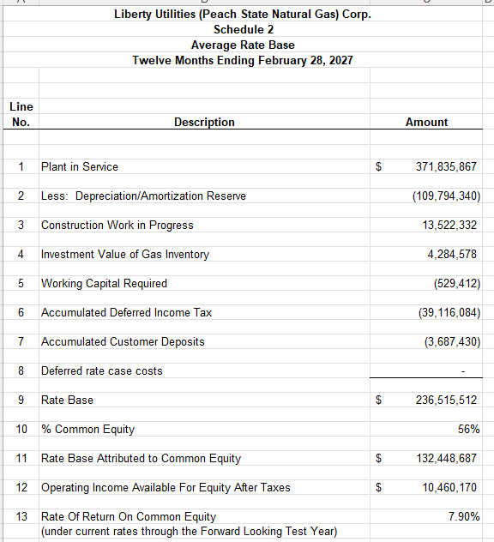

In Table-2 below, the revised Schedule-3 Operating Income shows the amount of $37,325,306.

In the revised Schedule-2, the ROE calculation for the Forward-looking Test Year using current rates is 7.90%. This is transferred to Schedule-11 to calculate the revised revenue adjustment. In Table-3 below, the revised Schedule-11 Revenue Adjustment increase is provided in the amount of $3,767,449 after income taxes and adjustments. This Revenue Adjustment increase is transferred to WP 4-3 for the calculation of new rates.

Table-2: Revised Schedule-3 - Operating Income

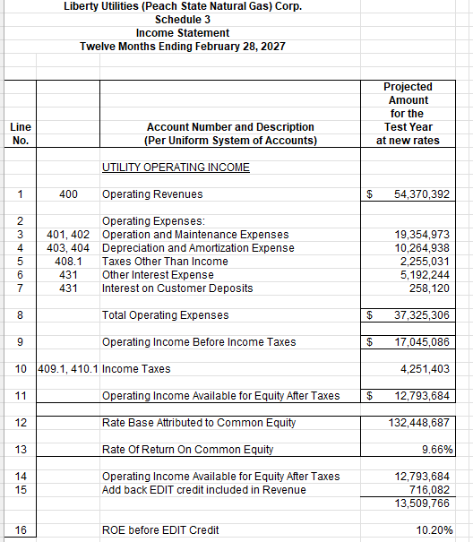

Table-3: Revised Schedule-11 - Calculation of Rate Revenue Adjustment
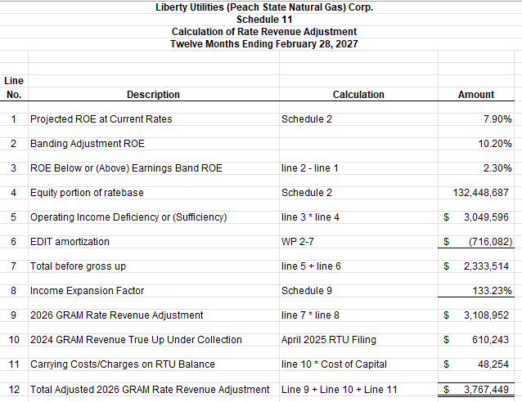

In Table-4 below, the proposed WP 4-2 rates can be compared with the percentage increase from current rates. The average Residential customer will receive an 8.36% increase in their Customer Charge and a 6.31% in the Volumetric Charge. The average residential customer will have an increase of $ $3.38 per month or $ 40.56 annually.

Table-4: WP 4-2 2026 GRAM - Proposed Rates

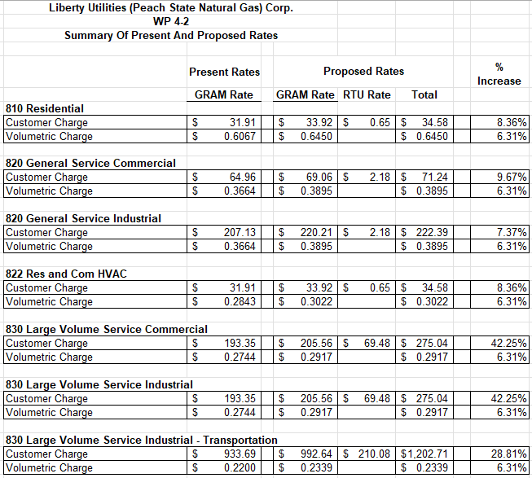
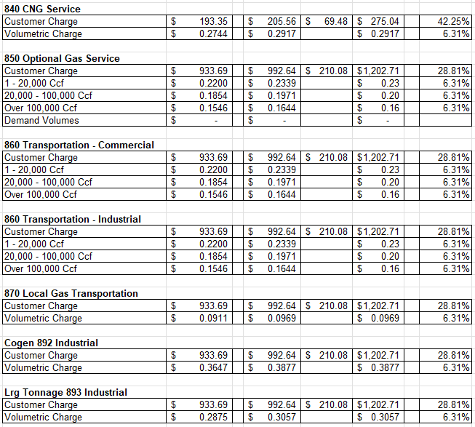

- Commission Decision
On December 16, 2025, the Commission voted at its regularly scheduled Administrative Session to approve the Revised Alternative 2026 GRAM, subject to any administrative corrections of calculation errors that Staff and Liberty may discover and mutually implement in the next 60 days.

* * * * *

- Ordering Paragraphs

WHEREFORE IT IS ORDERED, that the Revised Alternative 2026 GRAM is approved, subject to the mutual correction of errors in the Revised Alternative 2026 GRAM that may be identified in the next 60 days, with any agreed upon changes to be implemented the new rates effective March 1, 2026.

ORDERED FURTHER, that a motion for reconsideration, rehearing, or oral argument or any other motion shall not stay the effective date of this Order, unless otherwise directed by the Commission.

ORDERED FURTHER, that jurisdiction over this matter is expressly retained for the purpose of entering such further Order or Orders as this Commission may deem just and proper.

The above action of the Commission in Administrative Session on the 16th day of December, 2025.

________________________ ________________________
Sally Tanner Jason Shaw
Executive Secretary Chairman

________________________ ________________________
Date Date

The Final Order in Docket No. 56709 provides further information and approval of the SIR Tariff and supporting documents.

