Docket 56002 and 56003
PUBLIC DISCLOSURE Summary of Errata to the Direct Testimony of Trokey, Drugan, and Pol
Correction #1 – p. 17, Table 3
Original Table
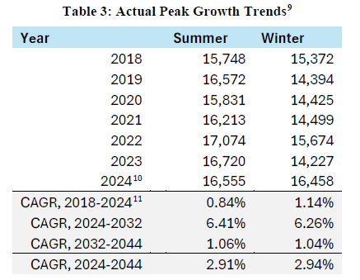
Edited Table
Year | Summer | Winter
2018 | 15,748 | 15,372
2019 | 16,572 | 14,394
2020 | 15,831 | 14,425
2021 | 16,213 | 14,499
2022 | 17,074 | 15,674
2023 | 16,720 | 14,227
2024 | 16,555 | 16,458
CAGR, 2018-2024 | 0.84% | 1.14%
CAGR, 2024-2032 | 5.75% | 5.69%
CAGR, 2032-2044 | 1.06% | 1.14%
CAGR, 2024-2044 | 2.91% | 2.94%

Correction #5 – p. 30, Table 7
Original Table
Table 7: Calibration of LT Energy Forecast to ST Energy Forecast
(% Calibration Relative to LT Forecasted Energy)
 | Including Adjustments |  |  | Excluding Adjustments
Year | Residential | Commercial | Industrial | Residential | Commercial | Industrial
2024 | -2% | 0% | -3% | X% | X% | X%
2025 | -2% | 6% | -2% | X% | X% | X%
2026 | 0% | 22% | 0% | X% | X% | X%
2027 | 1% | 55% | 1% | X% | X% | X%
2028 | 3% | 95% | 4% | X% | X% | X%
2029 | 4% | 130% | 5% | X% | X% | X%
2030 | 5% | 153% | 6% | X% | X% | X%
2031 | 6% | 164% | 8% | X% | X% | X%
2032 | 6% | 168% | 8% | X% | X% | X%
2033 | 7% | 170% | 7% | X% | X% | X%
2034 | 7% | 171% | 7% | X% | X% | X%
2035 | 8% | 172% | 7% | X% | X% | X%
2036 | 8% | 173% | 7% | X% | X% | X%
2037 | 9% | 172% | 6% | X% | X% | X%
2038 | 10% | 172% | 6% | X% | X% | X%
2039 | 10% | 173% | 6% | X% | X% | X%
2040 | 11% | 173% | 6% | X% | X% | X%
2041 | 11% | 173% | 5% | X% | X% | X%
2042 | 12% | 173% | 5% | X% | X% | X%
2043 | 13% | 173% | 5% | X% | X% | X%
2044 | 13% | 174% | 5% | X% | X% | X%

Edited Table
Table 7: Calibration of LT Energy Forecast to ST Energy Forecast
(% Calibration Relative to LT Forecasted Energy)
 | Including Adjustments |  |  | Excluding Adjustments
Year | Residential | Commercial | Industrial | Residential | Commercial | Industrial
2024 | -2% | 0% | -3% | X% | X% | X%
2025 | -2% | 6% | -2% | X% | X% | X%
2026 | 0% | 22% | 0% | X% | X% | X%
2027 | 1% | 55% | 1% | X% | X% | X%
2028 | 3% | 95% | 4% | X% | X% | X%
2029 | 4% | 130% | 5% | X% | X% | X%
2030 | 5% | 153% | 6% | X% | X% | X%
2031 | 6% | 164% | 8% | X% | X% | X%
2032 | 6% | 168% | 8% | X% | X% | X%
2033 | 7% | 170% | 7% | X% | X% | X%
2034 | 7% | 171% | 7% | X% | X% | X%
2035 | 8% | 172% | 7% | X% | X% | X%
2036 | 8% | 173% | 7% | X% | X% | X%
2037 | 9% | 172% | 6% | X% | X% | X%
2038 | 10% | 172% | 6% | X% | X% | X%
2039 | 10% | 173% | 6% | X% | X% | X%
2040 | 11% | 173% | 6% | X% | X% | X%
2041 | 11% | 173% | 5% | X% | X% | X%
2042 | 12% | 173% | 5% | X% | X% | X%
2043 | 13% | 173% | 5% | X% | X% | X%
2044 | 13% | 174% | 5% | X% | X% | X%

Correction #6 – p. 41, Table 12
Original Table
Table 12: LT Forecast Calibration (% of Original LT Forecast Value)
 | Excluding Adjustments
Year | Residential | Commercial | Industrial
2024 | x% | x% | x%
2025 | x% | x% | x%
2026 | x% | x% | x%
2027 | x% | x% | x%
2028 | x% | x% | x%
2029 | x% | x% | x%
2030 | x% | x% | x%
2031 | x% | x% | x%
2032 | x% | x% | x%
2033 | x% | x% | x%
2034 | x% | x% | x%
2035 | x% | x% | x%
2036 | x% | x% | x%
2037 | x% | x% | x%
2038 | x% | x% | x%
2039 | x% | x% | x%
2040 | x% | x% | x%
2041 | x% | x% | x%
2042 | x% | x% | x%
2043 | x% | x% | x%
2044 | x% | x% | x%
Average | 0% | 6% | 6%

Edited Table
Table 12: LT Forecast Calibration (% of Original LT Forecast Value)
 | Excluding Adjustments
Year | Residential | Commercial | Industrial
2024 | x% | x% | x%
2025 | x% | x% | x%
2026 | x% | x% | x%
2027 | x% | x% | x%
2028 | x% | x% | x%
2029 | x% | x% | x%
2030 | x% | x% | x%
2031 | x% | x% | x%
2032 | x% | x% | x%
2033 | x% | x% | x%
2034 | x% | x% | x%
2035 | x% | x% | x%
2036 | x% | x% | x%
2037 | x% | x% | x%
2038 | x% | x% | x%
2039 | x% | x% | x%
2040 | x% | x% | x%
2041 | x% | x% | x%
2042 | x% | x% | x%
2043 | x% | x% | x%
2044 | x% | x% | x%
Average | 0% | 6% | -6%

Correction #10 – p. 54, Table 17
Original Table
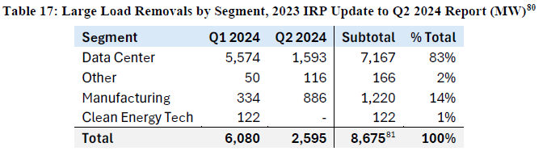
Edited Table
Segment | Q1 2024 | Q2 2024 | Subtotal | % Total
Data Center | 5,574 | 1,593 | 7,167 | 83%
Other | 50 | 166 | 216 | 2%
Manufacturing | 334 | 700 | 1,034 | 12%
Clean Energy Tech | 122 | 136 | 258 | 3%
Total | 6,080 | 2,595 | 8,675 | 100%

Correction #11 – p. 54, Table 18
Original Table
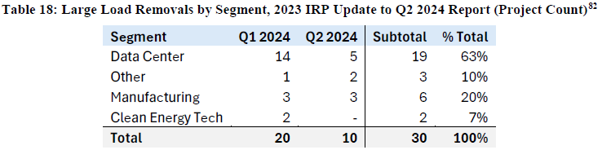
Edited Table
Segment | Q1 2024 | Q2 2024 | Subtotal | % Total
Data Center | 14 | 5 | 19 | 63%
Other | 1 | 2 | 3 | 10%
Manufacturing | 3 | 1 | 4 | 13%
Clean Energy Tech | 2 | 2 | 4 | 13%
Total | 20 | 10 | 30 | 100%

Correction #12 – p. 55, Table 19
Original Table
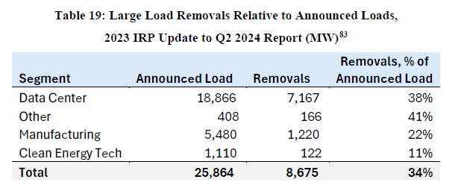
Edited Table
Segment | Announced Load | Removals | Removals,  % of Announced Load
Data Center | 18,866 | 7,167 | 38%
Other | 408 | 216 | 53%
Manufacturing | 5,480 | 1,034 | 19%
Clean Energy Tech | 1,110 | 258 | 23%
Total | 25,864 | 8,675 | 34%

Technical Appendix Volume 1, PUBLIC DISCLOSURE Budget 2025 Load and Energy Forecast Report, 2025 to 2044, Attachments 5.1.1-1, 5.1.1-2, & 5.1.1-3, and associated workpapers.
Excludes adjustments to the LT energy forecasts for Solar, EVs, DSM, and Cogeneration.
Company Response to Data Request STF-DEA-1-37 and associated TRADE SECRET Attachment.
Company Response to Data Request STF-DEA-1-38 and associated TRADE SECRET Attachment.
Company Response to Data Request STF-DEA-1-39 and associated TRADE SECRET Attachment.
Technical Appendix Volume 1, PUBLIC DISCLOSURE Budget 2025 Load and Energy Forecast Report, 2025 to 2044, Attachments 5.1.1-1, 5.1.1-2, & 5.1.1-3, and associated workpapers.
Excludes adjustments to the LT energy forecasts for Solar, EVs, DSM, and Cogeneration.
Company Response to Data Request STF-DEA-1-37 and associated TRADE SECRET Attachment.
Company Response to Data Request STF-DEA-1-38 and associated TRADE SECRET Attachment.
Company Response to Data Request STF-DEA-1-39 and associated TRADE SECRET Attachment.
Company Response to Data Request STF-DEA-1-37 and associated TRADE SECRET Attachment.
Company Response to Data Request STF-DEA-1-38 and associated TRADE SECRET Attachment.
Company Response to Data Request STF-DEA-1-39 and associated TRADE SECRET Attachment.
Company Response to Data Request STF-DEA-1-37 and associated TRADE SECRET Attachment.
Company Response to Data Request STF-DEA-1-38 and associated TRADE SECRET Attachment.
Company Response to Data Request STF-DEA-1-39 and associated TRADE SECRET Attachment.

