

Integrated Hydrogen Microgrid Project

Quarterly Report

Reporting Period End Date: December 31, 2024

Table of Contents
Key Updates (October 1, 2024 – December 31, 2024) 3
Project Background 3
Vehicles Update 6
Fueling Update 6
Microgrid Update 7
Analysis Update 8
Southern Company Accomplishments During Previous Reporting Period 9
Southern Company Plans for Next Reporting Period 10
Southern Company Budget and Schedule 10

List of Tables
Table 1. Revised actual and forecasted costs per calendar year. Contains actuals through December 2024 and forecast for the remainder. 10

List of Figures
Figure 1: Hydrogen microgrid energy system 4
Figure 2. Overall project timeline organized by workstreams 5
Figure 3. Gen2 FCEV is similar to the vehicle to be demonstrated in this project. The GPC vehicle will have conventional cab, not crew cab, and longer toolbox. 6
Figure 4. Layout showing the refueler and fencing. 7

Key Updates (October 1, 2024 – December 31, 2024)
- Scope and estimate challenge were completed October 2024.
- First RFP package for the project was issued in November 2024.
- Detailed schedule with logic ties completed by December 2024.
- Updates have been made to the schedule reflecting:
  - Delivery of first vehicle from GM - beginning of Q2 2025
  - Delivery of temporary refueling system to end of Q1 2025, which may minimize or eliminate the need for mobile refueler system
  - Expected Subrecipient Agreement execution with EPRI in Q1 2025

Project Background
Hydrogen is an area that may provide customers with benefits as renewable penetration increases and technology improvements occur. Using a process known as electrolysis, energy providers can create hydrogen using electrical energy and water. The hydrogen created from this process can be utilized for many purposes. For electricity production, hydrogen fuel can offset or eliminate natural gas while reducing carbon emissions. Hydrogen can also be utilized in Distributed Energy Resources (“DER”) applications, as a transportation fuel, or even in certain industrial processes. Through stored hydrogen, these energy end uses could be decarbonized, providing additional low-carbon energy to energy users throughout Georgia.

To prepare for this possibility, as approved by the PSC in the 2022 IRP, Southern Company Services (“SCS”) and Georgia Power Company (“Georgia Power” or the “Company”) are partnering with key stakeholders to develop an integrated hydrogen microgrid as illustrated in Figure 1. This project seeks to create hydrogen from an electrolysis system utilizing grid energy. The hydrogen produced will then be used in a fuel cell microgrid application and for transportation fuel. The fuel cell component will create electricity that can be utilized to charge electric vehicles, provide backup power, or provide peaking services, thus demonstrating the flexible nature of stored energy via hydrogen for both vehicles and stationary power loads.

Figure 1: Hydrogen microgrid energy system
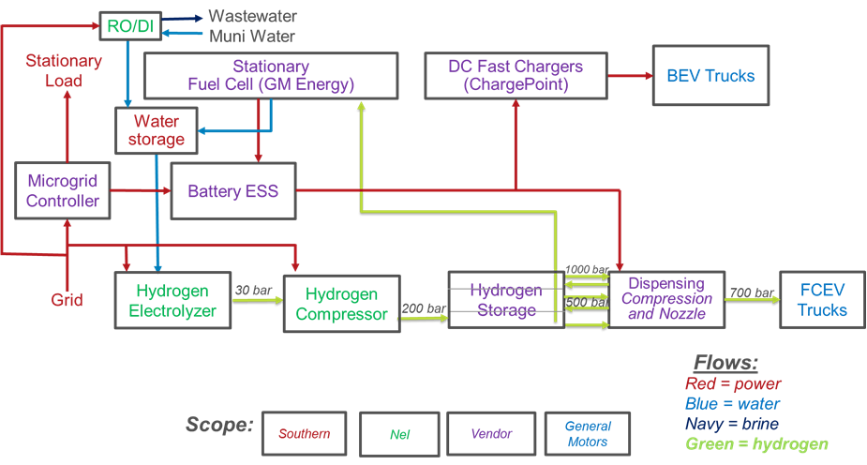

This project will include hydrogen fuel cell Class 4 trucks and battery electric trucks. No production zero emission vehicles are available for Class 4 trucks which are the most common fleet vehicles in the utility industry. Based on DOE guidance, the battery electric trucks used in this project may be light-duty pickup trucks rather than Class 4 trucks owing to lack of BEV in the medium-duty classes. This project leverages federal funding and collaboration between General Motors (“GM”), Southern Company Services and Georgia Power Company, Nel Hydrogen, and the Electric Power Research Institute (“EPRI”).

Specific objectives include:
- Demonstrate system benefits to grid and create value through use-case stacking:
  - Electrolyzer and fuel cell as dispatchable loads
  - Fuel cell for peak shaving
  - Fuel cell for back-up power
- Develop path toward deployment of energy storage systems
- Design and demonstrate zero-emission vehicles for utility applications
- Illustrate Green House Gas (“GHG”) emissions reductions
- Demonstrate microgrid and zero-emission vehicle integration for customers

The project is executed through four workstreams, with associated high-level activities shown in Figure 2. Specific updates are provided in the following sections.

Figure 2. Overall project timeline organized by workstreams
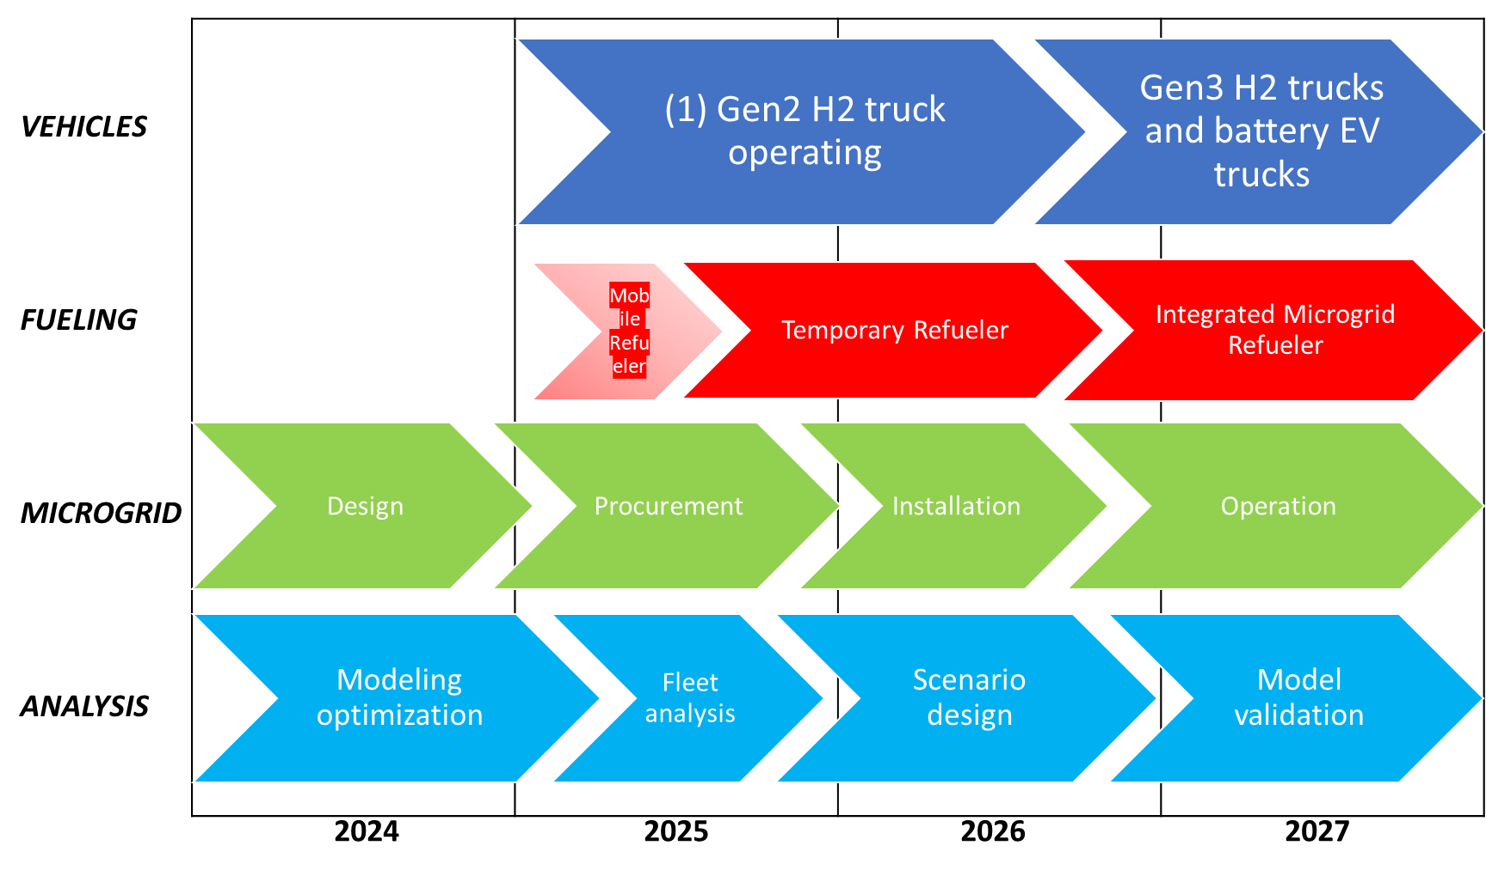

Vehicles Update
GM is providing a Gen2 hydrogen fuel cell electric vehicle (FCEV) for initial demonstration (3), followed by Gen3 FCEV which will be medium-duty vehicles for vocational service. Battery electric vehicles may be supplied by GM or utilized from existing fleet vehicles. The initial vehicle will be a Class 4 pickup with a shop-service body for use by GPC Fleet Services (Sands Place facility in Marietta) in support of system maintenance. This vehicle has already been constructed by GM using an existing conventional vehicle frame atop a new chassis with two (2) GM Hydrotec fuel cells and with an estimated range of greater than 300 miles at Gross Vehicle Weight, or greater than 100 miles range with 10 hours of export power at a worksite. It is planned for delivery in April 2025. Once it is on-site in Georgia, additional safety and operational training will be provided by GM.

Figure 3. Gen2 FCEV is similar to the vehicle to be demonstrated in this project. The GPC vehicle will have conventional cab, not crew cab, and longer toolbox.
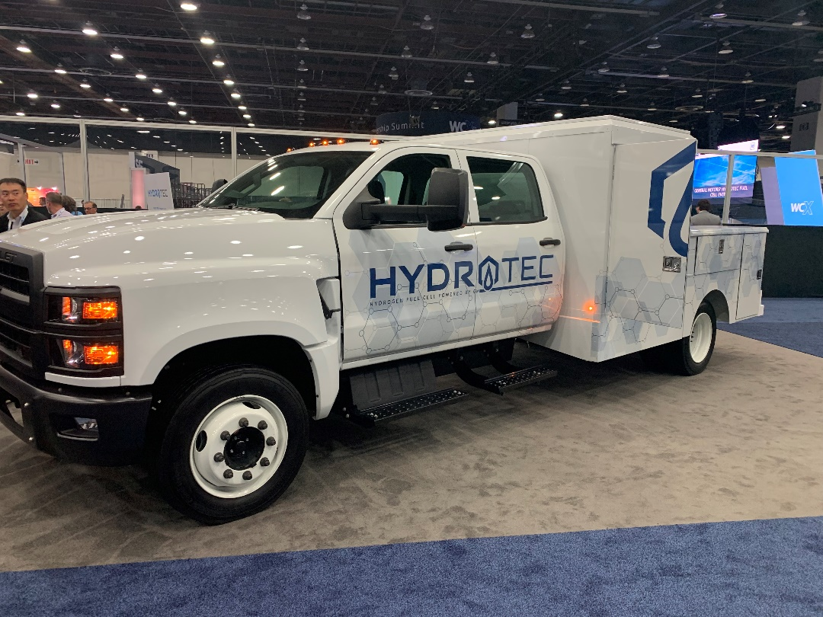

Fueling Update
Initial fueling for the first FCEV will be provided from a mobile refueler supplied by GM to the site at Georgia Power’s Plant McDonough. This self-contained dispenser will be mounted on-board a flat-bed trailer and parked at the Plant McDonough site. The first quarter 2025 delivery of the mobile refueler is expected to coincide with delivery of the first vehicle. Site prep work for the mobile refueler is completed. Also, a permit from the Office of the Commissioner of Insurance (OCI) has been obtained.

Figure 4. Layout showing the refueler and fencing.

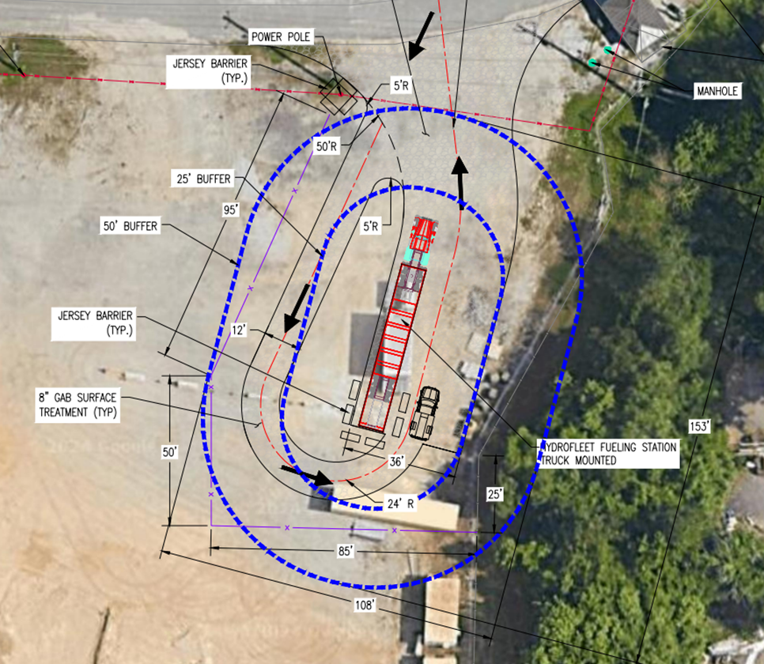

However, based on the revised timeline for delivery of the first truck, the mobile refueler system may be unnecessary. GM has procured a site-based refueling system from Air Liquide, which is under construction in Houston and planned for installation in the 1st quarter 2025. This system will use hydrogen supplied from a conventional tube trailer and compress it for dispensing into the vehicle. SCS Supply Chain Management is issuing PO under existing master agreements with an industrial gas company for this supply. This conventional tube trailer is the same type used at Plant McDonough to supply hydrogen for generator cooling. The balance of plant to support the Air Liquide system is well underway and will be installed in the 1st quarter of 2025.

Microgrid Update
Conceptual design and layout are complete for the integrated hydrogen microgrid at the site. Figure 4 Site Layout shows the layout for the project. Piping and instrumentation diagrams as well as detailed civil design are underway. The preliminary electrical load list was created to size electrical infrastructure needed to power the project, and the electrical drawing for the temporary refueling system has been issued, with installation expected in Q1 2025 for the temporary refueling system.

Following the detailed mechanical design, a hazard identification (HAZID) process will take place. Hydrogen will be produced (approximately 160 kg/day) at the site using up to 400 kW electrolyzer supplied by Nel (two C30 units) installed in a small building. Hydrogen compression, compressed gas storage, and a stationary fuel cell are also designed, as is a 350-kW fast charger from ChargePoint. The stationary fuel cell will provide the energy for the fast charger, thus avoiding impacts to the local power distribution system. The stationary fuel cell will also provide resilient power to a nearby warehouse at Plant McDonough site. A battery energy storage system will be designed and added to site to help stabilize the microgrid in islanded operations and maximize economic dispatch in grid-connected operations. An RFP has been issued through SCS Supply Chain Management to qualified bidders with expected responses in Q1 2025 for the microgrid controller, battery energy storage system, and associated switchgear and installation.

Figure 5 Site Layout
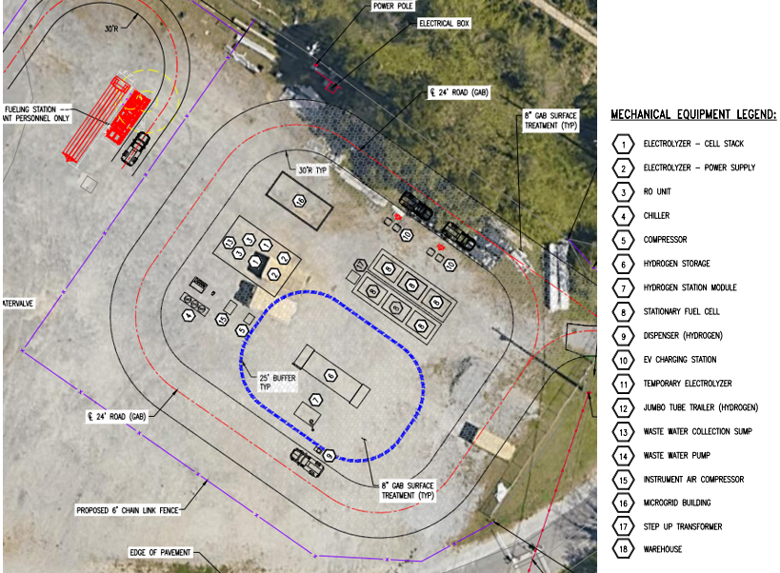

Analysis Update
Preliminary operational simulation has been completed, and it has been shown that most of the stored hydrogen would be used in support of peaking or resilient power. EPRI and SCS are currently reviewing a Subrecipient Agreement that is expected to be executed in Q1 2025, pursuant to which EPRI will analyze impacts of broad deployment of the hydrogen microgrid approach, including an assessment of fleets and scenarios for providing infrastructure as those fleets convert to ZEV. EPRI is providing cost-share to this project by doing the work in the Low Carbon Resources Initiative program, and by doing so, provides additional opportunities to highlight the entire project to electric and/or gas utilities.

Southern Company Accomplishments During Previous Reporting Period
Task | Accomplishments
Task 1: Simulation & Analysis | See detail in Tasks below for Southern Company scope
Task 1.2: Fleet identification, baselining, and planning | Complete
Task 1.2.1: Identification of vocational fleet vehicles for the demonstration | Complete
Task 1.2.2: Collection of baseline fueling and performance data | Complete  - MPG ranges from 5.5 to 9.4 and average of ~8,000 miles (about 12874.75 km) per year  - Additional telematics provided to GM for drive train optimization  - Trucks from Sands Place facility
Task 1.2.3: Simulation and analysis for charging and electrolysis scenarios for GHG and price optimization | Ongoing with expected complete by end of BP4  - Operational model completed to calculate maximum price and GHG from primary power (typical grid ~0.4 kgCO2/kWh)  - Most of the stored hydrogen needed to support resilient power
Task 1.2.4: Model impacts of utility scale adoption | Moved to BP3 and BP4  - EPRI is being added as a subrecipient with plans to complete this scope over next 2 years. The overall subtasks within this Task are:  - Assessment of medium duty vehicles in the utility sector  - Cost and GHG estimation for refueling and recharging if all MD utility vehicles were ZEV  - Cost and GHG estimation for nationwide deployment of integrated hydrogen microgrids for vehicles in utility sector
Task 2: Design | See detail of Tasks below for Southern Company scope
Task 2.4.: Site planning and design at the fleet site | Ongoing  - Site layout and general arrangements for all three types of refueling completed in 24Q2  - Electrical drawing issued for construction for the temporary refueling system  - Preliminary P&ID completed in 24Q2  - Collected budgetary quotes for hydrogen delivery for 2025 and 2026 until installation is complete.  - Completed scope and estimate challenge.  - Preliminary Electrical load list completed in 24Q4  - Siting drawings underway

Southern Company Plans for Next Reporting Period
Task 1.2.4
- Execute EPRI Subrecipient Agreement

Task 2.4
- Complete the P&ID siting drawings for the project 25Q1.
- Evaluate bids for the microgrid controller and associated scope
- Prepare specifications for hydrogen equipment with long lead time (compressor and refueler) in support of procurement activities.
- Site preparation activities will be completed for receiving the vehicle and temporary (and/or mobile) refueling system(s).
- Complete foundation drawings for the Air Liquide system during 25Q1.
- Prepare RFPs for hydrogen equipment during 25Q1.
- Update Risk Register during 25Q1.

The resource-loaded schedule has been updated and the contract modification for BP3 has been executed with GM, including the authorization to proceed with major equipment procurement.

Task 4
- Anticipate delivery of first truck by GM in early Q2 2025

Southern Company Budget and Schedule
Table 1. Revised actual and forecasted costs per calendar year. Contains actuals through December 2024 and forecast for the remainder.
Year | 2023 | 2024 | 2025 | 2026 | 2027 | Total
Federal Cost ($) | $14,062 | $153,131 | REDACTED | REDACTED | REDACTED | REDACTED
Company Cost ($) | $27,298 | $297,109 | REDACTED | REDACTED | REDACTED | REDACTED
Total Cost ($) | $41,360 | $450,240 | REDACTED | REDACTED | REDACTED | REDACTED

The Project schedule is included on the next page.

Overall Project Schedule
This schedule is fully redacted.

Super Truck 3 – DOE Proposal Awarded - https://www.energy.gov/articles/doe-announces-nearly-200-million-reduce-emissions-cars-and-trucks

