COMMISSIONERS:  JASON SHAW, Chairman  TIM G. ECHOLS, Vice-Chairman  FITZ JOHNSON  LAUREN “BUBBA” McDONALD  TRICIA PRIDEMORE |  | REECE McALISTER  EXECUTIVE DIRECTOR  SALLIE TANNER  EXECUTIVE SECRETARY

Georgia Public Service Commission
(404) 656-4501  (800) 282-5813 | 244 WASHINGTON STREET, SW  ATLANTA, GEORGIA 30334-5701 | FAX: (404) 656-2341  psc.ga.gov

DOCKET NO. 41559: IN RE: ATLANTA GAS LIGHT COMPANY'S ECON-1 TARIFF

FINAL ORDER APPROVING ATLANTA GAS LIGHT COMPANY’S PETITION TO APPROVE JACKSON COUNTY PROJECT – SUGARLOAF INTERNATIONAL

- Background

On October 10, 2017, the Commission approved Atlanta Gas Light Company’s (“AGL”) Economic Development Tariff (“ECON-1 Tariff”) as part of efficiency changes to AGL’s customer growth initiatives. The ECON-1 Tariff, Section 27, was approved for large economic development projects with economic development parameters based on customer class, capital investment, new jobs created, and new gas load. The initial tariff allowed up to $15 million per year for ECON-1 Tariff projects. On August 28, 2023, the Commission approved changes to the ECON-1 Tariff that increased the annual limit to $25 million per year. ECON-1 projects were approved to be recovered through a surcharge mechanism similar to the i-CDP’s SRR rider, a known and approved recovery mechanism, to recover the ECON-1 rate base.

- Jackson County Project – Sugarloaf International
On September 2024, AGL filed a petition for the approval of an ECON-1 project for Jackson County for a customer called Sugarloaf International (“Customer”). The Staff designated the project as the Jackson County Project-SI, to separate it from prior ECON-1 projects in Jackson County. AGL stated that the Customer is constructing a multi-unit commercial development within the city limits of Jefferson, and this new development will include eight (8) new meters that will include a BP gas station convenience store and seven yet to be determined retail establishments.

AGL stated that the Jackson County Project qualifies for approval under Section 3.C. of the ECON-1 Tariff as a Customer in the G-11 rate class. The estimated total customer capital investment amount for this project is $5,000,000. It is expected that the BP gas station and convenience store will add approximately 10 jobs to the local community. AGL estimated that the tax base for this project will be $575,000. AGL further stated that the BP gas station and convenience store will add connected load on a Firm basis of approximately 1,080 dekatherms per year. The project meets or exceeds the minimum requirements as an ECON-1 project.

To serve the customer, AGL proposed to tie into 4” plastic main at the intersection of Winder Highway and Paxon Lane and install approximately 1,825 feet of 4” plastic main (MAOP 60 psi) along Winder Highway and Galilee Church Road to reach the site and install approximately 540 feet of 1-1/4” plastic service line to serve the new customers. The estimated cost of the project was $210,000 with a 10% contingency.

- Staff's Analysis

- Project Analysis

The Staff reviewed the filing and the required minimum filing requirement (“MFR”) information was provided as part of Tariff Section 3(C)(i-iv), and it was found to be whole and complete. See Table-1 below.

Table-1: AGL’s ECON-1 Tariff Section 3(C)(i-iv)
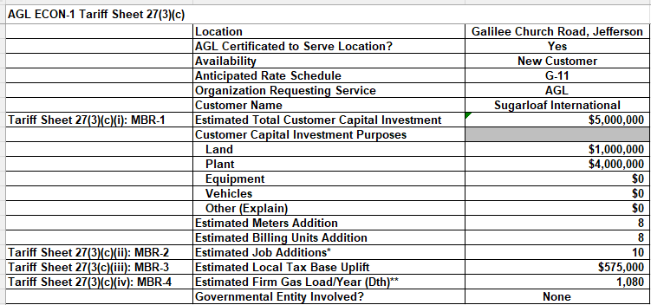

In Tariff Section 4(a-d), AGL was required to provide a technical description of the project, that the project meets the ECON-1 requirements, the detailed engineering cost estimates, and a map of the project area. Please see Table-2 below. AGL provided this information.

Table-2: AGL’s ECON-1 Tariff Section 4(a – d)
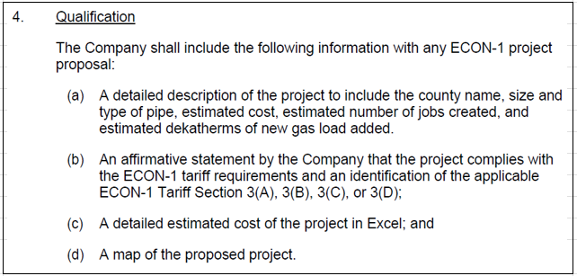

This map can be seen as Map-1a below. The Staff also provided a Google Map of the project area below as Map-1b.

Staff Map-1a
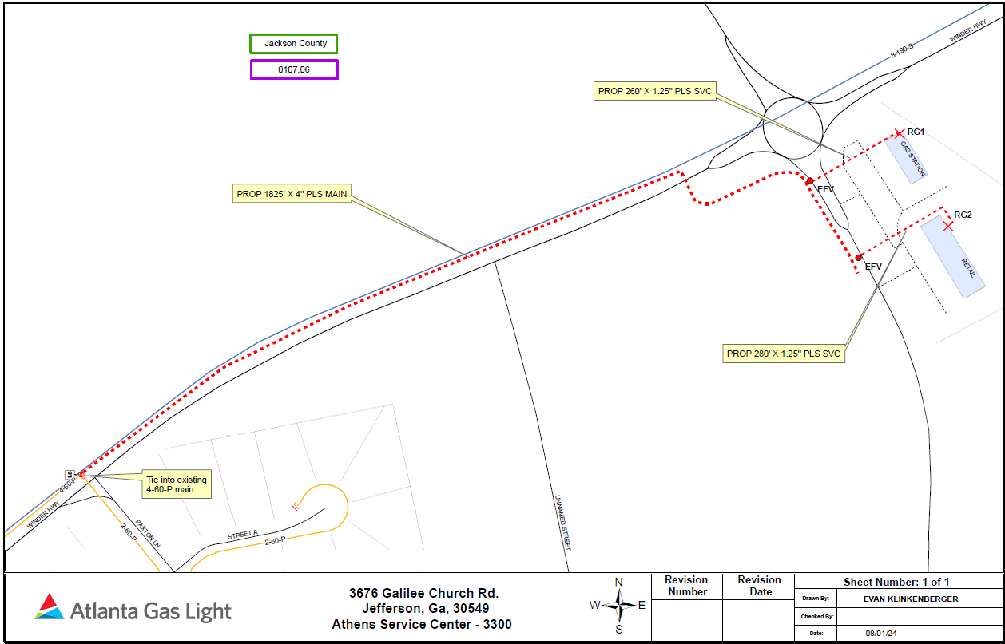

Staff Map-1a
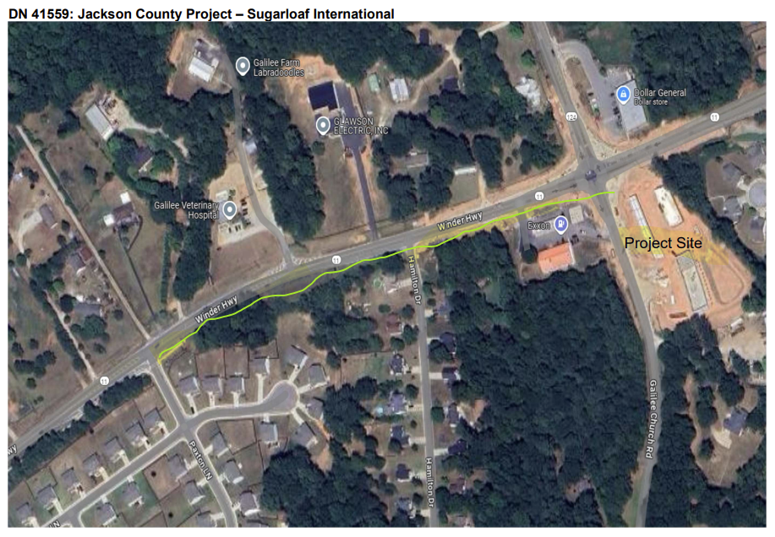

Though the AGL petition provided the required MFRs, the Staff had concerns about certain areas of the project.

- Staff Concerns

The Staff had a number of items that were concerns related to the Jackson County Project-SI. On September 30, 2024, the Staff filed its 19th Set of Data Requests. On October 15th, 2024, AGL filed responses. The following items are selected highlights of items that were addressed.

First, the Staff reviewed Sugarloaf International on the Georgia Secretary of State’s website. It is listed as a Domestic Limited Liability Company that has been registered since October 24, 2014. There were no additional details. See Table-3 below. The Staff found no other details in its research.

Table-3: Georgia Secretary of State Information
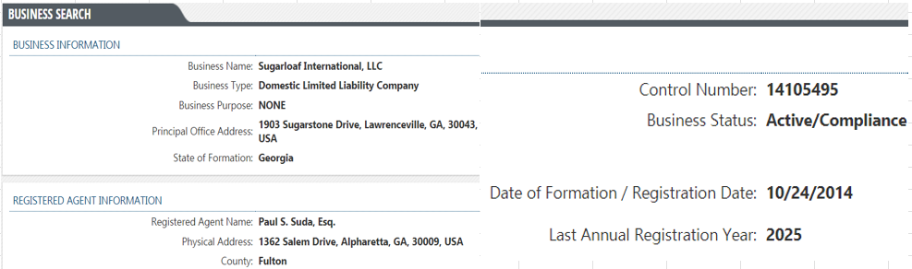

On November 30, 2024, the Staff issued its Nineteenth Set of Data Requests to gather additional information. On October 15, 2024, AGL filed responses. In STF-19-1, the Staff requested additional details about Sugarloaf International. In AGL’s response, it stated the following:

Sugarloaf International LLC (“SI”) is a domestic limited liability company that is developing the property and constructing the retail buildings. They will also be the owner of both buildings on the property.

Second, the Staff wanted to understand the role of Sugarloaf International related to this project. In response to STF-19-2 and STF-19-3, AGL stated that the Customer would own the new constructed buildings that will require the eight (8) gas meters. The Customer will operate the BP gas station and convenience store, and it will lease the other seven (7) business units that with their own individual gas meter.

Third, the Staff wanted to know if the Customer would provide a Contribution In Aid of Construction (“CIAC”), and AGL responded in STF-19-8 that it would not.

The Staff was satisfied with AGL’s responses and all concerns were resolved.

- ECON-1 Recovery Rider Analysis

As seen in in Table-4 below, the beginning 2024 balance for funding projects was $25 million. Currently for 2024, the Commission has approved over $6,719,751 for projects. The current available 2024 funds are $18, 280,249. If the Jackson County Project-SI were approved with an estimated cost of $210,000, the new balance of the 2024 available funds would be $18,070,249. There are no issues with funding this project.

Table-4: 2024 ECON-1 Tariff Available Funds
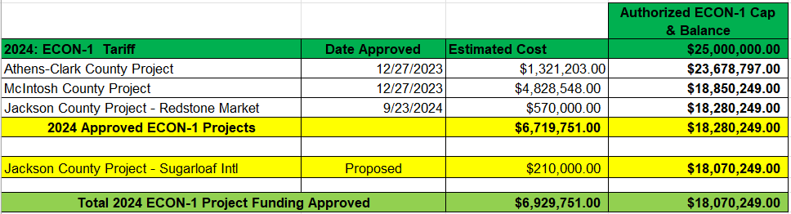

- Commission Decision
During the December 3, 2024 Administrative Session, the Commission approved the Jackson County Project for Sugarloaf International with an estimated cost of $210,000.

* * * * *

- Ordering Paragraphs

WHEREFORE IT IS ORDERED, that the Commission approves AGL’s petition in Docket No. 41559 as filed for the Jackson County Project for Sugarloaf International with an estimated cost of $210,000.

ORDERED FURTHER, that all findings, conclusions, statements, and directives made by the Commission and contained in the foregoing sections of this Order are hereby adopted as findings of fact, conclusions of law, statements of regulatory policy, and orders of this Commission.

ORDERED FURTHER, that a motion for reconsideration, rehearing, oral argument, or any other motion shall not stay the effective date of this Order, unless otherwise ordered by the Commission.

ORDERED FURTHER, that jurisdiction over this matter is expressly retained for the purpose of entering such further Order or Orders as the Commission may deem just and proper.

The above by action of the Commission in Administrative Session on the 3rd day of December 2024.

Sallie Tanner Jason Shaw
Executive Secretary Chairman

Date Date

