COMMISSIONERS:  JASON SHAW, Chairman  TIM G. ECHOLS, Vice-Chairman  FITZ JOHNSON  LAUREN “BUBBA” McDONALD  TRICIA PRIDEMORE |  | REECE McALISTER  EXECUTIVE DIRECTOR  SALLIE TANNER  EXECUTIVE SECRETARY

Georgia Public Service Commission
(404) 656-4501  (800) 282-5813 | 244 WASHINGTON STREET, SW  ATLANTA, GEORGIA 30334-5701 | FAX: (404) 656-2341  psc.ga.gov

BEFORE THE GEORGIA PUBLIC SERVICE COMMISSION

IN RE: ATLANTA GAS LIGHT COMPANY’S } DOCKET NO. 41559
ECON-1 TARIFF }

STAFF’S NINETEENTH SET OF DATA REQUESTS TO
ATLANTA GAS LIGHT COMPANY

TO: BLAKE O’FARROW
DIRECTOR, EXTERNAL AFFAIRS
ATLANTA GAS LIGHT COMPANY
TEN PEACHTREE PLACE NE, BIN GAS 114
ATLANTA, GEORGIA 30309

COMES NOW the Georgia Public Service Commission Staff (“Staff”) and, pursuant to the authority vested in it by the Georgia Public Service Commission (“Commission”) pursuant to O.C.G.A. § 46-2-57, herein propounds the following interrogatories and requests for production of documents (collectively, “data requests”), to be answered under oath by Atlanta Gas Light Company (“AGL” or “Company”) or its designated representatives. AGL has Thirty (30) days to respond to data requests the Company shall file with the Executive Secretary’s Office using the Alternative E-filing instructions. Public and Trade Secret responses shall be Accompanied therewith shall be an electronic version in Microsoft Word® format for text documents and Excel® for spreadsheets.
Please provide responses on or before 4:00 p.m. on October 29, 2024.
INSTRUCTIONS
- These requests shall be deemed to be continuing. The Respondent is obliged to change, supplement, and correct all answers to requests to conform to available information, including such information as first comes available to the Respondent after the answers are hereto filed.
- The answers provided should first restate the question asked and also identify the person(s) supplying the information.
- All information is to be divulged that is within the knowledge, possession, control, or custody of the Respondent or may be reasonably ascertained thereby.
- As used herein the “document” included, but is not limited to, the original and all copies (regardless of origin and whether or not including additional writing thereon or attached thereto) of memoranda, reports, books, manuals, instructions, directives, records, forms, notes, letters, notices, confirmations, telephone calls, meetings or other communications, bulletins, transcripts, diaries, analyses, summaries, correspondence and enclosures, circulars, opinions, studies, investigations, questionnaires and surveys, work sheets, and all drafts, preliminary versions, alterations, modifications, revisions, changes, amendments and written comments concerning the foregoing, in whatever form, stored or contained in or on whatever medium including computerized memory or magnetic media.

Information Request
Docket No. 41559: ECON-1

Jackson County Project – Sugarloaf International
STF-19-1 On September 19, 2024, AGL filed a petition in DN 41559 for a Jackson County Project to serve a customer called Sugarloaf International. Please provide a business description of Sugarloaf International?

STF-19-2 Does Sugarloaf International own the multi-unit commercial development where the new businesses will be located, which is at the corner of Winder Highway and Galilee Church Rd?

STF-19-3 Will Sugarloaf International own any of the eight (8) new businesses that will be located at the new multi-unit commercial development?

STF-19-4 Will all eight (8) businesses have eight (8) separate gas meters?

STF-19-5 Has all eight (8) businesses, that AGL calls customers in the petition, committed to taking natural gas?

STF-19-6 Please provide the names of the eight (8) new customers.

STF-19-7 How did AGL calculate the 1,080 annual dekatherms, since there will be eight (8) separate businesses?

STF-19-8 Has Sugarloaf Internation made a Contribution In Aid of Construction (“CIAC”) payment related to this project, or are any other of the eight (8) new businesses making a CIAC?

STF-19-9 What is the expected timeline for the new line-extension to be completed?

STF-19-10 What is AGL’s contingency, if no customer takes gas service after construction is completed?

STF-19-11 Related to the Google Map image below, has AGL representatives talked with any of the businesses or residential developments along the proposed route of the new line-extension about establishing natural gas service?

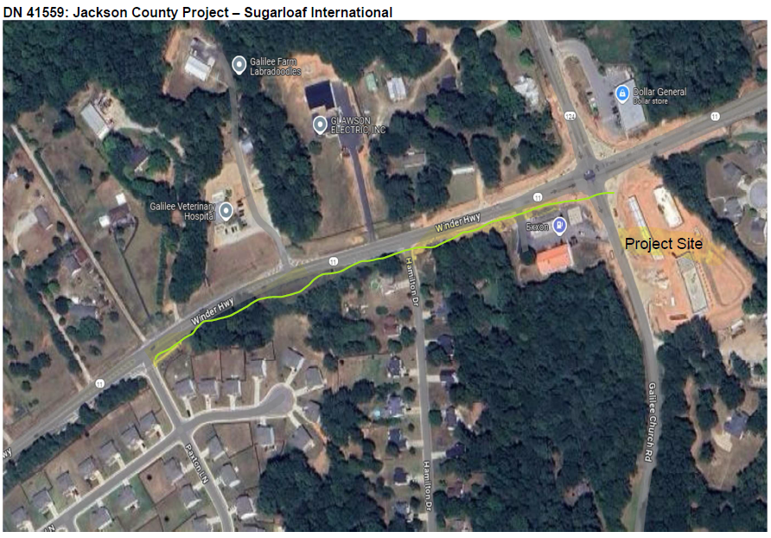

STF-19-12 Since the inception of the ECON-1 tariff, twenty (20) ECON-1 projects have been filed. The Staff has made the observation that eighteen (18) of them listed in the MFR Sheet 27(3) MEB Line-7, Organization Requesting Service, were either the actual gas customer or a third party, such as a County development authority. In the last two filings for Effingham County Project and current Jackson County Project, Sugarloaf International, AGL listed itself as the Organization Requesting Service. Why is AGL requesting service on behalf of these entities instead of the gas customer, or the third party listed on Line-8 requesting service?

STF-19-13 Since AGL is the Organization Requesting Service, how did AGL become aware that this customer needed gas service?

STF-19-14 Since the Jackson County Project – Redstone Market, the Effingham County Project, and the Jackson County Project – Sugarloaf International were low cost line-extension projects, why didn’t AGL file them as part of the 2025 Universal Service Fund Facilities Expansion Plan and save the ECON-1 funding for larger more costly economic development projects?

STF-19-15 How does AGL decide, or a differentiation, a proposed USF project from an ECON-1 project?

