COMMISSIONERS:  JASON SHAW, Chairman  TIM G. ECHOLS, Vice-Chairman  FITZ JOHNSON  LAUREN “BUBBA” McDONALD  TRICIA PRIDEMORE |  | REECE McALISTER  EXECUTIVE DIRECTOR  SALLIE TANNER  EXECUTIVE SECRETARY

Georgia Public Service Commission
(404) 656-4501  (800) 282-5813 | 244 WASHINGTON STREET, SW  ATLANTA, GEORGIA 30334-5701 | FAX: (404) 656-2341  psc.ga.gov

DOCKET NO. 41559: IN RE: ATLANTA GAS LIGHT COMPANY'S ECON-1 TARIFF

FINAL ORDER APPROVING ATLANTA GAS LIGHT COMPANY’S PETITION TO APPROVE JACKSON COUNTY PROJECT – REDSTONE MARKET

- Background/Recovery Mechanism

On October 10, 2017, the Commission approved Atlanta Gas Light Company’s (“AGL”) Economic Development Tariff (“ECON-1 Tariff”) as part of efficiency changes to AGL’s customer growth initiatives. The ECON-1 Tariff, Section 27 of AGL’s tariff, was approved for large economic development projects with economic development parameters based on customer class, capital investment, new jobs created, and new gas load. The initial tariff allowed up to $15 million per year for ECON-1 Tariff projects. On August 28, 2023, the Commission approved changes to the ECON-1 Tariff that increased the annual limit to $25 million per year. ECON-1 projects were approved to be recovered through a surcharge mechanism similar to the i-CDP’s SRR rider, a known and approved recovery mechanism, to recover the ECON-1 rate base.

By October 1st of each year, AGL will file a petition with the Commission to request a proposed update to the surcharge dollar amount, if necessary, with supporting information included in the filing. In keeping with base rates and past surcharge programs, including the SRR, the ECON-1 Rider rate recovery for each rate class shall be as follows:

- R-1, G-10, AG-1, and S-51 customers shall be charged an amount equal to
the approved ECON-1 rate.

- G-11 customers shall be charged an amount equal to three (3) times the
approved ECON-1 rate.

- G-12 customers shall be charged an amount equal to 25 times the
approved ECON-1 rate.

The Staff will make a recommendation on the proposed surcharge amount, and the approved new rate will take effect on January 1st of each year.

The proposed changes to the ECON-1 Tariff provide for quarterly reporting to be filed with the Commission similar to the SRR reporting requirements. This will allow the Commission Staff an opportunity to review the status of the approved projects and the tracking of the recovery through the surcharge for any imbalances to cost and recovery.

- Jackson County Project
On August 15, 2024, AGL filed the Jackson County Project. As part of the Jackson County Project, AGL petitioned to serve a multi-unit retail establishment in Athens, Georgia. AGL stated that the retail development will be located within the city limits of Athens. The retail development will have six natural gas customers:
- Unnamed hotel
- The Silo restaurant
- The Rustic Rooster restaurant
- St. Mary’s medical facility
- Ace Hardware
- Stripling’s country store with gasoline sales named Redstone Market.

AGL’s petition further stated that the Jackson County Project qualified for approval under Section 3.C. of the ECON-1 Tariff as customers in the G-11 rate class, or the Commercial Class. The estimated total customer capital investment amount for this project is $18,500,000 with a minimum required investment of $1 million. The six (6) combined customers are expected to add approximately 270 jobs to the local community, surpassing the minimum requirement of 10 jobs. AGL anticipates that the tax base for this project will be approximately $500,000, exceeding the minimum required tax base of $20,000. The combined load for the six (6) customers is expected to be approximately 12,610 dekatherms per year on a Firm basis exceeding the required minimum of 10 dekatherms.

In order to serve this commercial development, AGL proposes the following:
- AGL will tie-into an existing 4” plastic main located at the intersection of Lebanon Church Road and Bellamy Road.

- AGL will also install approximately 3,833 feet of 4” plastic main (MAOP 60 psi) along Lebanon Church Road and Jefferson Road to reach the site.

- AGL estimates that the Jackson County Project can be completed for approximately $570,000 as indicated in the attached estimate. AGL stated that it is certificated to serve the relevant area of Jackson County. The Company conducted an analysis of this project under its Tariff Rule 8 which indicated that the Customer would owe a contribution in aid of construction of approximately $100,000.

- Staff's Analysis

- Project Analysis

The Staff reviewed the filing and found it to be whole and complete. The Jackson County Project is unique because six (6) companies are seeking natural gas service while simultaneously seeking funding under the ECON-1 tariff. AGL’s ECON-1 minimum filing requirements (“MFRs”) included the aggregate dollar amounts for the six (6) companies. The Staff requested that AGL file a revised Section 27(3) for each of the six (6) companies to show the contribution of each company to the MFRs.

On August 28, 2024, AGL filed an amended Jackson County Project that provided the requested revised Section 27(3) for each of the six (6) companies, breaking out their contribution to the MFRs. The Staff found no issues with the amended filing. Table-1 below compares requirements of Section 3(C) and Section 4 of the MFRs to AGL’s filing. The filing met all of the MFRs requirements.

Table-1: AGL’s ECON-1 Tariff Section 3(C) & 4
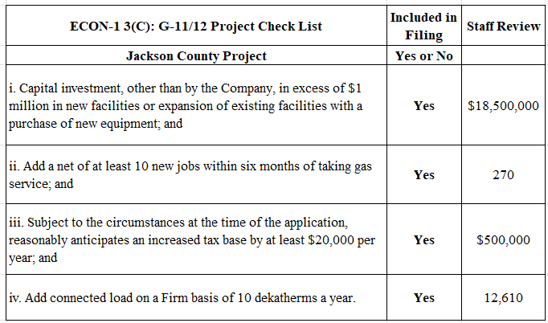

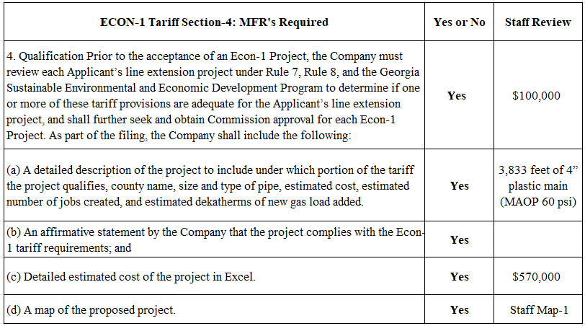

AGL provided a map of the project, and the Staff reviewed Google Maps of the location.

- ECON-1 Recovery Rider Analysis

As seen in Table-2 below, the beginning 2024 balance for funding projects was $25 million. The Commission has approved over $6.1 million for 2024. The remaining balance for available funds is $18.8 million. With the approval of the Jackson County Project with an estimated cost of $570,000, the remaining available balance for future projects will be $18.2 million.

Table-2: 2024 ECON-1 Recovery Rider Available Funds
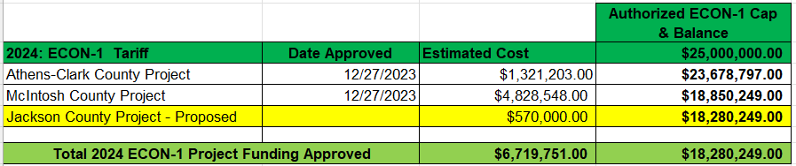

- Commission Decision
During the September 17, 2024 Administrative Session, the Commission approved the Jackson County Project with an estimated dollar amount of $570,000.

* * * * *

- Ordering Paragraphs

WHEREFORE IT IS ORDERED, that the Commission approves AGL’s petition in Docket No. 41559 as filed for the Jackson County Project with an amount of $570,000.

ORDERED FURTHER, that all findings, conclusions, statements, and directives made by the Commission and contained in the foregoing sections of this Order are hereby adopted as findings of fact, conclusions of law, statements of regulatory policy, and orders of this Commission.

ORDERED FURTHER, that a motion for reconsideration, rehearing, oral argument, or any other motion shall not stay the effective date of this Order, unless otherwise ordered by the Commission.

ORDERED FURTHER, that jurisdiction over this matter is expressly retained for the purpose of entering such further Order or Orders as the Commission may deem just and proper.

The above by action of the Commission in Administrative Session on the 17th day of September 2024.

Sallie Tanner Jason Shaw
Executive Secretary Chairman

Date Date

