COMMISSIONERS:  JASON SHAW, Chairman  TIM G. ECHOLS, Vice-Chairman  FITZ JOHNSON  LAUREN “BUBBA” McDONALD  TRICIA PRIDEMORE |  | REECE McALISTER  EXECUTIVE DIRECTOR  SALLIE TANNER  EXECUTIVE SECRETARY

Georgia Public Service Commission
(404) 656-4501  (800) 282-5813 | 244 WASHINGTON STREET, SW  ATLANTA, GEORGIA 30334-5701 | FAX: (404) 656-2341  psc.ga.gov

DOCKET NO. 43510 ATLANTA GAS LIGHT COMPANY’S UNIVERSAL SERVICE FUND ANNUAL FACILITIES EXPANSION PLAN FILING

FINAL ORDER APPROVING ATLANTA GAS LIGHT COMPANY’S PETITION TO AMEND THE 2024 UNIVERSAL SERVICE FUND FACILITIES EXPANSION PLAN

- Background

Commission Rule 515-7-5-.02 states that, consistent with O.C.G.A. §46-4-161, the Commission is authorized to create and establish regulations to administer a universal service fund for each gas company that elects to become subject to the provisions of Article 5 of Chapter 4 of Title 46 of the Official Code of Georgia Annotated, and which satisfies the requirements of O.C.G.A. §46-4-154. With respect to each such gas company, which is also termed an "electing distribution company" under the Natural Gas Competition and Deregulation Act, the Commission is charged with making a determination prior to the commencement of the electing distribution company's fiscal year as to the amount of funding that is appropriate for that year. Commission Rule 515-7-5-.03 states that, a universal service fund shall be created for each electing distribution company for the purposes set forth in O.C.G.A. §46-4-161(a). These purposes include assuring that gas is available for sale by marketers to firm retail customers within a territory certificated to each such marketer; enabling the electing distribution company to extend and expand its facilities and service in the public interest; assisting low-income residential consumers in times of emergency as determined by the Commission; and consumers of the regulated provider of natural gas in accordance with Code Section 46-4-166. Commission Rule 515-7-5-.07 outlines procedures related to applications for disbursement from the Universal Service Fund for an electing distribution company.

- AGL’s Amended USF 2024 Plan Filing

On August 9, 2024, Atlanta Gas Light Company (“AGL” or “Company”) filed a petition to amend its 2024 Universal Service Fund Facilities Expansion Plan (“Amended USF 2024 Plan”). The petition was composed of the following minimum filing requirements (“MFR”) files:

- MFR-1: Project Description
- MFR-4: Maps
- MFR-6: Project Financial Analysis
- MFR-7: Project Technical Analysis

AGL provided three (3) projects for consideration and included the following project descriptions related to MFR-1.

White County Project

For the first project, AGL proposed new facilities to serve a church building and other potential retail businesses in Cleveland, Georgia. AGL discussed a tie-in to an existing 4” plastic pipeline at the intersection of W Kytle Street and Bell Street. Approximately 1,175 feet of 4” plastic pipeline (MAOP 60 psi) would be installed to serve the church building. AGL stated that there is a possibility of additional commercial infill along the proposed route. The estimated cost of the project is $139,074, with income taxes and finance costs applied.

Staff contacted AGL to obtain the name of the church. This church is called, Gathering Community Church. Staff researched and found its location at 156 Wilford Ash Sr. Parkway, Cleveland, GA 30528.

Cherokee County Project

For the second project, AGL proposed to serve the new Cherokee High School. AGL stated that there will be two (2) meters at this location: One (1) meter for the main school building, and one (1) meter for the athletic fieldhouse.

The Company stated that the project requires a pressure improvement to serve the new school. AGL proposes to upsize approximately 600 feet of 4” plastic pipeline on Riverstone Parkway between Milton Drive and Transit Avenue to 6” plastic pipeline (MAOP 60 psi). This requires the installation of approximately 700 feet of 6” plastic pipeline to re-establish the feed to the existing medium high-pressure main along Riverstone Parkway. The pressure improvement also involves the installation of approximately 50 feet of 2” plastic pipeline (MAOP 60 psi) to re-establish the feed to the MHP main on Milton Drive. AGL also proposes to tie into existing 4” plastic pipeline on Bluff’s Parkway and install approximately 495 feet of 4” plastic pipeline (MAOP 60 psi) along the new road approaching the school, and approximately 2,275 feet of 2” plastic pipeline (MAOP 60 psi) along MLK Drive to serve the school and fieldhouse. The estimated cost of the project is $579,475, with income taxes and finance costs applied.

Based on Staff’s research in Google Maps, Cherokee High School is a new facility located along Reservoir Drive between Hickory Log Drive and Reinhardt College Parkway and Dr. Martin Luther King Jr Blvd.

Chatham County Project (“Bryan County Project”)

For the third project, AGL proposed to serve the New Richmond Hill High School. AGL proposed to tie into new 6” plastic pipeline on Belfast Keller Road and extend that main by installing approximately 1,500 feet of 6” plastic pipeline (MAOP 60 psi) along Belfast Keller Road to serve the school. The Company stated that the main to be tied into is currently proposed as part of a New Business line extension scheduled to be installed in 2024. The estimated cost of the project is $388,558, with income taxes and finance costs applied.

The Staff determined that the new Richmond Hill High School is located in Bryan County. Based on this determination, the Staff has renamed this project the Bryan County Project. Based on Staff’s research in Google Maps, this is a new facility located on Belfast Keller Rd.

- Staff’s Analysis

The Staff reviewed the petition, the MFR details, and researched information regarding the potential customers. Additionally, the Staff researched each location on Google Maps for accuracy. The Staff had communications with AGL regarding customer names, project names, and locations. After reviewing the petition, the Staff found it to be whole and complete.

Regarding the 2024 USF $25 million cap, as required in O.C.G.A. 46-4-161(b), the current unencumbered and available USF funds are $8,032,419. If the three (3) proposed projects totaling $1,107,107 are approved, the new unencumbered balance would be $6,925,312. In Table-1 below, the 2024 $25 million encumbrance analysis is provided. It is the Staff’s opinion that there are sufficient USF funds for the proposed projects.

Table-1: 2024 $25 Million Encumbrance Analysis
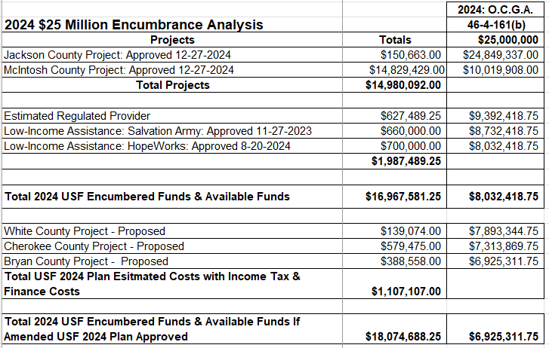

- Commission Decision
During the September 4, 2024, Administrative Session, the Commission approved Atlanta Gas Light Company’s Petition to Amend the 2024 Universal Service Fund Facilities Expansion Plan as filed.

* * * * *

- Ordering Paragraphs

WHEREFORE IT IS ORDERED, that the Commission approves Atlanta Gas Light Company’s Petition to Amend the 2024 Universal Service Fund Facilities Expansion Plan as filed.

ORDERED FURTHER, that all findings, conclusions, statements, and directives made by the Commission and contained in the foregoing sections of this Order are hereby adopted as findings of fact, conclusions of law, statements of regulatory policy, and orders of this Commission.

ORDERED FURTHER, that a motion for reconsideration, rehearing, oral argument, or any other motion shall not stay the effective date of this Order, unless otherwise ordered by the Commission.

ORDERED FURTHER, that jurisdiction over this matter is expressly retained for the purpose of entering such further Order or Orders as the Commission may deem just and proper.

The above by action of the Commission in Administrative Session on the 4th day of September 2024.

Sallie Tanner Jason Shaw
Executive Secretary Chairman

Date Date

