BEFORE THE GEORGIA PUBLIC SERVICE COMMISSION

In Re:  2019 ATLANTA GAS LIGHT RATE CASE/AFFILIATE TRANSACTION AUDIT | )  )  )  ) | DOCKET 42315

STAFF’S FORTY-NINTH SET OF DATA REQUESTS TO THE
ATLANTA GAS LIGHT COMPANY

TO: BLAKE O’FARROW
DIRECTOR – REGULATORY AFFAIRS
ATLANTA GAS LIGHT COMPANY
TEN PEACHTREE PLACE
ATLANTA, GA 30309

COMES NOW the Georgia Public Service Commission Staff (“Staff”) and, pursuant to the authority vested in it by the Georgia Public Service Commission (“Commission”) pursuant to O.C.G.A. § 46-2-57, herein propounds the following interrogatories and requests for production of documents (collectively, “data requests”), to be answered under oath by Atlanta Gas Light Company, (“AGL” or “Company”) or its designated representatives. The Company shall file with the Executive Secretary’s Office using the Alternative E-filing instructions. Public and Trade Secret responses shall be Accompanied therewith shall be an electronic version in Microsoft Word® format for text documents and Excel® for spreadsheets.

Please provide responses on or before 4:00 p. m. on October 4, 2024.

INSTRUCTIONS
- These requests shall be deemed to be continuing. The Respondent is obliged to change, supplement, and correct all answers to requests to conform to available information; including such information as first comes available to the Respondent after the answers are hereto filed.

- The answers provided should first restate the question asked and also identify the person(s) supplying the information.

- All information is to be divulged that is within the knowledge, possession, control, or custody of the Respondent or may be reasonably ascertained thereby.

- As used herein the “document” included, but is not limited to, the original and all copies (regardless of origin and whether or not including additional writing thereon or attached thereto) of memoranda, reports, books, manuals, instructions, directives, records, forms, notes, letters, notices, confirmations, telephone calls, meetings or other communications, bulletins, transcripts, diaries, analyses, summaries, correspondence and enclosures, circulars, opinions, studies, investigations, questionnaires and surveys, work sheets, and all drafts, preliminary versions, alterations, modifications, revisions, changes, amendments and written comments concerning the foregoing, in whatever form, stored or contained in or on whatever medium including computerized memory or magnetic media.

Information Request
Docket No. 42315

2025 GRAM
STF-49-1 On August 6, 2025, AGL filed an amended 2025 GRAM. In part, the amended filing contained the following GRAM models
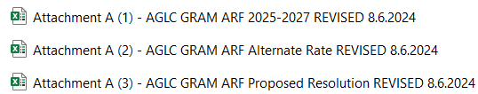

When reviewing the Proposed Resolution 2025 – 2027 GRAM model compared to the Traditional Rate GRAM model, refer to Exhibit-STF-49-1 and Table-1 below. Please answer the following:

- As provided in Table-1 below, the Proposed Resolution GRAM Revenue Requirement Calculation (“RRC”) had a total for 2025-2027 that was $38.7 million larger than the Traditional GRAM model before any adjustments (no RTU) on Row-23/Line-7. Is the main reason for the larger RRC dollar amount related to the Proposed Resolution GRAM model because AGL included a $30.4 million Levelized Rate Adjustment in the Schedule-11b as a part of the Proposed Resolution GRAM model on Row-31/Line-11 for deferral for 2025 with recovery in 2027?

- As provided in Table-1 below, the Proposed Resolution “Residential levelized Combined Customer Charge and DDDC Rates” (“R-1 Combined Rates”) total increase is $7.65 compared to the Traditional GRAM R-1 Combined Rates; total increase of $7.09. the Proposed Resolution RRC and R-1 Combined Rates increase is larger than the Traditional GRAM model. Does AGL attribute this increase to the inclusion of a $30.4 million Levelized Rate Adjustment in the Schedule-11b as part of the Proposed Resolution GRAM model on Row-31/Line-11 for deferral for 2025 with recovery in 2027?

- Regarding the $30.4 million deferral, please answer the following:

- Why has AGL included a $30.4 million deferral for 2025 when the original deferral was only $29 million as provided in the Alternative Rate model?

- Why has AGL included the recovery of the $30.4 million in 2027?

- What is the carrying costs of the $30.4 million deferral?

- In discussions with AGL, the original issue was that the $29 million deferral was deferred in 2025 but not applied for recovery in a later year. As part of the 2025 GRAM petition on page 6, AGL stated that it was proposing a levelized rate of $2.99 for 2025-2027 in the Proposed Resolution GRAM model. How does the Proposed Resolution model achieve this result when it has a $30.4 million deferral for 2025 with full recovery in 2027?

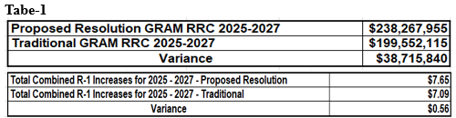

STF-49-2 When reviewing the Proposed Resolution 2025 – 2027 GRAM model compared to the Alternative Rate GRAM model, refer to Exhibit-STF-49-1 and Table-2 below. Please answer the following:

- As provided in Table-2 below, the Proposed Resolution GRAM Revenue Requirement Calculation (“RRC”) had a total 2025-2027 that was $3 million larger than the Alternative Rate GRAM model before any adjustments (no RTU) on Row-23/Line-7. Does AGL attribute the larger RRC and R-1 Combined Rates increase in the Proposed Resolution to it having a $30.4 million Levelized Rate Adjustment in the Schedule-11b as part of the Proposed Resolution GRAM model on Row-31/Line-11 for deferral for 2025 and a recovery in 2027 where the Alternative Rate GRAM model had a lower $29 million deferral?

- As provided in Table-2 below, the Proposed Resolution R-1 Combined Rates increase is $7.65 compared to the Alternative Rate GRAM model R-1 Combine Rates increase of $8.43. The Alternative Rate GRAM model has a Levelized Rate Adjustment on Line-31/Row-11 of $29 million deferral for 2025 with recovery in 2027. Does AGL attribute the larger RRC and R-1 Combined Rates increase in the Proposed Resolution GRAM model to it having a $30.4 million Levelized Rate Adjustment in the Schedule-11b as part of the Proposed Resolution GRAM model on Row-31/Line-11 for deferral for 2025 and a recovery in 2027 where the Alternative Rate GRAM model had a lower $29 million deferral in 2025 with recovery in 2027?

- What are the carrying costs of the 29 million?
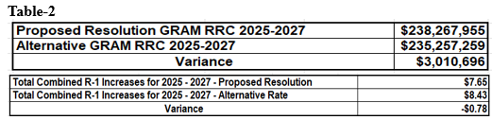

STF-49-3 When reviewing Exhibit-STF-49-1, the Alternative Rate GRAM model shows the $29 million Levelized Rate Adjustment in Row-31. The $29 million appears as a reduction to the 2025 RRC, and then it is added back for recovery in 2027.

Likewise, in AGL’s 2025 GRAM petition page 5, it stated the Alternative Rate GRAM model R-1 Combined Rates increase would be a levelized $3.74 for 2025, $3.75 for 2026, and 2027. When reviewing the data in Schedule-11a, Staff’s analysis shows that the increase to the R-1 Combined Rates in AGL’s Alternative GRAM model were different with 2025 at $1.22, 2026 at $3.95, and 2027 at $3.26.

Please answer the following:

- Regarding the R-1 Combined Rates levelized rate increases discussed on page five of the 2025 GRAM petition for the Alternative Rate model, discussed above, do they only include GRAM base rate increases with no Peaking?

- Please provide a breakout of the components in the levelized dollar rate increases involved in the R-1 Combined Rate in the Alternative Rate GRAM for each year from 2025 to 2027.

- Why are the levelized R-1 Combined Rates discussed on page 5 of the petition different from the actual R-1 Combined Rates in Schedule-11b of the Alternate Rate GRAM?

STF-49-4 When reviewing the Proposed Resolution GRAM model, AGL has a $30.4 million Levelized Rate Adjustment in Row-31 as a reduction in 2025, and then it is added back and recovered in 2027. AGL proposed a levelized rate of $2.99 for 2025-2027 on page 6 of the 2025 GRAM petition. The actual R-1 Combined Rate increases were $2.51 for 2025, $2.37 for 2026, and $2.77 for 2027. Please answer the following:

- When reviewing the Levelized Rate Adjustment, deferral, why did AGL provide $30.4 million for a 2025 deferral and then add the error back for recovery in 2027?

- Regarding the actual R-1 Combined Rate increases discussed above, do they include GRAM base rate increases only, no Peaking?

- Please provide a breakout of the components in the levelized dollar rate increases involved in the R-1 Combined Rate in the Proposed Resolution GRAM for each year 2025-2027.

- Why are the levelized R-1 Combined Rates discussed on page 5 of the petition different from the actual R-1 Combined Rates in Schedule-11b of the Proposed Resolution GRAM?

STF-49-5 On page 6 of the 2025 GRAM petition, AGL stated that it would recover $23 million less revenue under the Proposed Resolution GRAM model than the Traditional GRAM. Please answer the following:

- In Table-3 below, does AGL agree that when the revenue requirement dollar amounts are added for 2025-2027 on Schedule-11a of these GRAM models, the Proposed Resolution GRAM model will generate $38.7 million more revenue requirement, as additional revenue, than the Traditional GRAM model for 2025-2027?

Table-3
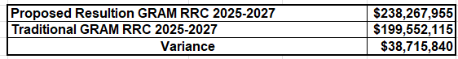

- Please explain how the Proposed Resolution GRAM will cause $23 million less in revenues.

STF-49-6 Regarding Schedule-9, as seen in Table-4 below, the Traditional, Alternative Rate, and Proposed Resolution models have the same presentation. For the Forward-Looking-Test-Year (“FTY”), AGL included a State Income Taxe Rate of 5.39%.

Table-5 below, provides a link to the www.house.ga.gov website that provides the schedules of State of Georgia tax rates from 2018 to 2030. The approved corporate tax rates for 2025-2027 are the following:

2025: 5.29%
2026: 5.19%
2027: 5.09%

Does AGL agree to revise Schedule-9 to show a State of Georgia Effective Tax Rate and resulting Tax Expansion Factor for each of the GRAM years 2025-2027 with revenue requirement impacts?
Tabe-4
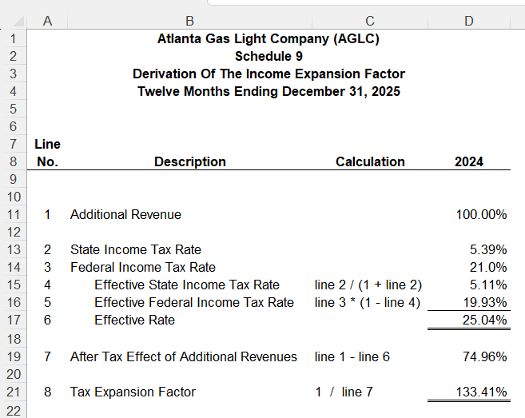

Table-5
PowerPoint Presentation (ga.gov)
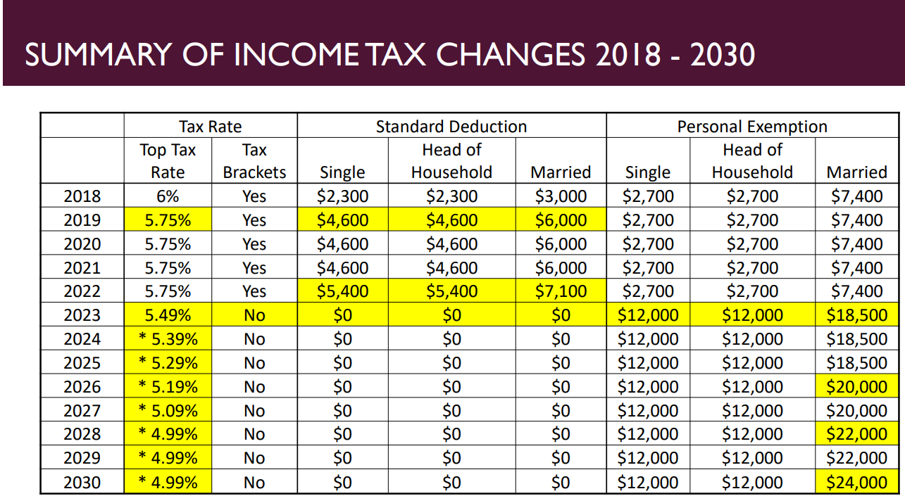

STF-49-7 On page 6 of the 2025 GRAM petition ,AGL states that $23.2 million less revenue requirement will be achieved in the Proposed Resolution GRAM model, and it has been removed since AGL was not going to seek recovery. This means AGL would recover $5.8 million However, it appears that AGL has not absorbed the $23.2 million, but is the deferring an entire $30.4 million. Please make adjustments to the Proposed Resolution model clearly showing the actual dollar amount being deferred to achieve the levelized $2.99 increase to rates for 2025-2027.

