BEFORE THE GEORGIA PUBLIC SERVICE COMMISSION

In Re:  ATLANTA GAS LIGHT COMPANY’S INTEGRATED CAPACITY AND DELIVERY PLAN (i-CDP) | )  )  )  ) | DOCKET 43820

STAFF’S REVISED TWENTIETH SET OF DATA REQUESTS TO
ATLANTA GAS LIGHT COMPANY
i-CDP

TO: BLAKE O’FARROW
DIRECTOR – REGULATORY AFFAIRS
ATLANTA GAS LIGHT COMPANY
TEN PEACHTREE PLACE
ATLANTA, GA 30309

COMES NOW the Georgia Public Service Commission Staff (“Staff”) and, pursuant to the authority vested in it by the Georgia Public Service Commission (“Commission”) pursuant to O.C.G.A. § 46-2-57, herein propounds the following interrogatories and requests for production of documents (collectively, “data requests”), to be answered under oath by Atlanta Gas Light Company, (“AGLC” or “Company”) or its designated representatives. The Company shall file with the Executive Secretary’s Office using the Alternative E-filing instructions. Public and Trade Secret responses shall be Accompanied therewith shall be an electronic version in Microsoft Word® format for text documents and Excel® for spreadsheets.
Please provide responses on or before 4:00 p. m. on May 6, 2024.

INSTRUCTIONS
- These requests shall be deemed to be continuing. The Respondent is obliged to change, supplement, and correct all answers to requests to conform to available information; including such information as first comes available to the Respondent after the answers are hereto filed.

- The answers provided should first restate the question asked and also identify the person(s) supplying the information.

- All information is to be divulged that is within the knowledge, possession, control, or custody of the Respondent or may be reasonably ascertained thereby.

- As used herein the “document” included, but is not limited to, the original and all copies (regardless of origin and whether or not including additional writing thereon or attached thereto) of memoranda, reports, books, manuals, instructions, directives, records, forms, notes, letters, notices, confirmations, telephone calls, meetings or other communications, bulletins, transcripts, diaries, analyses, summaries, correspondence and enclosures, circulars, opinions, studies, investigations, questionnaires and surveys, work sheets, and all drafts, preliminary versions, alterations, modifications, revisions, changes, amendments and written comments concerning the foregoing, in whatever form, stored or contained in or on whatever medium including computerized memory or magnetic media.

Information Request

Docket No. 43820

i-CDP

STF-20-1 Regarding Table-1A below, in Figure 5.10.1, AGL provided estimated revenue requirements for 2025 – 2027. The total three (3) year revenue requirement was $247 million.

Table-1A: Figure 5.10.1: GRAM Impact with Traditional Rate Increase Implementation
Estimated Residential Bill Impacts | 2025 | 2026 | 2027
Annual Revenue Deficiency ($ millions) | $ 154 | $ 38 | $ 55
Annual Impact | $ 74.08 | $ 15.45 | $ 23.33
Monthly Impact | $ 6.17 | $ 1.29 | $ 1.94
 |  |  |  | 3yr Average
Non-Gas Impact | 16.5% | 3.0% | 4.3% | 7.9%
Total Bill Impact-Includes Est Gas Costs | 7.7% | 1.5% | 2.2% | 3.8%

As seen in Table-1B below, it contains AGL’s response to STF-12-9b.1, which included different revenue requirement dollar amounts for 2025 – 2027. The total three (3) year revenue requirement was $206.8 million.

Table-1B: Attachment-STF-12-9b.1
 | Approved | Proposed
Year | 2024 | 2025 | 2026 | 2027
GRAM Capital Budgets | $596,909,696 | $555,998,267 | $607,730,570 | $601,764,584
AGL Revenue Requirements |  | $116,907,042 | $33,649,092 | $56,199,189
 |  |  | ($83,257,950) | $22,550,097
AGL Customer Charge Monthly | $25.24 | $28.54 | $29.48 | $31.05
DDDC Charge Monthly | $9.12 | $10.31 | $10.65 | $11.22

When comparing the dollar amounts in Figure 5.10.1 and Attachment-STF-12-9b.1, these dollar amounts aren’t the same. Please answer the following:
- In Figure 5.10.1, when reviewing the revenue requirement dollar amounts for 2025 – 2027, there is a decrease in 2026 from 2025 in the amount of $116 million. When reviewing the revenue requirement in 2027, there is an increase in 2027 from 2026 in the amount of $17 million.

- In Attachment-STF-12-9b.1, when reviewing the revenue requirement dollar amounts for 2025 – 2027, there is a decrease in 2026 from 2025 in the amount of $83.2 million. When reviewing the revenue requirement in 2027, there is an increase in 2027 from 2026 in the amount of $22.5 million.

There has been increasing capital spending through 2024 with a proposed larger capital budget for 2025. With the increasing growth in CWIP and Plant Additions, how did AGL calculate a drop in revenue requirements in 2026 from 2025 in both Figure 5.10.1 and Attachment-STF-12-9b.1 with only a slight increase in revenue requirements in 2027 that never get above the projected 2025 levels.

- Does AGL agree that with increase capital spending through 2025 and increasing O&M costs through 2025, the 2026 and 2027 continued capital spending and increasing O&M will cause revenue requirements for 2026-2027 to be larger than that projected for 2025, without any reductions related to the RTU, current 10% i-CDP reduction, or a Billing Commitment reduction?

STF-20-2 Regarding the dollar amounts in Table-1A, Figure 5.10.1 and Table-1B, Attachment-STF-12-9b.1 for 2025-2027, how did AGL arrive at very different dollar amounts between the two revenue requirement presentations?
STF-20-3 Regarding the revenue requirement numbers in Table-1A, Figure 5.10.1 and Table-1B, Attachment-STF-12-9b for 2025 – 2027, did AGL leave out any ratemaking rate base components when calculating these dollar amounts that may have contributed to lower revenue requirement dollar amounts, such as Service Company plant, cash working capital, CWIP, or other rate base components?
STF-20-4 Regarding the revenue requirement numbers in Table-1A, Figure 5.10.1 and Table-1B, Attachment-STF-12-9b for 2025 – 2027, did AGL leave out any ratemaking Operating Expense components when calculating these dollar amounts that may have contributed to lower revenue requirements dollar amounts for 2025 - 2027, such as O&M, depreciation expense, taxes other than income, or other operating expense items?
STF-20-5 Regarding Table-2A below, the Staff has provided the basic budget for GRAM, ECON-1, Cherokee LNG expansion, and SRR related to AFUDC, and Overheads for 2025 – 2027. In Table-2B, the Staff has provided a variance analysis between AFUDC and Overheads for each category.
What the analysis demonstrates is for GRAM, ECON-1, and Cherokee LNG Expansion, the AFUDC is a much lower dollar amount than Overheads. When reviewing the SRR, the AFUDC is much larger than the Overheads. Please answer the following:
- In a separate Excel spreadsheet, please provide how AGL calculated the AFUDC and Overheads for GRAM.

- In a separate Excel spreadsheet, please provide how AGL calculated the AFUDC and Overheads for ECON-1.

- In a separate Excel spreadsheet, please provide how AGL calculated the AFUDC and Overheads for Cherokee.

- In a separate Excel spreadsheet, please provide how AGL calculated the AFUDC and Overheads for the SRR.

- As part of the calculation process, please explain how AFUDC is much lower than that of GRAM, ECON-1, and Cherokee when it is all the same type of capital spending.

- As capital spending on construction projects increases, CWIP increases, and as a result, AFUDC increases. Why do AFUDC calculations show much lower dollar amounts than Overheads.

- Please explain what is driving Overheads to increase beyond that of AFUDC.

Table-2A: AGL’s Proposed Capital Budgets 2025 - 2027
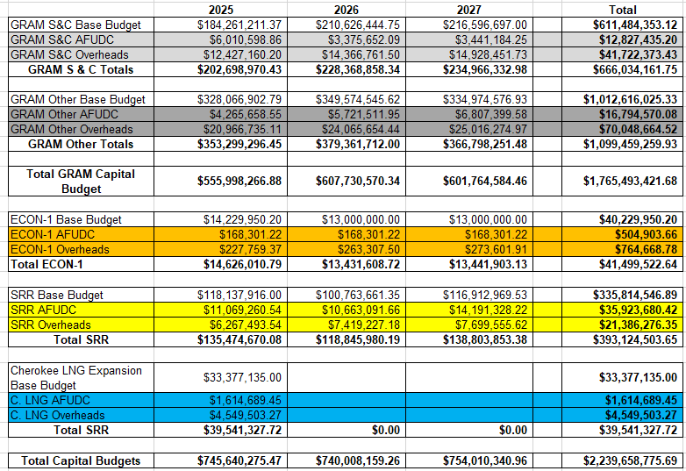

Table-2B: AFUDC & Overheads
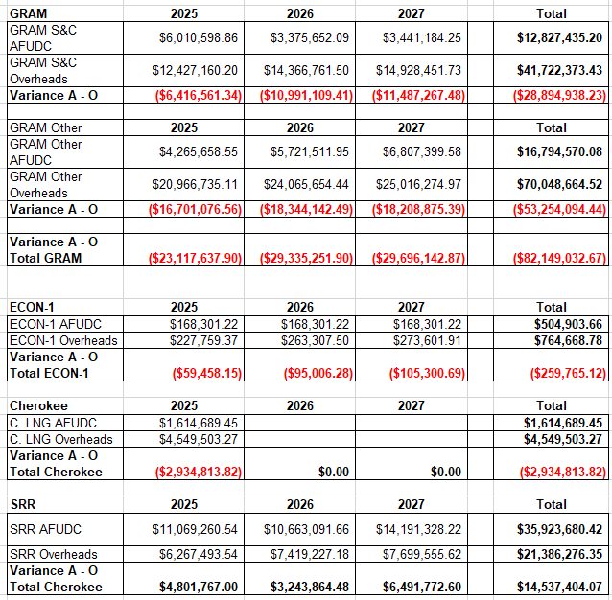

STF-20-6 Regarding Table-3 below, the Staff has provided revenue requirement dollar amounts related to Attachment-STF-12-9b.1 and b.2. Please answer the following.
- When reviewing these dollar amounts, why is the 2025 levelized revenue requirement lower than that of 2026 and 2027? Levelized would indicate all the dollar amounts should be the same.

- The total for 2025 – 2027 for the Base b.1dollar amounts was $206,815,323, but the levelized total was $216,442,461. Why was the levelized total three-year revenue requirement $9,627,138 larger than the Base b.1 dollar amount?

- Regarding Figure 5.10.2 that also provided a levelized revenue requirements. Why did it show a consistent $86 million a year, when the Base b.1 presentation did not?

- In the Figure 5.10.2 presentation, its three-year total was also larger than the Figure 5.10.1 total three-year revenue requirements. Was the reason for this similar to the issue provided STF-20-6(b)?

Table-3: GRAM Revenue Requirement Comparison
 | 2025 | 2026 | 2027 | Totals
GRAM Capital Budget | $555,998,267 | $607,730,570 | $601,764,584 | $1,765,493,421
Revenue Requirements (Base b.1) | $116,967,042 | $33,649,092 | $56,199,189 | $206,815,323
Revenue Requirements (Levelized b.2) | $57,112,335 | $79,665,063 | $79,665,063 | $216,442,461

