**Georgia Power Company’s**

**Bi-Annual Hydro Modernization Update**

**For the Period Ending June 30, 2023**

This Hydro Modernization Update (“Update”) is provided in accordance with the Order Adopting Stipulation as Amended (the “Order”) issued by the Georgia Public Service Commission (the “Commission”) in the matter of Georgia Power Company’s 2019 Integrated Resource Plan (“IRP”) under Docket No. 42310. As such, it provides information to allow the Commission to monitor Georgia Power Company’s (“Georgia Power” or the “Company”) modernization efforts at Plant Terrora, Plant Tugalo, Plant Bartletts Ferry, Plant Nacoochee, and Plant Oliver.

This report also includes updates on the modernization projects at Plants Burton and Sinclair,   
in accordance with the Order for Georgia Power’s 2022 IRP under Docket No. 44160.

**Summary of Work Performed by Site**

**Plant Terrora**

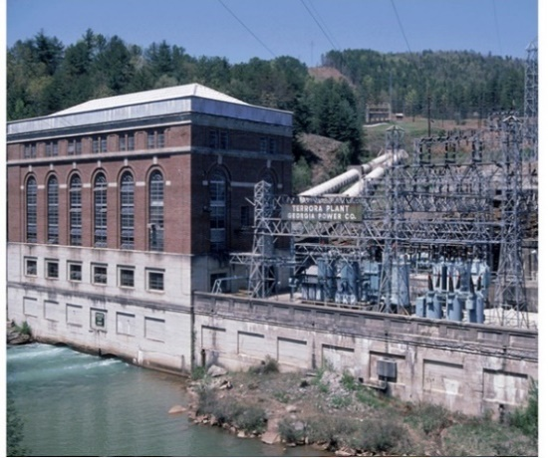Plant Terrora Units 1-2 are part of the North Georgia hydro group. These units began commercial operation in 1925.

**Summary of Scope of Work:** The scope of work for Plant Terrora Units 1-2 included generator rewinds, turbine replacements, and the replacement of the Balance of Plant (BOP) systems, such as lubricating oil, service water systems, 480V switchgear, and the plant control system.

**Project Status:** Modernization work at Plant Terrora is complete. Unit 1 was returned to normal operation on November 19, 2021. Unit 2 was returned to normal operation on December 30, 2020.

**Plant Tugalo**

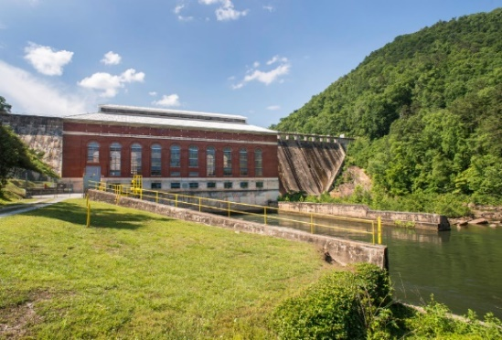Plant Tugalo Units 1-4 are part of the North Georgia hydro group. Plant Tugalo Units 1-2 began commercial operation in 1923. Plant Tugalo Units 3-4 began commercial operation in 1924.

**Summary of Scope of Work:** The scope of work for Plant Tugalo Units 1-4 includes generator replacements, turbine replacements, and replacement of the BOP systems, such as lubricating oil, service water systems, 480V switchgear, and the plant control system.

**Project Status:** Unit 1 turbine and generator are on site and being installed. Unit 1 BOP construction is underway with an estimated completion of October 2023. Unit 2 and Unit 3 demolition has begun. Unit 2 turbine and generator fabrication is complete. Units 3 and 4 turbines and generators are currently being fabricated. The first set of 3 spillway gates has been removed. The new spillway gates are on site and are staged for installation.

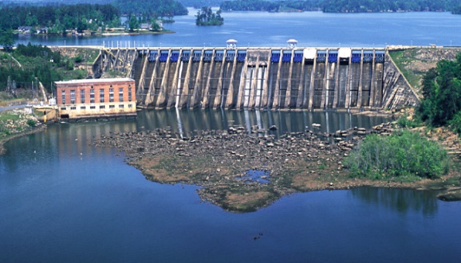**Plant Bartletts Ferry 1-4**

Plant Bartletts Ferry Units 1-4 are part of the Chattahoochee hydro group. These units began commercial operation at varying times as shown below:

* Bartletts Ferry Units 1-2 in 1926
* Bartletts Ferry Unit 3 in 1928
* Bartletts Ferry Unit 4 in 1951

**Summary of Scope of Work:** The scope of work is limited to Plant Bartletts Ferry Units 1-4. The work on these units includes generator rewinds, turbine replacements, and replacement of the BOP systems, such as lubricating oil, service water systems, 480V switchgear, and the plant control system. Plant Bartletts Ferry Units 5-6 are not included in the scope of work at this time.

**Project Status:** Scope development is complete, and detailed design work was completed in the first quarter of 2023.  The new turbines are being fabricated.  The generator rewind procurement package has been awarded. Some powerhouse activities, such as the crane modernization, have been completed. Unit 1 generator and turbine have been disassembled. Georgia Power is currently awaiting FERC approval to proceed with installation of the new equipment, as applicable.

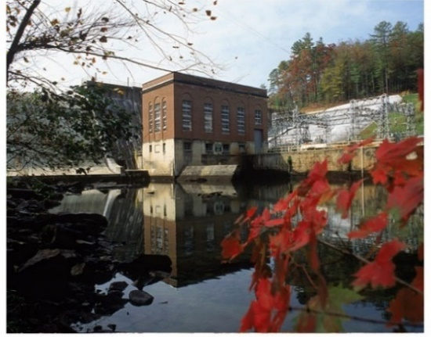**Plant Nacoochee**

Plant Nacoochee Units 1-2 are part of the North Georgia hydro group. These units began commercial operation in 1926.

**Summary of Scope of Work:** The scope of work expected for Plant Nacoochee Units 1-2 includes generator rewinds, turbine replacement on Unit 2, and replacement of the BOP systems, such as lubricating oil, service water systems, 480V switchgear, and the plant control system.

**Project Status:** The logistical planning is complete for the project. The turbine package has been awarded, and the generator procurement package is in development. Remaining engineering and procurement activities are underway. Site preparation will begin in third quarter 2023 to support construction work on the units expected to begin in 2024.

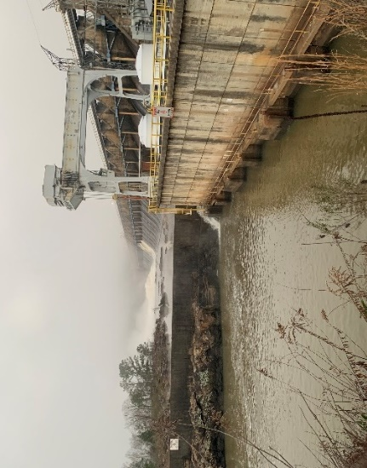**Plant Oliver**

Plant Oliver Units 1-4 are part of the Chattahoochee hydro group. These units began commercial operation in 1959.

**Summary of Scope of Work:** The scope of work expected for Plant Oliver Units 1-4 includes turbine replacements and replacement of the BOP systems, such as lubricating oil, service water systems, 480V switchgear, and the plant control system. Additionally, generator rewinds will be performed on Units 3 and 4. Generator rewinds were previously completed for Units 1 and 2 during their maintenance cycles in 2015 and 2016, respectively.

**Project Status:** A scoping kickoff meeting has been completed and detailed design work has commenced.  The procurement of new turbines for Units 1-3 has been issued; the Unit 4 package is in development.  The generator procurement package for Unit 3 is in development; the Unit 4 package will be developed upon the award of the Unit 4 turbine package.

**Plant Burton**

Plant Burton Units 1-2 are part of the North Georgia hydro group. These units began commercial operation in 1927.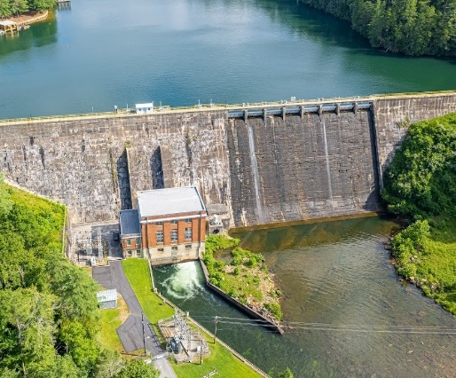

**Summary of Scope of Work:** The scope of work expected for Plant Burton Units 1-2 includes generator rewinds/replacement, turbine replacements, and replacement of the BOP systems, such as lubricating oil, service water systems, 480V switchgear, the plant control system, and spillway gates.

**Project Status:** A scoping kickoff meeting will be scheduled during 2023. Initial work on the turbine and generator specifications has commenced.

**Plant Sinclair**

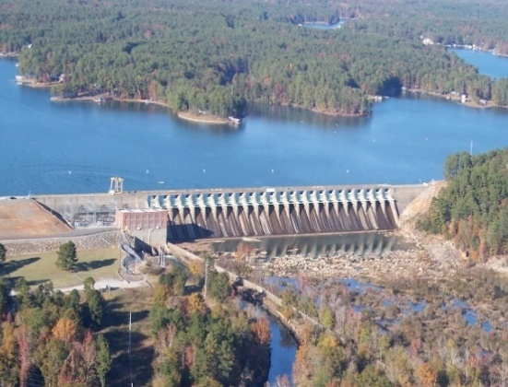Plant Sinclair Units 1-2 are part of the Central Georgia hydro group. These units began commercial operation in 1953.

**Summary of Scope of Work:** The scope of work expected for Plant Sinclair Units 1-2 includes generator rewinds/replacement, turbine replacements, and replacement of the BOP systems, such as lubricating oil, service water systems, 480V switchgear, and the plant   
 control system.

**Project Status:** A scoping kickoff meeting will be scheduled during 2023. Initial work on the turbine and generator specifications has commenced.