March 21, 2023

Via Electronic Filing

Sallie Tanner
Executive Secretary
Georgia Public Service Commission
244 Washington Street, SW
Atlanta GA, 30334-5701

Re: Change of Address for Southern Light LLC (L-0454)

Dear Ms. Tanner:

Please accept this letter as a request to change the Commission’s address of record for Southern Light LLC (a subsidiary of Uniti Group Inc.).

The address for Southern Light LLC should be:

107 St. Francis Street
Suite 1800
Mobile, AL 36602

Thank you for your attention to this matter.

Sincerely,
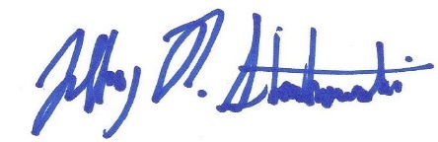

Jeffrey R. Strenkowski
VP, Deputy General Counsel of Governmental Affairs
Uniti Group Inc. and Southern Light LLC
(T) 501-458-4397
jeffrey.strenkowski@uniti.com

