STATE OF GEORGIA

BEFORE THE

GEORGIA PUBLIC SERVICE COMMISSION

**In Re: Georgia Power Company’s**

**Docket No. 44280 2022 RATE CASE**

**____________________________________________________________________________**

**APPLICATION OF Anita Garnes**

# FOR LEAVE TO INTERVENE

Anita Garnes_ hereby applies to the Georgia Public Service Commission (“Commission”) for leave to intervene in the above-referenced dockets pursuant to O.C.G.A. §§ 46-2-59 and 50-13-14 and Commission Rule 515-2-1-.06. In support of this application, ______________ respectfully shows the Commission as follows:

1.

On June 24, 2022, Georgia Power Company (“Georgia Power” or “the Company”) filed its 2022 Rate Case, for which it seeks Commission approval. The Commission already has an established procedural and scheduling order in this docket, which was filed on April 7, 2022.

This application is thus timely filed.

2.

Anita Garnes is a resident of Fulton County and lives on a fixed income. Anita Garnes lives on a single income and ant increase would be a burden. Because Anita Garnes lives on a fixed income, she will be impacted by the base rate increase Georgia Power is proposing and as a result has substantial interest in this case. Anita desires to intervene to protect her interests.

3.

Anita Garnes

_______________ rights and interests cannot be adequately represented by any other party to the above-styled dockets and its participation in this matter will not unduly delay these proceedings or prejudice of any other party.

4.

Anita Garnes

________________ respectfully requests that the following persons receive all notices, correspondence and copies of orders and other materials in this docket, and be placed upon the official service list:

Anita Garnes

________________

Deborah Opie

Brionte McCorkle

Georgia Conservation Voters Education Fund

725 Ponce De Leon Ave FL 2

Atlanta, GA 30306

## P: (404) 955-7013

_anitagarnes17@gmail.com

deborah@gcvoters.org brionte@gcvoters.org

5.

Anita Garnes

If this application is granted, _________________ intends to participate fully as parties in these dockets, including cross-examining witnesses, filing and presenting direct testimony, and filing proposed orders and/or briefs.

6.

Anita Garnes

**WHEREFORE,** ______________ respectfully requests that the Commission grant this application for leave to intervene and admit them as full parties of record in these proceedings with all rights attendant thereto.

7/14/2022

Respectfully submitted ___________

**_____________________**



Anita Garnes

**___________________** anitagarnes17@gmail.com

**______**Atlanta 30310

770-710-2987

**____________________**

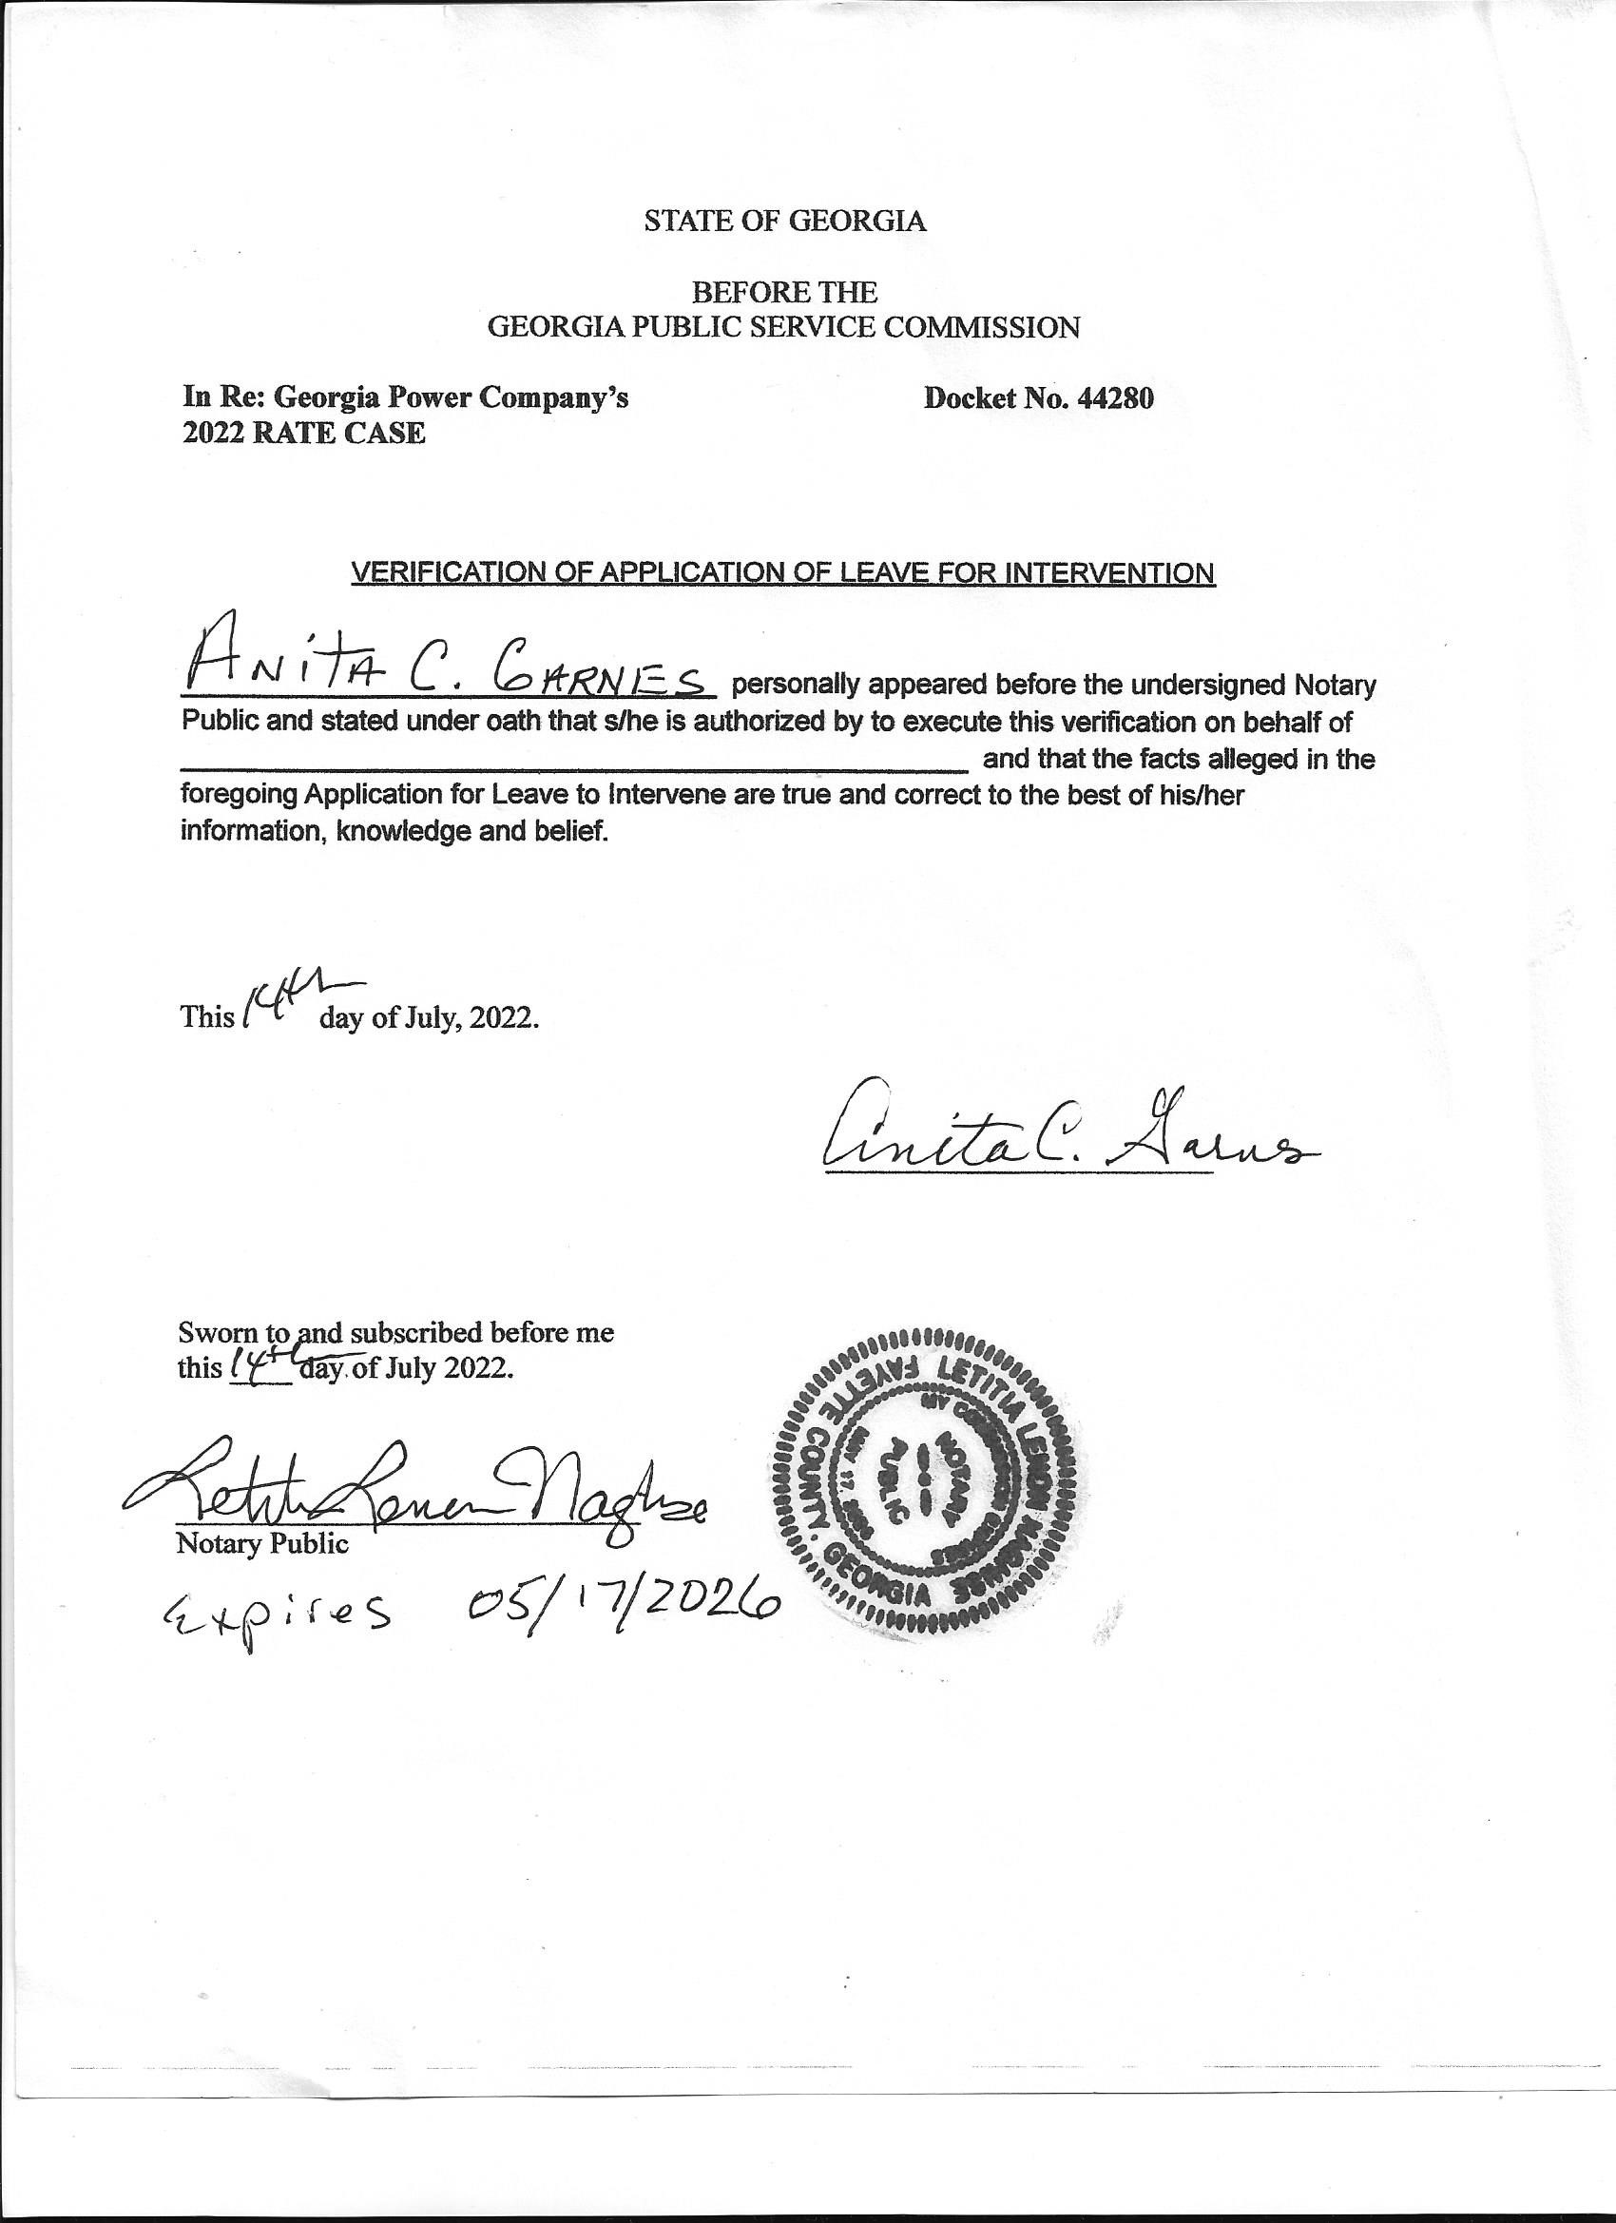

DocuSign Envelope ID: 46BADB73-A95E-4912-BDE1-CA0DA3965197

STATE OF GEORGIA

BEFORE THE

GEORGIA PUBLIC SERVICE COMMISSION

**In Re: Georgia Power Company’s Docket No. 44280 2022 RATE CASE**

## **CERTIFICATE OF SERVICE**

I certify that the foregoing application in Docket No. 44280 was filed with the Public Service Commission by electronic delivery on the 7/20/2022. An electronic copy of same7/20/2022 was served upon all parties listed below by electronic mail as follows:

____________________________

Anita Garnes

Sallie Tanner

Executive Secretary

Georgia Public Service Commission

244 Washington Street, SW Atlanta, Georgia 30334 stanner@psc.ga.gov

Mr. Charles B. Jones, III

Mr. Lloyd Avram

Mr. Roy Bowen

Georgia Association of Manufacturers

The Hurt Building 50 Hurt Plaza, Suite 985

Atlanta, Georgia 30303 cjones@gamfg.org lavram@gamfg.org rbowen@gamfg.org

Mr. Jeffry C. Pollock

J. Pollock Incorporated

12647 Olive Boulevard, Suite 585 St. Louis, Missouri 63141 jcp@ipollockinc.com

|  |  |
| --- | --- |
| Deborah Opie | Jim Clarkson |
| Brionte McCorkle | Resource Supply Management |
| GCV Education Fund | 135 Emerald Lake Rd |
| 725 Ponce De Leon Ave FL 2 | Columbia, SC 29209 |
| Atlanta, GA 30306 | 803-312-3500 |
| P: (404) 955-7013deborah@gcvoters.org brionte@gcvoters.org | jclarkson@rsmenergy.com |
| Brandon Marzo | Liz Coyle |
| Troutman Pepper | Georgia Watch |
| Bank of America Plaza, Suite 5200 | 55 Marietta Street, Suite 903 |
| 600 Peachtree Street, N.E. | Atlanta, GA 30303 |
| Atlanta, GA 30308-2216 | 404-525-1085 ext. 402 |
| TEL: 404-885-3146 | lcoyle@georgiawatch.org |

brandon.marzo@troutman.com

Kurt J. Boehm, Esq.

Jody Kyler Cohn, Esq.

Boehm, Kurtz & Lowry

36 East Seventh Street, Suite 1510

Cincinnati, OH 45202

TEL: 513-421-2255 FAX: 513-421-2764 kboehm@bkllawfirm.com jkylercohn@bkllawfirm.com

Kevin Higgins

Justin Bieber

Energy Strategies, LLC

215 South State Street, Suite 200

Salt Lake City, UT 84111

TEL: 801-355-4365 FAX: 801-5219142

khiggins@energystra.com jbieber@energystrat.com Emily W. Medlyn

General Attorney

U.S. Army Legal Services Agency

ELD Division

9275 Gunston Road

Fort Belvoir, VA 22060-4446

TEL: 703-614-3918

FAX: 703-806-0123

emily.w.medlyn.civ@army.mil

|  |  |
| --- | --- |
| Cynthia Tucker | Fenika Miller |
| cynthiatucker34@yahoo.com | fenikamiller@gmail.com |
| Cynthia Pryor | Harriet Feggins |
| skeetscynthia@yahoo.com | olivialoveu78@gmail.com |
| H. Benjamin Williams | James Riles |
| docben@att.net | jrismoney@aol.com |
| Christopher Stathums | Linda Clark Gray |
| christathums@gmail.com | linda.clark64131990@outlook.com |
| Chaqueta Riles | McKelson Fraser |
| criles111@aol.com | mckelsonfraser@yahoo.com |
| Carol Dollison | Sandra Willis |
| directordoll@yahoo.com | mssanwil@gmail.com |
| Brandon Winns | Shelia Edwards |
| Coronerbrandonmichael@gmail.com | shelia@trappcomm.com |
| Anita Garnes | Terry Cummings |
| anitagarnes17@gmail.com | cummingsterry3@gmail.com |
| Dorothy Burnam | Tia Brightwell |
| dorothyburnam@icloud.com | brightwelltia35@gmail.com |
| Eddie White | Trudy Willis Jones |
| Edman1226@gmail.com | dr.twj1@gmail.com |
| Eugene Vickerson | Lode Coleman |
| eugenecvickerson@gmail.com | hellodirectors@FTCCharity.org |