BEFORE THE GEORGIA PUBLIC SERVICE COMMISSION
STATE OF GEORGIA

In Re: Generic Proceeding to Implement House Bill 244 | :  : | Docket No. 43453

REBUTTAL TESTIMONY
OF
JEFF CHANDLER

ON BEHALF OF GEMC
AND ITS 38 EMC MEMBERS

NOVEMBER 9, 2020

BEFORE THE
GEORGIA PUBLIC SERVICE COMMISSION

PRE-FILED REBUTTAL TESTIMONY OF
JEFF CHANDLER
ON BEHALF OF
GEORGIA ELECTRIC MEMBERSHIP CORPORATION

DOCKET NO. 43453

Please state your name, title and business address.
My name is Jeff Chandler. I am the Managing Director of Chandler Consulting LLC. My business address is 802 Duncan Place S.E., Leesburg, Virginia 20175.
Have you previously submitted testimony and exhibits in this proceeding?
Yes. I submitted pre-filed direct testimony and exhibits in this matter on October 23, 2020 on behalf of Georgia Electric Membership Corporation (“GEMC”) and its 38 not-for-profit cooperative members (“Georgia EMCs”) that are subject to the Georgia Broadband Opportunity Act.
What is the purpose of your rebuttal testimony?
I would like to respond to some of the assertions made by a few of the witnesses who testified on behalf of the Georgia Cable Association (“GCA”) and the Georgia Telecommunications Association (“GTA”) concerning pole attachment rates and the impact those rates have on business decisions to deploy broadband networks in rural Georgia. Specifically, I want to share my opinion that the academic/hypothetical analyses set forth in the direct testimony of Dr. Michelle Connolly, Mr. Jim Davies (Charter/Spectrum), Mr. Douglas Frank (Mediacom), Mr. Jason Gumbs (Comcast), and Mr. James Yates (Comcast) grossly exaggerate the impact pole attachment rates have in planning broadband deployment projects in a manner that simply does not match the real world.
What do you mean by “academic/hypothetical” analyses?
Dr. Connolly testified that “[r]educed state-wide pole attachment rates will enhance rural deployment of broadband services and the EMCs pole attachment rates and practices should be regulated.” She supports this notion by explaining that: “all else equal, higher pole attachment costs in one area relative to another will push a BSP [broadband service provider] to first deploy in the area with a lower present value of all future pole attachment costs.” She continues by asserting that “[a]t the margin, this will push BSPs to either avoid areas served by EMCs, or will push BSPs to deploy in states with well enforced cost-based rate regulation (such as using FCC cable rate formula).”
Do you agree with Dr. Connolly’s analysis?
A: No. I am not an economist, but unlike Dr. Connolly who has “researched broadband investments,” I have actually participated in planning, decision-making and implementation of broadband investments. In my experience, there is no “all things equal” environment in the broadband business world—every county, town, topography, income situation (among other things) is different. In addition, the relative scale of significant capital costs in relationship to pole attachment fess is lost in Dr. Connolly’s number-less hypothetical. Projects costs projected to be in excess of $30,000 per mile (and even much higher) are not impacted, much less derailed, by $20 or even $38 per pole rental fees (or $360-$684 per mile). Instead, pole attachment rates have a de minimis impact in the planning process for broadband deployment, if any impacts at all. So, while Dr. Connolly’s “all things equal” and “at the margins” analysis may be an academically accurate data-free classroom hypothesis - that is not how things play out in the real world.
As outlined in my direct testimony, I have looked at the pole attachment rate impact on deployment decisions from multiple angles and demonstrated that pole attachment rates at the levels being discussed in this proceeding simply do not move the meter on investment decisions. For companies that build broadband networks in rural America for a living (including in Georgia), the meter-moving issues are construction costs, density and customer take-rate.
Do you have a response to Dr. Connolly’s “two rural areas” comparison?
I did not find it pragmatically persuasive at all. Dr. Connolly asks the Commission to consider “two rural areas, both currently lacking broadband services.” She then paints the two areas as “identical (in population, average income, average population density, topography, costs of deployment, etc.” She then posits that in one of the make-believe counties, the Georgia EMC pole attachment rate would apply while the FCC rate would apply in the other. She, of course, concludes that the FCC rate is the tipping point that causes broadband to be deployed in the FCC-regulated county.
First, as I have already mentioned, no two counties are identical and no two costs projection models can be identical. So “all things are never equal rendering Dr. Connolly’s two county comparison unpersuasively academic. Even so, the lack of translation of her example to the real-world can be found right here in Georgia. As noted in the direct testimony of Allen Bell, and in mine, multiple providers have been enjoying the benefits of the extremely low FCC rates in large areas of Georgia (and the country for that matter) for decades. Yet, particularly in rural areas, we still have large swaths of under and unserved areas where broadband is virtually unavailable.
Stated alternatively, if the FCC rate was the magic “all things equal” formula needed to close the digital divide (as the communications companies in this case portray it to be), there should be no such divide in any area where the FCC rate applies. We all know that is simply not borne out across rural America (and in Georgia in particular) because pole attachment rates are not a barrier - or even a speed bump – to deployment of broadband.
Please explain what you mean by your earlier reference to having examined pole attachment rates from “multiple angles.”
I compared pole attachment fees to real-world capital costs associated with broadband deployment. I examined actual build-outs that have taken place, in Georgia and elsewhere to confirm that accuracy of my analysis. I provided an exemplar broadband network business plan (and it is worth noting that my costs inputs are very much in line with data found in the direct testimony of Mr. Gumbs (Comcast) and Mr. Frank (Mediacom)). I confirmed my conclusions with two other companies that are in the business of deploying broadband to unserved areas across the country (and in Georgia) (Pulse and Conexon). I also compared pole attachment rates to the present value of future operating costs (including pole attachment fees). I analyzed and introduced into evidence an actual broadband feasibility study performed by one of the Georgia EMCs (Canoochee EMC - whose COO confirmed that the concept of pole attachment fees being as a some kind of barrier to the potential project never came up – not once). I contrasted the lack of meaningful broadband expansion in rural areas of Georgia Power Company’s service territory—notwithstanding the fact that attaching entities have had the FCC rate and FCC policies there for many, many years. Finally, on the other end of the rate spectrum, I pointed out that the Tennessee Valley Authority has a pole attachment rate even higher than the $20 rate currently in place for the Georgia EMCs – a rate cable obviously thinks is too high. Yet, there is significant broadband activity in Tennessee, and much of it began after TVA adopted its rate. Regardless of the comparative data point, the reality is that pole attachment rates are not the issue, much less the exaggerated “significant” or “critical” issue the communications companies are making it out to be in this proceeding. Thinking back on my own professional experience, I don’t ever recall having ever given any thought to pole attachment rates as an element of planning a broadband network for rural deployment. There are simply much larger cost components that drive the “go or no-go” analysis.
How do you react to Dr. Connolly’s focus on the “present value of all expected costs (current and future)”?
As I just mentioned, I actually addressed the present value of all future costs in my direct testimony. I estimated 20 years of actual operational expenses. In my example, I used operational costs totaling $47,760 per mile. The Net Present Value (NPV) of the operational cost included the current Georgia EMC pole attachment fee of $20 per pole. I then added the 20 years of pole attachment fees and reduced them to a NPV of $2,538 per mile. With the operational NPV per mile of $47,760 and the capital cost per mile of $34,390, I directly compared the sum of these two numbers ($82,150) to the NPV of the pole attachment fees per mile of $2,538 in Graph 2 (set forth again below):

Graph 2
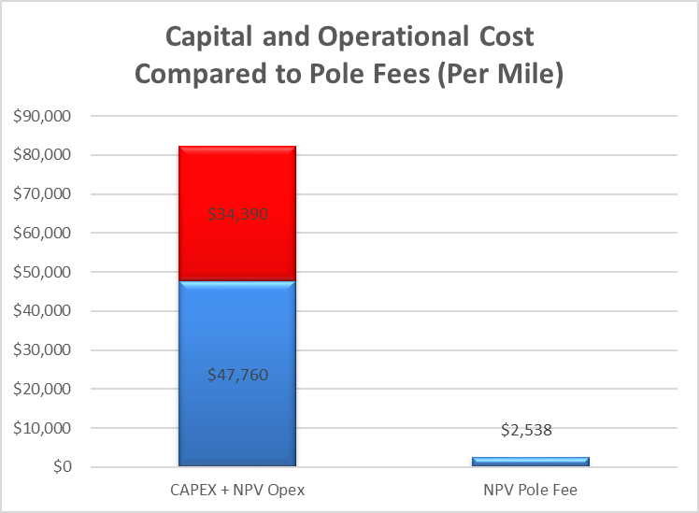
Using Graph 2, the relationship of pole attachment rates at the current Georgia EMC Rate ($20 per pole) to the capital and other costs necessary to deploy a network is in the range of about 3% of the total present value of costs. The right side of Graph 2 is not going to impact the decisions made about the left side—and in the overall scheme, the left side is the focus.
If the communications companies are successful in getting the FCC rate they want in Georgia, this may reduce that relationship from 3.2% to 1.2%. To borrow a term Dr. Connolly employs very differently, this “marginal” cost difference is not moving the meter for any reasonable business planner. If this 2% is truly a tipping point for Comcast, Spectrum and Mediacom, they could easily capture those same type of cost savings by implementing the more efficient Georgia One-Touch Make-Ready process proposed by the Georgia EMCs or even by employing a competent project manager to bring the project in under cost projections. In my view, the communications companies’ pole attachment rate proposal is a transparent profit play.
Did you see anything in the testimony provided by cable witnesses that supports your view that this is a profit play?
Absolutely. Mr. Davies (Spectrum) admitted that his company is looking for the “best return.” Mr. Gumbs (Comcast) went even further stating “Comcast is a Fortune 50, publically traded company with a fiduciary responsibility to deploy capital to maximize shareholder returns.” Mr. Gumbs added that “investment decisions are ultimately based on expected return on investment.”
As I said in my direct testimony, common sense and real-word data makes clear that pole attachment rates are not a barrier to broadband deployment. Instead, reducing pole attachment rates in Georgia will have a significant revenue impact benefitting cable companies where they already serve – with no meaningful impact on the business case to deploy where they do not. Reducing pole attachment rates would be a Day One win for the communications companies, with no assurance that unserved Georgians get anything in return on Day Two and beyond.
If expanding broadband in Georgia is such a high corporate priority for these big, for-profit companies, why don’t they simply adjust their return on investment targets instead of picking at the margins on the pole attachment rates charged by non-profit Georgia EMCs?
On the point of “assurances,” did you see anything in cable’s testimony that confirmed your concerns?
Yes. I was particularly struck by Mr. Davies’ testimony that “if the Georgia EMC rate were lowered, there would be millions of dollars that could be invested in extending and building new plant.” The “would” portion of this statement confirms the Day one win for communications companies that would accompany a decision to adopt the low FCC rate that I discussed above, the contrasting “could” portion confirms that there is no commitment that Georgians get anything in return. A simple “lower rates and we might come” is not a good gamble. It is certainly a “give” that has not paid off in areas in Georgia where the low FCC rate has been in place for decades, but there is still no broadband.
Did you find similar equivocation on the testimony submitted by other cable witnesses?
Unfortunately, yes. Mr. Gumbs (Comcast) expressly qualified his company’s “commitment” on the other side of this proceeding: “Comcast’s commitment to provide state-of-the-art and other advanced communications services to its residential and business customers in Georgia and to extend those services into rural areas of Georgia to the extent economically feasible.” Spectrum’s witness offered similar testimony: “Q: Will Spectrum invest more if pole costs go down? A: I certainly think that is possible.”
In evaluating cable’s request for huge cost savings on pole attachment rates as an apparent trade-off for broadband expansion, the Commission should be mindful that business is not a zero sum game where those savings are guaranteed to be altruistically reinvested into new networks in unserved Georgia. Cable’s hedged testimony and qualified answers concerning their commitment to expanding broadband in Georgia underscore my suggestion.
Does this conclude your rebuttal testimony?
Yes.

See Pre-Filed Direct Testimony of Dr. Michelle Connolly, 3.
See Pre-Filed Direct Testimony of Dr. Michelle Connolly, 4.
See Pre-Filed Direct Testimony of Dr. Michelle Connolly, 4.
See Pre-Filed Direct Testimony of Dr. Michelle Connolly, 2.
See Pre-Filed Direct Testimony of Dr. Michelle Connolly, 3.
See Pre-Filed Direct Testimony of Dr. Michelle Connolly, 3.
See Pre-Filed Direct Testimony of Jim Davies, 18.
See Pre-Filed Direct Testimony of Jason Gumbs, 12.
See Pre-Filed Direct Testimony of Jason Gumbs, 12.
See Pre-Filed Direct Testimony of Jim Davies, 15.
See Pre-Filed Direct Testimony of Jason Gumbs, 3 (emphasis added).
See Pre-Filed Direct Testimony of Jason Gumbs, 17 (emphasis added).

