BEFORE THE
GEORGIA PUBLIC SERVICE COMMISSION

IN THE MATTER OF GEORGIA POWER COMPANY’S TWENTIETH AND TWENTY-FIRST SEMI-ANNUAL VOGTLE CONSTRUCTION MONITORING REPORT |  | DOCKET NO. 29849
PUBLIC DISCLOSURE

DIRECT TESTIMONY
 | AND EXHIBITS
 | OF
STEVEN D. ROETGER

WILLIAM R. JACOBS, JR., PhD.

ON BEHALF OF THE

GEORGIA PUBLIC SERVICE COMMISSION

PUBLIC INTEREST ADVOCACY STAFF

NOVEMBER 22, 2019

Table of Contents
I. INTRODUCTION 2
II. PROJECT STATUS 7
III. THE APRIL 2019 REBASELINE 13
IV. CONSTRUCTION STATUS 18
V. IMPACTS OF OVERLY AGGRESSIVE SCHEDULE 28
VII. REGULATORY ISSUES 30
VIII. RECOMMENDATIONS 33

Exhibits:
STF-SDR-1 Resume of Steven D. Roetger
STF-WRJ-1 Resume of William R. Jacobs, Jr., Ph.D.

I. INTRODUCTION
Q. PLEASE STATE YOUR NAMES, TITLES AND BUSINESS ADDRESSES.
A. My name is Steven D. Roetger. I am the lead analyst for the Georgia Public Service Commission (“Commission”) Staff Public Interest Advocacy Team for the Vogtle Construction Monitoring Docket 29849. My business address is 244 Washington Street, S.W., Atlanta, Georgia, 30334. My name is William R. Jacobs, Jr., Ph.D. I am an executive consultant with GDS Associates, Inc. My business address is 1850 Parkway Place, Suite 800, Marietta, Georgia, 30067.

Q. MR. ROETGER, PLEASE SUMMARIZE YOUR EDUCATIONAL BACKGROUND AND EXPERIENCE.
A. I hold a Bachelor of Business Administration degree from Georgia State University. I have been employed by the Georgia Public Service Commission since September of 2008, primarily in the capacity as the team leader for the Plant Vogtle Unit 3 and 4 Project under Docket 29849. Also, I was a member of the Public Interest Advocacy Staff team for the Plant Vogtle Unit 3 and 4 Certification (Docket 27800), and a Commissioner Advisory Staff team member for various other proceedings. Prior to joining the Commission, I held various positions in either an accounting or finance capacity for firms in different industries. My resume is included in Exhibit STF-SDR-1.

Q. DR. JACOBS, PLEASE SUMMARIZE YOUR EDUCATIONAL BACKGROUND AND EXPERIENCE.
A. I received a Bachelor of Mechanical Engineering in 1968, a Master of Science in Nuclear Engineering in 1969 and a Ph.D. in Nuclear Engineering in 1971, all from the Georgia Institute of Technology. I am a registered Professional Engineer and a member of the American Nuclear Society. I have more than forty years of experience in the electric power industry including more than twelve years of nuclear power plant construction and start-up experience. I have participated in the construction and start-up of seven nuclear power plants in this country and overseas in management positions including start-up manager and site manager. As a loaned employee to the Institute of Nuclear Power Operations (“INPO”), I participated in the Construction Project Evaluation Program, performed operating plant evaluations and assisted in development of the Outage Management Evaluation Program. Since joining GDS Associates, Inc. in 1986, I have participated in rate case and litigation support activities related to power plant construction, operation and decommissioning. I have evaluated nuclear power plant outages at numerous nuclear plants throughout the United States. I served on the management committee during construction of Plum Point Unit 1, a 650 Megawatts Electric (“MWe”) coal fired power plant. As a member of the management committee, I assisted in providing oversight of the Engineering, Procurement and Construction (“EPC”) contractor for this Project. I have assisted the Georgia Public Service Commission as the Independent Construction Monitor in providing oversight of the Vogtle 3 and 4 Project since August 2009. My resume is included in Exhibit STF-WRJ-1.

Q. WHOM ARE YOU REPRESENTING IN THIS PROCEEDING?
A. We are representing the Commission’s Public Interest Advocacy Staff (“Staff”) team in this matter.

Q. MR. ROETGER, WHAT IS YOUR INVOLVEMENT WITH THE VOGTLE 3 AND 4 PROJECT?
A. Since Docket No. 27800, I have been directly involved in the oversight of the Plant Vogtle Unit 3 and 4 Project (“Project”) as lead analyst of the Staff Team. I have closely monitored the Project with Dr. Jacobs since certification. Among other oversight, along with Dr. Jacobs, I monitor the Project areas that either have realized schedule delays or show a risk of potentially experiencing delay or increased Project cost. I have testified in the Eighth through Nineteenth Semi-Annual Vogtle Construction Monitoring (“VCM”) proceedings.

Q. DR. JACOBS, WHAT IS YOUR INVOLVEMENT WITH THE VOGTLE 3 AND 4 PROJECT?
A. I am the Commission’s Independent Construction Monitor (“CM”) for the Project. My duties are to assist the Staff Team in its regulatory oversight of all aspects of the Project and to keep the Commission informed of significant Project issues or changes in the Project forecast Cost and Schedule as they occur. In addition, I keep the Commission informed of significant challenges to the Project that could impact the Project forecast Cost and/or Schedule. I have presented testimony in the Plant Vogtle Unit 3 and 4 Certification (Docket 27800) and the First through the Nineteenth Semi-Annual VCM proceedings describing the construction monitoring activities, the status of the Project and any concerns or significant issues.

Q. WHAT IS YOUR ASSIGNMENT IN THIS PROCEEDING?
A. Our assignment is to present the results of the Staff’s oversight from certification of the Project to the present with emphasis on the time period covered by the Twentieth and Twenty-First Semi-annual VCM Report, July 1, 2018 to June 30, 2019. In this testimony, we present our analysis of the current status of the Project and discuss at a high level the status of the most recent forecast Schedule and Cost provided by the Company and identify risks and areas of concern for the Project. Details of the schedule and cost analyses are provided in the testimony of Mr. Don Grace. Finally, we make a recommendation regarding Georgia Power Company’s (“Company”) request for verification and approval of costs incurred during the period in the amount of $1.248 billion.

Q. PLEASE DESCRIBE THE CONSTRUCTION MONITORING PROGRAM THAT THE STAFF TEAM HAS IMPLEMENTED TO MONITOR THE CONSTRUCTION OF THE VOGTLE 3 AND 4 PROJECT.
A. The Staff Team continues to actively monitor the Project. Monitoring activities include monthly meetings between Staff and Company personnel to discuss Project status and regular trips to the Vogtle Project site to observe the Monthly Project Review (“MPR”) meeting and to witness firsthand construction activities’ progress. We review the Company’s Weekly Metrics reports, Monthly Update Reports including addenda, and submit data requests to the Company for additional information. The Team has continued its review of the Company’s process for handling Project invoices from WEC and Bechtel, and other Company contractors. This includes review of the Project cost control procedures and sampling of processed invoices. Other activities conducted by the Staff Vogtle Construction Monitoring Team include:
- Review of Monthly status reports issued by Bechtel and Westinghouse;
- Review of the Company’s Semi-Annual VCM Reports;
- Preparation of discovery requests for additional information as needed following review of the monthly status reports, semi-annual construction monitoring reports or meetings with the Company;
- Attendance at management briefings by the Vogtle Construction Review Board;
- Participation in Nuclear Regulatory Commission (“NRC”) public meetings in person and via conference call as appropriate;
- Review of public correspondence between the Company and the NRC;
- Review of correspondence between the Contractor and the Company;
- Review of trade articles and journals related to new nuclear power plant development;
- Witnessing significant construction activities.
In addition, as described in our testimony in the Nineteenth VCM, the Vogtle Project monitoring activities by Staff and the Construction Monitor have been augmented by the addition of the Vogtle Monitoring Group (“VMG”) personnel to the Staff team. VMG activities include a fulltime experienced construction manager stationed at the Vogtle site and detailed schedule and cost analyses as presented in Mr. Grace’s testimony.

II. PROJECT STATUS
Q. PLEASE DESCRIBE THE CURRENT STATUS OF THE PROJECT.
A. Construction continues on the Vogtle Project with SNC’s emphasis being on completion of systems for turnover to the Initial Test Program (“ITP”) Group. Through September 2019, the total Project is reported to be 81.3% complete compared to a plan of 82.3% which are based on a weighted average of the Project components as shown below:
Project Phase | September 2019  Plan | September 2019  Actual
Engineering | 98.7% | 98.6%
Procurement | 97.5% | 97.1%
Construction  Bechtel  Direct Subs | 74.5%  71.5%  80.2% | 73.0%  69.3%%  79.8%%
I&C/Cyber Security | 98.9% | 98.7%
Initial Test Program | 19.8% | 17.4%
Total Project | 82.3% | 81.3%

Q. HAS THE PROJECT ACCOMPLISHED MAJOR CONSTRUCTION MILESTONES DURING THE 20TH – 21ST VCM PERIOD?
A. Yes, several significant construction milestones have been accomplished during the 20th – 21st VCM period. These milestones include:
- Set Unit 3 Containment Vessel Top Head;
- Commence Unit 3 Initial Energization;
- All Major Modules Delivered to Site;
- Set Unit 4 Reactor Vessel and Pressurizer;
- Complete the Raw Water and Cooling Water Intake Structure.
However, in spite of achieving these construction milestones, construction progress on the Project fell far behind the production needed to achieve what was called the +21-month schedule with a Unit 3 COD of April 14, 2019. In our testimony in the 19th VCM we identified many concerns with the Project’s ability to meet the required production while transitioning the Project from the bulk construction mode to system completion and turnover. We concluded that “Staff believes that the +21-month schedule is highly unlikely to be achieved.” As discussed in the next section of this testimony, the challenges to construction production and system turnover necessitated the development of a new baseline schedule in April 2019.

Q. DOES SNC USE MILESTONES TO ASSESS PROGRESS ON THE PROJECT?
A. Yes. At the end of each year SNC develops a series of quarterly milestones that are to be met the following year.

Q. DOES STAFF HAVE ANY CONCERNS WITH THE USE OF MILESTONES AS A PRIMARY MEANS OF DETERMINING THE STATUS OF WORK COMPLETED ON THE PROJECT?
A. Yes. Each milestone must be carefully selected so that it is indicative of actual work performed. For example, SNC selected ‘Start of Integrated Flush’ as a Major Milestone to be accomplished in the third quarter of 2019. SNC did meet this Major Milestone. The issue, however, is that the ‘Start’ of any activity could constitute the laying of only several feet of cable or installing one pipe hanger. The critical milestone, in Staff’s opinion, is not the ‘Start’ of an activity but rather the ‘Finish’ of an activity.

Q. CAN INAPPROPRIATE MAJOR MILESTONES MASK THE ACTUAL PROGRESS ON THE PROJECT?
A. Yes. Please see the table below.
As shown on this Table, all Major Milestones selected by SNC have been achieved as of the filing of this testimony. However, the backlog of hours to complete the Project since the second quarter have steadily increased during 2019 and, in Staff’s opinion, will continue to increase.

Q. WHY DOES THE DEFICIT IN HOURS DECREASE IN THE SECOND QUARTER?
A. This is due to the April 2019 Baseline. The deficit hours prior to the April 2019 Baseline were re-distributed to future months.

Q. DOES STAFF BELIEVE THIS DEFICIT IN EARNED HOURS TO BE ACCURATE?
A. No. As is shown in the Don Grace testimony, the assumed unit rates in the 2019 Baseline are, for many commodities, understated. If actual experienced unit rates are substituted for the assumed unit rates, the deficit would be larger. Actual experienced unit rates by commodity are discussed in more detail in the Don Grace testimony.

Q. HOW LARGE HAS THE DEFICIT FOR UNIT 3 ELECTRICAL COMMODITIES GROWN SINCE THE APRIL 2019 BASELINE TO DATE?
A. Please see the graph below. As shown, the current deficit is approximately 640,000 hours.
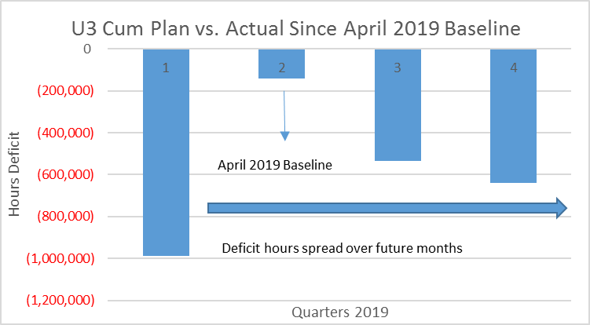

Q. HOW HAVE THE CUMULATIVE BACKLOG OR SURPLUS OF PLANNED HOURS BY COMMODITY AND UNIT 3 AND UNIT 4 FAIRED SINCE THE APRIL 2019 BASELINE?
A. The first graph below represents Unit 3 and the second graph represents Unit 4. For Unit 3 Above Ground Piping and Electrical have fallen behind the April 2019 Baseline almost since its issuance. For Unit 4, Electrical and Civil, since August, have shown a negative trend.
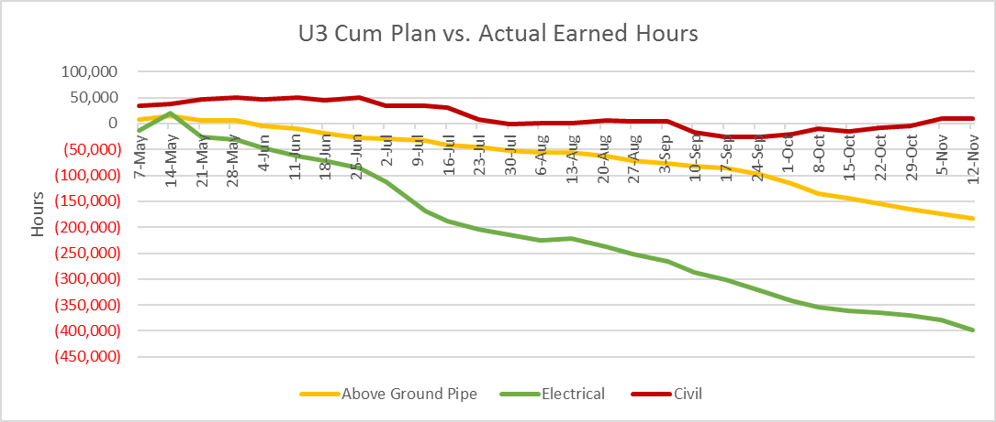
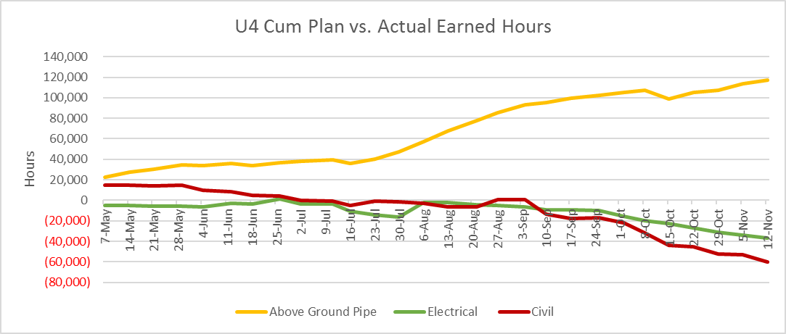

III. THE APRIL 2019 REBASELINE
Q. WHY WAS A NEW SCHEDULE BASELINE NEEDED IN APRIL 2019?
A. As Staff has continually stated since the Sixth VCM and as affirmed in INPO Principle for Excellence in Nuclear Construction No. 4, schedules must be realistic and understood. A realistic schedule drives many critical elements of project management including construction priorities, procurement needs and staffing requirements. In addition, comparison of the Project status to a realistic schedule allows project management to identify problem areas and develop possible mitigation strategies. Without a realistic, achievable schedule, project management is typically in a poor position to support all the disciplines needed for a project. Project management often finds itself fighting fires because long range planning is not effective to identify upcoming problems with sufficient time and resources to take proper corrective actions. By the end of 2018, it was clear that the Project Schedule was not realistic or achievable and thus was not a viable management tool. Staff believes another consequence of not having such a schedule was that it was difficult for stakeholders to determine the true completion status of work and the work that remains.

Q. PLEASE DESCRIBE THE RESULTS OF THE APRIL 2019 SCHEDULE REBASELINE.
A. The work done on the April 2019 Baseline resulted in some improvements when compared to the June 2018 baseline. These improvements are discussed in Staff’s July 30, 2019 report on the April 2019 Vogtle Unit 3 and 4 Re-baseline of Forecast Cost and Schedule and include:
- Integration of sub-contractor work;
- Additional detail in construction and ITP schedule logic;
- Additional resource loading;
- Reduction in the number of hard constraints;
- Verification of to-go commodity quantities.
However, the primary result of the April 2019 Baseline was a relatively small change in the forecast CODs from April 14, 2021 to May 23, 2021 for Unit 3 and from April 25, 2022 to May 23, 2022 for Unit 4.

Q. IN ITS JULY 30, 2019 REPORT, STAFF IDENTIFIED SEVERAL CONCERNS WITH THE APRIL 2019 BASELINE. HAVE THESE CONCERNS BEEN REALIZED IN THE PERIOD SINCE YOUR JULY 30TH REPORT?
A. Yes, they have. Only four months after issuance of the April 2019 Baseline, it is no longer relevant to the Project. The actual status of construction is many hours behind the April 2019 Baseline and system turnovers to ITP are several months delayed. In Staff’s opinion, the April 2019 Baseline is no longer a relevant benchmark for SNC and Bechtel to manage, or status. the Project. Many System turnovers are 90 days or more later than shown in the April 2019 Baseline. In other words, in the four months since the April 2019 Baseline was established, these system turnovers have slipped 90 days.

Q. DOES STAFF EXPECT THIS TREND OF UNDER-EARNING CRAFT HOURS AND DELAYS WITH SYSTEM TURNOVERS TO CONTINUE?
A. Yes. Without significant improvements in production, productivity and planning i.e. a realistic schedule forecast, Staff believes this trend will continue.

Q. HOW DID SNC MEET THE ‘START INTEGRATED FLUSH’ MILESTONE ACTIVITY?
A. The Project managed to achieve the “Start Integrated Flush (“IF”)” milestone by using the Partial Release for Test (“PRT”) process, which allows some testing to be done on piping and components that are not turned over to ITP as scheduled, by performing a flush on a small length of pipe. Use of the PRT process and the negative impacts is described later in this testimony.

Q. WHY IS ACTUAL CONSTRUCTION PROGRESS SIGNIFICANTLY BEHIND THE APRIL 2019 BASELINE ONLY FIVE MONTHS AFTER THE BASELINE WAS ISSUED?
A. In our opinion, the primary reason that construction progress is far behind the April 2019 Baseline is that the schedule assumptions including unit rates were, from the outset, unrealistic and unachievable. As a result, in order to meet the April 2019 Baseline, the unit rates used to develop the April 2019 Baseline were not achievable and were not based on experienced actual unit rates that have been achieved on the Project to date.

Q. PLEASE EXPLAIN THE TERM UNIT RATE AND WHY IT IS RELEVANT TO THIS DISCUSSION.
A. A unit rate is the estimate of the number of hours required to complete installation of a unit of commodity such as feet of pipe or cable. For the April 2019 Baseline, the unit rates were based, with a few minor exceptions, on the unit rates established by Fluor and Westinghouse in 2017 and incorporated in the Bechtel contract which, as shown in Mr. Grace’s testimony, are much lower than the actual experienced unit rates achieved on the Project. The use of unrealistically low unit rates results in fewer man-hours and implies shorter activity durations than are realistic or achievable. This usually leads to delays in system turnovers because completion of construction is later than planned.

Q. DOES STAFF ANTICIPATE ANOTHER RE-BASELINE IN THE NEAR FUTURE?
A. Yes, Staff anticipates that a new forecast of Schedule and Cost will be issued in early 2020.

Q. WHAT IS STAFF’S EXPECTATION FOR THE SCHEDULE RE-FORECAST?
A. Staff expects that the upcoming reforecast may again be overly aggressive and result in small, incremental delays to the forecast CODs of both units. Staff’s concern is that the forthcoming re-baseline will again be unrealistic and therefore become irrelevant within a short period of time after issuance. It may logically lay out the activities to complete Unit 3 and 4 but the explicit production and productivity assumptions may again be overly aggressive.

Q. CAN BECHTEL BE FINANCIALLY AT RISK FOR THE DELAY OF COMMERCIAL OPERATION OF THE UNITS?
A. No. Bechtel and for the most part, all of the sub-contractors working on the site, will be made whole because of the Time and Materials nature of these contracts. The Company agreed with the characterization that Bechtel gets paid for every hour worked. (Transcript, Abramovitz, p. 58). Bechtel does have an “At Risk” fee in their contract. However, Bechtel has the opportunity to submit construction trends to protect that fee.

IV. CONSTRUCTION STATUS
Q. PLEASE PROVIDE THIS COMMISSION AN UPDATE ON THE CONSTRUCTION STATUS OF THE VOGTLE PROJECT.
A. Unfortunately, it is difficult to provide such an update because there is no relevant baseline schedule against which to compare the current status of the Project. As of September 2019, SNC states that construction was 73.0% complete. However, without a realistic Schedule we cannot confirm the percent complete. Staff can state that because it is significantly behind the schedule established in the April 2019 Baseline and because many more hours than planned are being required to complete construction activities, the percent may not accurately represent the balance of work needed to attain the May CODs.

Q. BASED ON STAFF’S KNOWLEDGE CAN STAFF PREDICT WITH ANY CERTAINTY WHEN THE CODS WILL BE ACHIEVED?
A. This question could be answered if the schedule was realistic. But without an IPS based on realistic and achievable unit rates, an estimate of Project completion is simply an educated guess. When asked if the Company used actual rates that might have projected a more realistic duration on unit rate, Company Witness Abramovitz responded by stating that, “…we did not change the unit rates from 2018. (Transcript, Abramovitz p. 57). The status of direct construction on the Project, which is primarily the nuclear island, the power block and some Balance of Plant for Units 3 and 4, is shown in the figure below.
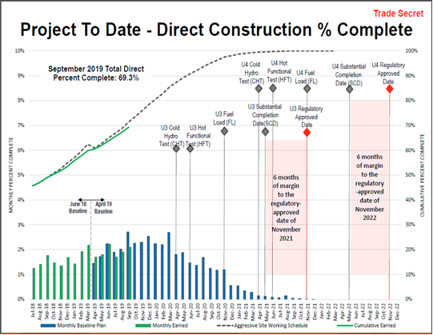
This figure shows that the overall Project is falling behind the April 2019 baseline. As shown below the situation is worse when looking at Unit 3 in isolation.

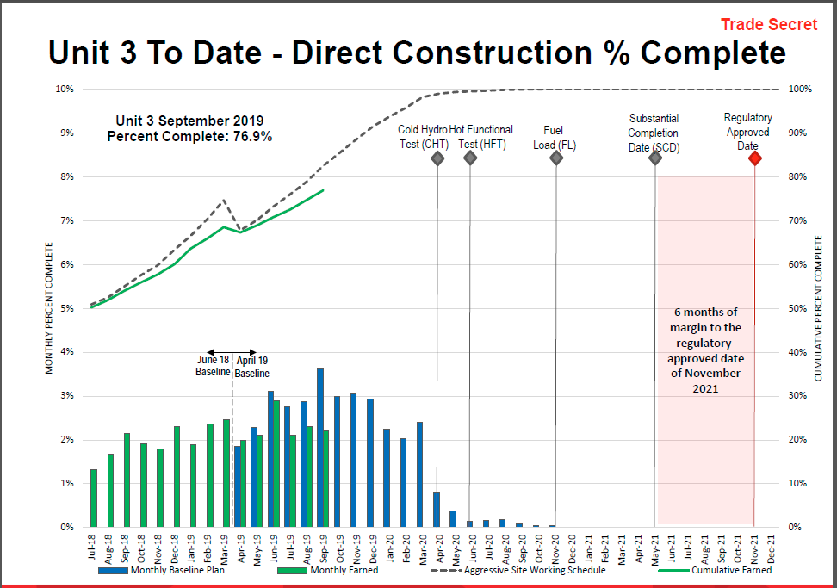
As shown above, the divergence of the green line from the dotted line represents direct construction falling behind the April 2019 Baseline.

Q. WHAT IS THE PRIMARY DRIVER FOR THE CONSTRUCTION SCHEDULE?
A. The primary driver of the construction schedule is to meet the required system turnovers to ITP.

Q. HOW HAS THIS FOCUS ON SYSTEM TURNOVERS IMPACTED THE PROJECT?
A. The construction focus on system turnovers has negatively impacted the Project’s ability to meet the required earned hours to support the Project Schedule. Work related to system completion is tedious and typically results in fewer earned hours. The most efficient approach to earning hours is in bulk construction where, for example, all the electrical cables needed in a given area are pulled at the same time rather than pulling just a few cables needed for a specific system turnover. SNC has stated that its primary approach is to support system completion and turnover to support the ITP Schedule. Since adoption of that approach, the Project has not achieved the required earned hours each month.

Q. HOW DOES SNC PROPOSE TO RECOVER THE CURRENT DELAYS COMPARED TO THE APRIL 2019 BASELINE?
A. Many Project documents state that schedule mitigation activities are being implemented or schedule mitigation activities are being evaluated to recover the current delays. We have heard this terminology many times throughout the course of the Vogtle Project and our observation and experience has been that the Project has implemented many mitigation strategies and improvement plans with little to no significant impact on recovery of delays on the Project. At best, these plans tend to prevent further delays in construction or system turnovers, but have not been able to recover existing schedule delays.

Q. SNC HAS STATED THAT IT WILL UTILIZE “MANAGEMENT TIME” TO MAINTAIN THE CURRENT SCHEDULE. WHAT IS “MANAGEMENT TIME” AND WHAT IS YOUR OPINION OF ITS USE TO MAINTAIN THE CURRENT SCHEDULE?
A. SNC has identified some periods in the current schedule in which they believe that less time will be required during that period to complete the scheduled activities than what is shown in the schedule. This is more typically called “schedule float” but it is called “management time” on the Vogtle Project. SNC believes that XXX XXXX of management time is available in the Unit 3 Schedule between Open Vessel Testing (“OVT”) and COD. Our first observation is that the management time identified by the Company is based on everything going perfectly in the remaining construction and commissioning testing activities. SNC’s position seems to be that while to date the Project has incurred delays at every point, in the future, construction and testing activities will be completed within the time allotted in the Schedule. As a former startup manager at two nuclear plants, I (Dr. Jacobs) assure you that everything will not go perfectly. Problems will be found with equipment and systems that will require time to correct and re-test.

Q. HAS ITP ENCOUNTERED PROBLEMS TO DATE DURING THE EARLY TESTING ACTIVITIES?
A. Yes, ITP has encountered numerous problems during the early phase of flush and hydro and component testing. These problems include:
- Numerous leaks in the fire protection system during initial hydro testing;
- High vibrations on the spent fuel system pumps during initial component testing;
- Current imbalance issue on the Normal Residual Heat Removal pump motor during initial testing;
- Numerous issues with system valves;
- Control circuits for 6.9kV/480V transformer not installed;
- Numerous issues with circuit breakers.

Q. IN YOUR EXPERIENCE, HAS THE PROJECT ENCOUNTERED AN ABNORMAL AMOUNT OF PROBLEMS DURING INITIAL TESTING?
A. No, the level of problems encountered has not been abnormal to date. One of the major objectives of the Test Program is to find problems and correct them. We mention these examples of problems found during testing to emphasize the point that it is not realistic to assume that testing will be completed within the scheduled durations and that schedule float or management time will be available during the testing windows. In addition, the late turnover of systems to ITP will result in compression of the time available to complete many preoperational tests. As these preoperational tests stack up, the capability of ITP to complete them during the Scheduled durations will be challenged.

Q. AS THE PROJECT HAS ENTERED THE EARLY TESTING PHASE, PLEASE BRIEFLY DESCRIBE THE TESTING REQUIRED TO START UP A NUCLEAR POWER PLANT.
A. The equipment that makes up a nuclear power plant is divided into many systems. The Vogtle Units are each broken down into approximately 104 systems. Some systems contain only electrical equipment while other systems consist of piping, valves, pumps and other mechanical equipment along with the electrical equipment required to operate these components. Testing typically begins with cleaning piping systems, called flushing and testing the piping systems to ensure they are capable of withstanding the designed pressures, called hydrostatic testing or hydros. Then individual components such as pumps and valves are tested to ensure they are operating within design parameters.
As systems are completed and turned over from construction, Pre-operational Testing can begin. Pre-operational Tests confirm the functionality of the full system and verify the system operates per design. Completion of Pre-operational Testing leads to a significant test called Hot Functional Testing (“HFT”). During HFT, the Reactor Coolant System is operated at normal operating temperature and pressure and a large portion of the plant is tested in an integrated fashion to verify that plant systems and the integrated plant operates per design prior to fuel load. The final steps in the Startup Program are loading the nuclear fuel and then testing the plant at increasing power levels leading to 100% power and finally Commercial Operation.

Q. WITH THE TURNOVER OF SYSTEMS APPROXIMATELY THREE MONTHS BEHIND SCHEDULE, HOW HAS SNC CONTINUED WITH ITP ACTIVITIES AND MET MAJOR MILESTONES SUCH AS START INTEGRATED FLUSH?
A. The Project uses a process called Partial Release for Test (“PRT”). The PRT process allows jurisdictional control of a portion of a system to be transferred to ITP to conduct testing activities prior to final turnover of that system. Once the testing activities are complete, ITP returns jurisdictional control to Construction to complete the system. This process allows ITP to conduct flushing, hydro and component testing activities prior to turnover of a complete or partial system.

Q. IS THE PRT PROCESS A REASONABLE APPROACH TO CONDUCT ITP ACTIVITIES?
A. It is reasonable to use the PRT process to conduct some testing activities prior to turnover. The question is a matter of to what degree it should be used. On the Vogtle Project, a large portion of the testing activities to date have been conducted using the PRT process rather than on systems that have been turned over to ITP as originally contemplated. SNC has stated that they are using the PRT process to mitigate the impact of the late system turnovers. For example, the Project met the major milestone of ‘Start Integrated Flush’ by using the PRT process to turnover a small portion of piping for flushing and have used the process to continue with Integrated Flushing activities. Use of the PRT allows some testing to be done sooner than could otherwise be accomplished due to the late system turnovers from Construction. However, meeting major milestones using this process can give a false impression of the status of the Project. In addition, extensive use of the PRT process greatly complicates and impedes Construction due to the change in jurisdictional control to ITP and then back to Construction. Construction is often left waiting to get back into a system to complete it while ITP completes its testing activities. It would be much more efficient to fully complete a system and then turn the system over to ITP for testing rather than changing jurisdictional control multiple times between construction and ITP by using the PRT process.

Q. IN ADDITION TO THE NEGATIVE IMPACT ON CONSTRUCTION EFFICIENCY AND PRODUCTION, WHAT OTHER CONCERNS DO YOU HAVE ABOUT THE EXCESSIVE USE OF THE PRT PROCESS?
A. Conducting testing in locations in which construction is also underway requires close coordination and control of equipment to ensure that construction and/or operating personnel are not in danger. Two recent examples from the Project highlight this concern:
- On 11/8/2019 night shift ITP was conducting a test on the Chemical and Volume System. A valve was not in the required closed position and water entered the room where electricians were working. Two electricians were injured while trying to exit the room.
- On 11/7/2019 while restoring the PXS system after conducting a flush, argon gas was vented from Core Makeup Tank A into a room where construction personnel were working. An air quality alarm went off and the room was evacuated.
The more the PRT process is used and construction personnel are working in close proximity to testing activities, the more likely these types of events are to occur.

V. IMPACTS OF OVERLY AGGRESSIVE SCHEDULE
Q. DOES STAFF BELIEVE THERE ARE RISKS ASSOCIATED WITH THE USE OF AN OVERLY AGGRESSIVE SCHEDULE?
A. Yes. First, Staff does agree with SNC that the Schedule should be challenging to ensure that all parties involved in the completion of the Project are pushed to perform to their utmost efficiency. However, Staff is of the opinion that the Target CODs of May 2021 and 2022 are not reasonable. The primary reason for this belief is discussed in the Grace Testimony regarding unattainable assumed unit rates in the April 2019 Baseline.

Q. WHAT IS THE PRIMARY RISK THAT STAFF SEES WITH AN OVERLY AGGRESSIVE SCHEDULE?
A. Lack of accountability for completion of activities. The April 2019 Baseline is one of the critical metrics by which SNC can hold Bechtel and all other sub-contractors accountable for work production. Staff believes that it is essential for activity durations to be reasonable and achievable. With the absence of these two qualities for activity durations, completion dates begin to shift to the right (they are delayed) without much questioning from line management.

Q. HAS STAFF WITNESSED THIS LACK OF QUESTIONING REGARDING SHIFTS TO THE RIGHT OF ACTIVITY COMPLETION DATES?
A. Yes. Staff has been present in many meetings where an activity date is declared unachievable by the responsible manager. Most often the team is told that the completion date can be met X number of days in the future without any challenge from leadership in the room. This practice is then often repeated until a reasonable date is finally declared.

Q. WOULD IT BE REASONABLE TO HOLD A MANAGER RESPONSIBLE FOR COMPLETING AN ACTIVITY WHEN THE DURATION OF THAT ACTIVITY IS UNREASONABLY SHORT?
A. No, it would not.

Q. ARE THERE OTHER POTENTIAL NEGATIVE IMPACTS THAT CAN DEVELOP AS A RESULT OF AN OVERLY AGGRESSIVE SCHEDULE?
A. Yes. For the most part they are self-explanatory and are listed below:
- Low staff morale;
- Staff attrition;
- High absenteeism;
- The need for accelerated procurement;
- Construction and Engineering’s inability to close work packages;
- Future bow wave of work that must be completed in an ever shrinking time-frame.

Q. WHAT IS THE CONSEQUENCE OF THE LAST BULLETED ITEM ABOVE?
A. Essentially it takes the overly-aggressive Schedule and inserts even more work into what time remains.
Q. WHEN MUST ESSENTIALLY ALL CONSTRUCTION BE COMPLETE FOR UNIT THREE?
A. With very few exceptions construction must be complete just prior to fuel load. In order for nuclear fuel to be on site at Unit 3, Unit 3 and the majority of Balance of Plant structures must be incorporated into the Station’s (Unit 1, Unit 2, and Unit 3) security perimeter. At that time, it would be very difficult to plan for efficient egress of craft workers into Unit 3. Fuel load is scheduled for November of 2020 which equates to about one year to finish all construction.

VII. REGULATORY ISSUES

Q. HAS THE DEFINITION OF COMMERCIAL OPERATION BEEN DEFINED IN A STIPULATION BETWEEN THE COMPANY AND STAFF?
A. Yes. From the stipulation adopted by the Commission dated October 20th, 2016 between Staff and the Company line items twelve and thirteen state Commercial Operation (per unit) has been defined as follows:
The Projects, consisting of Units 3 and 4, will be placed into retail rate base on December 31, 2020 or upon reaching commercial operation whichever is later.

Commercial Operation of a Unit as used in this Stipulation will be defined as the Unit being fully dispatchable on demand at the stated Net Electrical Output of 1,102MWe of the Unit. For ratemaking purposes, the Units will not be included in base rates until December 31, 2020 or when the Units reach Commercial Operation, whichever is later.

Q. DOES THIS DEFINITION CONTEMPLATE ANY FINANCIAL ACCOUNTING CRITERIA FOR DECLARING COMMERCIAL OPERATION?
A. No. If it did contemplate financial accounting criteria the Stipulation would have expressly stated so. It is Staff’s opinion that for each of the Units to be placed into base rates each Unit, mutually exclusive of the other, must perform as stated in the Stipulation. Furthermore, because these Units are nuclear generation, the dispatch is to be assumed twenty-four hours a day, seven days a week, until a scheduled outage is required. As the newly completed AP1000 Sanmen 2 has demonstrated, simply because a Unit starts producing power does not mean that the Unit will function as intended. It is important that the Units have demonstrated that they work as intended before ratepayers are asked to pay for them.

Q. ARE THERE OTHER CRITERIA UNDER WHICH PROJECT COSTS ARE GOVERNED BY STIPULATIONS?
A. Yes. From the same Stipulation line items four and five state the burden of proof for disallowance of costs are borne as follows:
4. Capital costs incurred up to $5.68 billion will be presumed to be reasonable and prudent. The burden of proof shall be on the party challenging those costs.

5. The Company will have the burden to show that Capital costs above the revised forecast of $5.68 billion are reasonable and prudent.

Q DOES LINE ITEM 4 FROM THE STIPULATION ABOVE FOREGO THE OPPORTUNITY OF A PARTY FROM CHALLENGING CAPITAL COSTS UP TO $5.68 BILLION?
A. No. Item one of the Stipulation deemed capital costs incurred by the Company through the end of the Fourteenth VCM prudent, with the exception that if any system, structure, or component embedded in that capital cost through the Fourteenth VCM does not perform per the design “…The Commission expressly reserves its right to review and disallow any cost and or schedule impacts of such deficiency.” Cost between those incurred through the Fourteenth VCM of approximately $3.5 billion were therefore deemed prudent. Costs incurred after the 14th VCM up to the $5.68 billion are challengeable, with the burden of proof on the party challenging the cost. For costs above $5.68, the burden to show prudence is the Company’s responsibility.

Q WITH THE CURRENT COMPANY CAPITAL COST FORECAST TO COMPLETE BOTH UNITS AT $7.3 BILLION, WHAT AMOUNT MUST THE COMPANY SHOW TO BE PRUDENTLY INCURRED?
A. It is the difference between the $7.3 billion current capital forecast and the $5.68 billion which is $1.62 billion. If costs exceed $7.3 billion, the Company would also have the burden of proof on those additional costs.

VIII. RECOMMENDATIONS

Q. WHAT IS STAFF’S RECOMMENDATION WITH REGARD TO THE AMOUNT REQUESTED BY THE COMPANY TO BE VERIFIED AND APPROVED?
A. We recommend that the expenditures of $1.248 billion incurred during the Twentieth and Twenty-First VCM periods be verified and approved. As Staff has previously explained, “verification and approval” of costs means a determination that such costs have actually been spent on the Project and does not preclude a subsequent disallowance by the Commission.

Q. DOES THIS CONCLUDE YOUR TESTIMONY?
A. Yes, it does.

EXHIBIT STF-SDR-1

Resume Of
Steven D. Roetger

Steven D. Roetger
244 Washington Street, S.W.
Atlanta, GA 30334

Professional Experience
Georgia Public Service Commission Atlanta, Georgia 2008-Present
Analyst Primary responsibilities include monitoring the Vogtle expansion of Units 3 and 4, attending site visits on a regular basis, participate with the Commission and Company interface, and assist in the preparation of testimony.
Key achievements
Manage the Vogtle Construction monitoring process including engineering, procurement, and construction; economic analysis of the value of the Project; and financial accounting review for the Project’s costs.
Write and review direct pre-filed testimony of the status of the Project for a semi-annual hearings.

BCD Travel Atlanta, Georgia 2007-2008
Finance Manager Primary responsibilities were to manage financial analysts, generate and review variance analyses, analyze departmental financials, and facilitate the coordination between our group and various internal departments.
Key achievements
Elevated team's performance to improve consistency, accuracy, and timeliness of service
Identified client missed revenue opportunities and communicated to Operations for recapture and/or inclusion with future invoicing
Key Requirements
Train, motivate, and develop 3 financial analysts to achieve an outstanding level of service and performance
Direct work flow to maintain efficiency and productivity without compromising standards
Analyze departmental financials to maximize profitability by reviewing contracts, perform variance analyzes, and ensure complete transaction billing
Review complex contracts and interpret for finance reconciliation and billing procedures
Prepare client budgets and forecasts

Marine Bank of Florida Marathon, Florida2003-2005
Accounting Operations Manager/Bank Officer Primary responsibilities were to manage the Bank's Accounting Department and, as directed by the COO, Deposit Operations' functions.
Key achievements
Identified high-risk, time sensitive accounts for dedicated review to significantly reduce financial risk to the Bank
In partnership with the CFO reduced audit management exceptions from 13 to zero year over year
Launched new wire department procedures to decrease response time, increase capacity, and improve customer service without increasing staff
In partnership with the COO implemented the Bank's new ACH operations to enhance existing customer relations, attract new business, and respond in a timely manner to ACH adjustments/returns
Key Requirements
Comprehensive G/L management including reconciliations, adjusting entries, and monthly/annual close
Manage and review the activities of 3 accounting and 2 deposit operations personnel responsible for accounts payable, wires, ACH operations, VISA check card operations, branch settlements, electronic funds transfers, and check clearing.
Establish and refine departmental policies and procedures to improve accuracy and timeliness of reporting, facilitate employee transition, and meet audit requirements
Oversaw Federal Reserve, FHLB, and IBB correspondent accounts
Supported the CFO to meet external audit requirements
Oversaw the Bank's daily cash position to minimize overnight net interest expense
Support branch operations by assisting branch managers maintain acceptable internal controls, provide training on Bank reporting procedures, and process exceptions

B. Terfloth &Co. USA) Inc. Atlanta, Georgia 1998-2000
Accounting Manager Primary responsibilities were to manage the Branch's Accounting Department with an emphasis on controlling expenses and manage the yearly audit process.
Key achievements
Re-established accurate and timely monthly reporting to the Corporate Office
Developed a cash flow forecasting model to assess the Branch's financing needs and negotiated under the President's supervision a working capital credit line to meet those needs
Key requirements
Comprehensive G/L management including reconciliations, adjusting entries, and monthly/annual close
Manage the annual audit process
Accounts payable and accounts receivable
Payroll and annual bonus calculations

Bridgetown Grill Restaurants Inc. Atlanta, Georgia1996-1997
Interim Controller Primary responsibilities were to re-establish a reliable Accounting process and once established facilitate the transition to a new Controller.
Key achievements
Established internal controls to better manage purchases, inventories, and reduce cash variances
Developed Accounting procedures for Unit Managers and trained the management staff on those procedures
Assisted the Owner in evaluating an outside purchase offer
Key requirements
Comprehensive G/L management including reconciliations, adjusting entries, and monthly close procedures
Coordinate the annual audit process
Manage accounts payable and payroll processing
Manage credit card transaction procedures to reduce charge backs

Turner Broadcasting System Inc. Atlanta, Georgia 1991-1996
Staff Accountant Primary responsibility was to support the Managers with accurate and timely completion of assigned tasks.
Key achievements
Partnered with Management to streamline the procedure for The Statement of Cash Flows
Corrected the EPS calculation
Streamlined governmental reporting and incorporated detailed procedures for each report
Provided a Companywide vacation and sick time accrual analysis
Key requirements
Worked, as part of a team, on the Consolidated Financial Statements of TBS, Inc.
Develop various footnotes to the Financial Statements
Provide analysis of accounts for actual to budget and actual to rolling12 month forecast variances
Provide analysis of, and recommendations for, lease capitalizations
Coordinate with 72 Operating Unit Controllers for the content and timely receipt of Unit financial data
Prepare debt covenant calculations for 4 issues and provide forecasts with sensitivity analysis
Prepare all U.S. Department of Commerce and U.S. Treasury Department statistical reports

Software
PeopleSoft/nVision reporting, Kirchman/Bankway and IPS Sendero banking software, MSA accounting software, Excel, Outtask, and Word

Education

BBA Georgia State University in Finance with an equivalent in Accounting
Completed 70 percent of course work toward an MBA in Finance from Georgia State University

EXHIBIT STF- WRJ-1

Resume Of
William R. Jacobs, Ph.D.

EDUCATION: Ph.D., Nuclear Engineering, Georgia Tech 1971
MS, Nuclear Engineering, Georgia Tech 1969
BS, Mechanical Engineering, Georgia Tech 1968

ENGINEERING REGISTRATION: Registered Professional Engineer

PROFESSIONAL MEMBERSHIP: American Nuclear Society

EXPERIENCE:

Dr. Jacobs has over thirty-five years of experience in a wide range of activities in the electric power generation industry. He has extensive experience in the construction, startup and operation of nuclear power plants. While at the Institute of Nuclear Power Operation (INPO), Dr. Jacobs assisted in development of INPO’s outage management evaluation group. He has provided expert testimony related to nuclear plant operation and outages in Texas, Louisiana, South Carolina, Florida, Wisconsin, Indiana, Georgia and Arizona. He currently provides nuclear plant operational monitoring services for GDS clients. Dr. Jacobs was a witness in nuclear plant certification hearings in Georgia for the Plant Vogtle 3 and 4 project on behalf of the Georgia Public Service Commission and in South Carolina for the V.C. Summer 2 and 3 projects on behalf of the South Carolina Office of Regulatory Staff. His areas of expertise include evaluation of reactor technology, EPC contracting, risk management and mitigation, project cost and schedule. He is assisting the Florida Office of Public Counsel in monitoring the development of four new nuclear units in the State of Florida, Levy County Units 1 and 2 and Turkey Point Units 6 and 7. He also evaluated extended power uprates on five nuclear units for the Florida Office of Public Counsel. He has been selected by the Georgia Public Service Commission as the Independent Construction Monitor for Georgia Power Company’s new AP1000 nuclear power plants, Plant Vogtle Units 3 and 4. He has assisted the Georgia Public Service Commission staff in development of energy policy issues related to supply-side resources and in evaluation of applications for certification of power generation projects and assists the staff in monitoring the construction of these projects. He has also assisted in providing regulatory oversight related to an electric utility’s evaluation of responses to an RFP for a supply-side resource and subsequent negotiations with short-listed bidders. He has provided technical litigation support and expert testimony support in several complex law suits involving power generation facilities. He monitors power plant operations for GDS clients and has provided testimony on power plant operations and decommissioning in several jurisdictions. Dr. Jacobs represents a GDS client on the management committee of a large coal-fired power plant currently under construction. Dr. Jacobs has provided testimony before the Georgia Public Service Commission, the Public Utility Commission of Texas, the North Carolina Utilities Commission, the South Carolina Public Service Commission, the Iowa State Utilities Board, the Louisiana Public Service Commission, the Florida Public Service Commission, the Indiana Regulatory Commission, the Wisconsin Public Service Commission, the Arizona Corporation Commission and the FERC.

A list of Dr. Jacobs’ testimony is available upon request.

1986-Present GDS Associates, Inc.

As Executive Consultant, Dr. Jacobs assists clients in evaluation of management and technical issues related to power plant construction, operation and design. He has evaluated and testified on combustion turbine projects in certification hearings and has assisted the Georgia PSC in monitoring the construction of the combustion turbine projects. Dr. Jacobs has evaluated nuclear plant operations and provided testimony in the areas of nuclear plant operation, construction prudence and decommissioning in nine states. He has provided litigation support in complex law suits concerning the construction of nuclear power facilities. Dr. Jacobs is the Georgia PSC’s Independent Construction Monitor for the Plant Vogtle 3 and 4 nuclear project.

1985-1986 Institute of Nuclear Power Operations (INPO)

Dr. Jacobs performed evaluations of operating nuclear power plants and nuclear power plant construction projects. He developed INPO Performance Objectives and Criteria for the INPO Outage Management Department. Dr. Jacobs performed Outage Management Evaluations at the following nuclear power plants:

• Connecticut Yankee - Connecticut Yankee Atomic Power Co.
• Callaway Unit I - Union Electric Co.
• Surry Unit I - Virginia Power Co.
• Ft. Calhoun - Omaha Public Power District
• Beaver Valley Unit 1 - Duquesne Light Co.

During these outage evaluations, he provided recommendations to senior utility management on techniques to improve outage performance and outage management effectiveness.

1979-1985 Westinghouse Electric Corporation

As site manager at Philippine Nuclear Power Plant Unit No. 1, a 655 MWe PWR located in Bataan, Philippines, Dr. Jacobs was responsible for all site activities during completion phase of the project. He had overall management responsibility for startup, site engineering, and plant completion departments. He managed workforce of approximately 50 expatriates and 1700 subcontractor personnel. Dr. Jacobs provided day-to-day direction of all site activities to ensure establishment of correct work priorities, prompt resolution of technical problems and on schedule plant completion.

Prior to being site manager, Dr. Jacobs was startup manager responsible for all startup activities including test procedure preparation, test performance and review and acceptance of test results. He established the system turnover program, resulting in a timely turnover of systems for startup testing.

As startup manager at the KRSKO Nuclear Power Plant, a 632 MWE PWR near Krsko, Yugoslavia, Dr. Jacobs' duties included development and review of startup test procedures, planning and coordination of all startup test activities, evaluation of test results and customer assistance with regulatory questions. He had overall responsibility for all startup testing from Hot Functional Testing through full power operation.
1973 - 1979 NUS Corporation

As Startup and Operations and Maintenance Advisor to Korea Electric Company during startup and commercial operation of Ko-Ri Unit 1, a 595 MWE PWR near Pusan, South Korea, Dr. Jacobs advised KECO on all phases of startup testing and plant operations and maintenance through the first year of commercial operation. He assisted in establishment of administrative procedures for plant operation.
As Shift Test Director at Crystal River Unit 3, an 825 MWE PWR, Dr. Jacobs directed and performed many systems and integrated plant tests during startup of Crystal River Unit 3. He acted as data analysis engineer and shift test director during core loading, low power physics testing and power escalation program.

As Startup engineer at Kewaunee Nuclear Power Plant and Beaver Valley, Unit 1, Dr. Jacobs developed and performed preoperational tests and surveillance test procedures.

1971 - 1973 Southern Nuclear Engineering, Inc.

Dr. Jacobs performed engineering studies including analysis of the emergency core cooling system for an early PWR, analysis of pressure drop through a redesigned reactor core support structure and developed a computer model to determine tritium build up throughout the operating life of a large PWR.

SIGNIFICANT CONSULTING ASSIGNMENTS:

Georgia Public Service Commission – Selected as the Independent Construction Monitor to assist the GPSC staff in monitoring all aspects of the design, licensing and construction of Plant Vogtle Units 3 and 4, two AP1000 nuclear power plants.

Georgia Public Service Commission – Assisted the Georgia Public Service Commission Staff and provided testimony related to the evaluation of Georgia Power Company’s request for certification to construct two AP1000 nuclear power plants at the Plant Vogtle site.

South Carolina Office of Regulatory Staff – Assisted the South Carolina Office of Regulatory Staff in evaluation of South Carolina Electric and Gas’ request for certification of two AP1000 nuclear power plants at the V.C. Summer site.

Florida Office of Public Counsel – Assists the Florida Office of Public Counsel in monitoring the development of four new nuclear power plants and extended power uprates on five nuclear units in Florida including providing testimony on the prudence of expenditures.

East Texas Electric Cooperative – Represented ETEC on the management committee of the Plum Point Unit 1 a 650 Mw coal-fired plant under construction in Osceola, Arkansas and represents ETEC on the management committee of the Harrison County Power Project, a 525 Mw combined cycle power plant located near Marshall, Texas.

Arizona Corporation Commission – Evaluated operation of the Palo Verde Nuclear Generating Station during the year 2005. Included evaluation of 11 outages and providing written and oral testimony before the Arizona Corporation Commission.

Citizens Utility Board of Wisconsin – Evaluated Spring 2005 outage at the Kewaunee Nuclear Power Plant and provided direct and surrebuttal testimony before the Wisconsin Public Service Commission.

Georgia Public Service Commission - Assisted the Georgia PSC staff in evaluation of Integrated Resource Plans presented by two investor owned utilities. Review included analysis of purchase power agreements, analysis of supply-side resource mix and review of a proposed green power program.

State of Hawaii, Department of Business, Economic Development and Tourism – Assisted the State of Hawaii in development and analysis of a Renewable Portfolio Standard to increase the amount of renewable energy resources developed to meet growing electricity demand. Presented the results of this work in testimony before the State of Hawaii, House of Representatives.

Georgia Public Service Commission - Assisted the Georgia PSC staff in providing oversight to the bid evaluation process concerning an electric utility’s evaluation of responses to a Request for Proposals for supply-side resources. Projects evaluated include simple cycle combustion turbine projects, combined cycle combustion turbine projects and co-generation projects.

Millstone 3 Nuclear Plant Non-operating Owners – Evaluated the lengthy outage at Millstone 3 and provided analysis of outage schedule and cost on behalf of the non-operating owners of Millstone 3. Direct testimony provided an analysis of additional post-outage O&M costs that would result due to the outage. Rebuttal testimony dealt with analysis of the outage schedule.

H.C. Price Company – Evaluated project management of the Healy Clean Coal Project on behalf of the General Contractor, H.C. Price Company. The Healy Clean Coal Project is a 50 megawatt coal burning power plant funded in part by the DOE to demonstrate advanced clean coal technologies. This project involved analysis of the project schedule and evaluation of the impact of the owner’s project management performance on costs incurred by our client.

Steel Dynamics, Inc. – Evaluated a lengthy outage at the D.C. Cook nuclear plant and presented testimony to the Indiana Utility Regulatory Commission in a fuel factor adjustment case Docket No. 38702-FAC40-S1.

Florida Office of Public Counsel - Evaluated lengthy outage at Crystal River Unit 3 Nuclear Plant. Submitted expert testimony to the Florida Public Service Commission in Docket No. 970261-EI.

United States Trade and Development Agency - Assisted the government of the Republic of Mauritius in development of a Request for Proposal for a 30 MW power plant to be built on a Build, Own, Operate (BOO) basis and assisted in evaluation of Bids.

Louisiana Public Service Commission Staff - Evaluated management and operation of the River Bend Nuclear Plant. Submitted expert testimony before the LPSC in Docket No. U-19904.

U.S. Department of Justice - Provided expert testimony concerning the in-service date of the Harris Nuclear Plant on behalf of the Department of Justice U.S. District Court.

City of Houston - Conducted evaluation of a lengthy NRC required shutdown of the South Texas Project Nuclear Generating Station.

Georgia Public Service Commission Staff - Evaluated and provided testimony on Georgia Power Company's application for certification of the Intercession City Combustion Turbine Project - Docket No. 4895-U.

Seminole Electric Cooperative, Inc. - Evaluated and provided testimony on nuclear decommissioning and fossil plant dismantlement costs - FERC Docket Nos. ER93-465-000, et al.

Georgia Public Service Commission Staff - Evaluated and prepared testimony on application for certification of the Robins Combustion Turbine Project by Georgia Power Company - Docket No. 4311-U.

North Carolina Electric Membership Corporation - Conducted a detailed evaluation of Duke Power Company's plans and cost estimate for replacement of the Catawba Unit 1 Steam Generators.

Georgia Public Service Commission Staff - Evaluated and prepared testimony on application for certification of the McIntosh Combustion Turbine Project by Georgia Power Company and Savannah Electric Power Company - Docket No. 4133-U and 4136-U.

New Jersey Rate Counsel - Review of Public Service Electric & Gas Company nuclear and fossil capital additions in PSE&G general rate case.

Corn Belt Electric Cooperative/Central Iowa Power Electric Cooperative - Directs an operational monitoring program of the Duane Arnold Energy Center (565 Mwe BWR) on behalf of the non-operating owners.

Cities of Calvert and Kosse - Evaluated and submitted testimony of outages of the River Bend Nuclear Station - PUCT Docket No. 10894.

Iowa Office of Consumer Advocate - Evaluated and submitted testimony on the estimated decommissioning costs for the Cooper Nuclear Station - IUB Docket No. RPU-92-2.

Georgia Public Service Commission/Hicks, Maloof & Campbell - Prepared testimony related to Vogtle and Hatch plant decommissioning costs in 1991 Georgia Power rate case - Docket No. 4007-U.

City of El Paso - Testified before the Public Utility Commission of Texas regarding Palo Verde Unit 3 construction prudence - Docket No. 9945.

City of Houston - Testified before Texas Public Utility Commission regarding South Texas Project nuclear plant outages - Docket No. 9850.

NUCOR Steel Company - Evaluated and submitted testimony on outages of Carolina Power and Light nuclear power facilities - SCPSC Docket No. 90-4-E.

Georgia Public Service Commission/Hicks, Maloof & Campbell - Assisted Georgia Public Service Commission staff and attorneys in many aspects of Georgia Power Company's 1989 rate case including nuclear operation and maintenance costs, nuclear performance incentive plan for Georgia and provided expert testimony on construction prudence of Vogtle Unit 2 and decommissioning costs of Vogtle and Hatch nuclear units - Docket No. 3840-U.

Swidler & Berlin/Niagara Mohawk - Provided technical litigation support to Swidler & Berlin in law suit concerning construction mismanagement of the Nine Mile 2 Nuclear Plant.

Long Island Lighting Company/Shea & Gould - Assisted in preparation of expert testimony on nuclear plant construction.

North Carolina Electric Membership Corporation - Prepared testimony concerning prudence of construction of Carolina Power & Light Company's Shearon Harris Station - NCUC Docket No. E-2, Sub537.

City of Austin, Texas - Prepared estimates of the final cost and schedule of the South Texas Project in support of litigation.

Tex-La Electric Cooperative/Brazos Electric Cooperative - Participated in performance of a construction and operational monitoring program for minority owners of Comanche Peak Nuclear Station.

Tex-La Electric Cooperative/Brazos Electric Cooperative/Texas Municipal Power Authority (Attorneys - Burchette & Associates, Spiegel & McDiarmid, and Fulbright & Jaworski) - Assisted GDS personnel as consulting experts and litigation managers in all aspects of the lawsuit brought by Texas Utilities against the minority owners of Comanche Peak Nuclear Station.

Westinghouse provides the engineering, design, and applicable analyses for the Design Certification Document (“DCD”).
Bechtel is the construction contractor.
Staff will refer the prior re-baselined Integrated Project Schedule (“IPS”) and Estimate at Completion (“EAC”) as the June 2018 Baseline and the April 2019 Baseline.

