**GEORGIA PUBLIC SERVICE COMMISSION STAFF TEAM REVIEW**

**OF**

**SOUTHERN NUCLEAR COMPANY’S APRIL 2019 VOGTLE UNITS 3 AND 4 RE-BASELINE OF FORECAST SCHEDULE AND COST**

**July 30, 2019**

**Executive Summary**

The Georgia Public Service Commission Public Interest Advocacy Staff (“Staff”) believes that the means and methods used by Southern Nuclear Company (“SNC”) to develop the April 2019 Baseline for Plant Vogtle Units 3 and 4 (“Project”) were generally sound. SNC incorporated all major stakeholders into the re-baseline effort. Each discipline, such as Engineering, Initial Test Program Group, Construction, etc., was involved in the development of the Integrated Project Schedule (“IPS” or “Schedule”) and the Cost Forecast. Georgia Power Company’s Nuclear Development organization (“GPCND”) observed and participated in the process and performed confirmatory analyses. Additionally, GPCND has personnel at the site performing verifications, reviewing processes, and challenging SNC as well as the responsible sub-contractor. Lastly, GPCND has begun to forecast schedule and cost scenarios to validate the information provided by SNC.

Although the process employed to develop the April 2019 Schedule Baseline was generally sound, it should be recognized that in order to address the aggressive schedule completion dates adopted by SNC there are approaches being taken to the Project which the Staff finds to be inconsistent with Staff’s collective experience in nuclear construction and large plant construction. Most noteworthy among these approaches is a premature focus on systems testing and turnover prior to achieving a greater percentage of the construction of bulk electrical and mechanical commodities. The potential consequences of this strategy are discussed under Integrated Project Schedule Concerns on page 5, most notable of which would be a quick erosion of the 5+ month schedule contingency in the April 2019 Baseline. Additionally, although there are many high probability schedule and cost risks that have been identified and are being tracked, few were incorporated into the IPS.

Staff does not believe that the April 2019 Baseline working schedule predicated on Commercial Operation Dates (“CODs”) of May 23, 2021 and 2022, are achievable. With regard to the Schedule approved in the 17th VCM containing CODs of November 2021 and 2022, Staff believes at this time that these dates will be a challenge to achieve. With regard to the Project Cost of $17.1 billion[1], assuming the November COD dates, Staff is of the opinion at this time that there is a chance of meeting the Cost forecast. The primary rationale for this opinion is that the Project Cost forecast includes a substantial construction Cost and Schedule contingency. As of the filing of this Report, the Construction Cost contingency has remained largely intact primarily because few high cost risk issues have been incorporated. The total SNC Construction Cost contingency is approximately $800 million; the total SNC Schedule Cost contingency is approximately $600 million; XXXXXXXXXX; XXXXXXXXXXXXXXXXXXXXXXXXXXXXXXXXX. However, as history has shown on this Project, should the Project be delayed beyond the November CODs, and/or risks not be effectively managed, the Project Cost could be exceeded[2].

With respect to SNC’s on-going management of the Project Cost and Schedule, although enhancements continue to be made, it is recommended that further improvements be made by SNC to establish a fully integrated Cost and Schedule Earned Value Management System[3] (“EVMS”). A potential improvement would be to expand the reported CPI to include Indirect Labor, Field Non-manual labor, Integrated Test Program (“ITP”), Sub-contracts, Westinghouse costs, SNC costs, and distributable costs. Currently, the CPI only reflects direct labor.

**Background**

On February 26, 2019 in its Nineteenth Vogtle Construction Monitoring (“VCM”) Order the Commission approved a joint Stipulation between Staff and Georgia Power Company (“GPC”) dated January 24, 2019 which required, among other items, GPC and Staff to submit a report on the impacts, if any, to the approved Project Schedule and Cost as a result of a re-baseline effort undertaken by SNC. SNC indicated that this re-baseline effort would be complete by April 1, 2019. The relevant item, 4(c) under the Stipulation states the following:

*No later than July 31, 2019, unless a later date is agreed to by the Parties, the Staff and the CM will file with the Commission their observations on the verification process and results. The Company may include its comments on the Staff and CM’s observations in its combined VCM 20 and 21 filing, and any hearing pertaining to the verification process and results will be included as part of the VCM 20 and VCM 21 combined proceeding.*

This Report contains Staff’s observations on the verification process and results.

On or about May 13, 2019 the results of SNC’s April 2019 Baseline Integrated Project Schedule and a preliminary Estimate At Completion[4] (“EAC”), among other items, were provided to Staff. While a preliminary forecast of the remaining Project Costs was performed by SNC in May, 2019 the final Cost forecasts were provided to Staff the second week of July 2019 at a joint site meeting. Staff notes that the change between the preliminary Cost forecast figures and the final Cost forecast figures was an immaterial increase sufficiently covered by Project contingency[5].

The April 2019 Baseline represents SNC’s current forecast for Project completion and cost. SNC’s forecast of CODs slipped for Unit 3 by 39 days from April 14, 2021 to May 23, 2021 and for Unit 4 by 28 days from April 25, 2022 to May 23, 2022. The Cost forecast remained the same as was reported in the 19th VCM. Staff’s analyses and opinions reflected in this Report were constrained by the short duration in which Staff could compare actual Project performance against the April 2019 Baseline, and generally by the scope and complexity of the Project. That is to say, one of the best methods for determining the reasonableness of any forecast is to compare the forecast, and the assumptions embedded in the forecast, with actual Project performance in the field. In future reporting, Staff’s analyses regarding SNC’s Schedule and Cost forecasts will be more robust and refined due to the passage of time.

Please note, under the Staff’s Observations and Concerns section of this Report, Schedule and Cost impacts are not mutually exclusive and the noted concerns should not be viewed as exhaustive lists.

**Staff’s Observations and Concerns**

**Integrated Project Schedule Observations**

1. The April 2019 Baseline is aggressive. SNC states that the primary reason for establishing an aggressive IPS was “…a strategic decision by Southern Nuclear to provide schedule margin against the regulatory-approved in-service dates for the Project.” [GPC Report dated May 1, 2019 page 2]
2. SNC’s overriding objective is to complete the Project as soon as possible, regardless of incremental Project costs, because SNC assumes that the incremental Project costs of finishing the Project as early as possible will be less than incremental delay costs, or ‘hotel costs’.
3. The April 2019 Baseline represents a major shift from the June 2018 Baseline management strategy from primarily a construction/bulk installation completion driven Schedule to a system completion driving construction/ bulk installation Schedule.
4. The April 2019 Baseline appears to be improved compared to prior iterations[6]. The balance of work scope not included in the IPS is significantly less; while ongoing, subcontractor work scope, Integrated Test Program work scope, and miscellaneous activities have been and continue to be loaded into the IPS; the use of hard constraints is primarily limited to milestones; and schedule logic is being improved with additional detail to minimize “hammock[7]” activities. In addition, the IPS is more resource loaded than prior IPS iterations.
5. The April 2019 Baseline represents a ‘plan’ for the Project to complete the Units. However, given the April 2019 Baseline’s aggressive nature and SNC’s decision to not incorporate highly probable risks, Staff is concerned that the April 2019 Baseline may quickly become an ineffective tool for management planning and reporting thus necessitating another re-baselining effort.

**Integrated Project Schedule Concerns**

1. SNC’s decision to shift from completing a large percentage of bulk electrical and mechanical commodities and civil work before focusing on system completions may have been premature which could result in unfavorable consequences to the Project.
   1. Industry practice is to complete almost all civil/structural work and install approximately 70% of bulk commodities before beginning to focus on construction completion on a system basis, followed by system testing and turnover.  This practice allows for management focus to ensure optimal bulk installation efficiency, reduces craft congestion, and allows for a more effective start of test activities.  For Unit 3, civil and structural work is not complete in all buildings and bulk commodity installation for both Piping and Electrical was much lower than 70% when the decision was made to change the Unit completion strategy and focus construction completion on a system basis.
   2. The strategy of now focusing on systems completions has and may continue to increase congestion within some of the Power Block[8] structures. SNC’s primary strategy for overcoming congestion and to realize the necessary amount of production is to utilize a large night shift. The explicit means for achieving the necessary step changes in earned man-hours is to rely on that increase in night shift. Industry experience suggests that night shifts are typically not as productive as day shifts. Staff believes that further congestion inefficiencies have a high probability of being created by this strategy.
2. The April 2019 Baseline IPS assumes that activities will occur as planned; or stated differently, most of the risks identified by SNC and confirmed by Staff have not been built into the underlying IPS assumptions. It is Staff’s belief that SNC’s strategy is to address risks as they occur, and mitigate those risks such that the November COD dates can be maintained. The schedule contingency will also need to be sufficient to absorb the impacts of unknown (unidentified) risks.
3. As compared to the June 2018 Baseline IPS, the April 2019 Baseline IPS shifted significant construction production to later dates. This fact is demonstrated on the graph from page 6 of GPC’s Report [a copy of this chart is included at the end of this report]. The June 2018 Baseline schedule shows a ramp-up in production occurring between the months of December 2018 through September 2019; the April 2019 Baseline schedule shows the ramp-up in production between the months of August 2019 through December 2019. Also, the production plan for the months of April, May, and June 2019 of the April 2019 Baseline were set at levels which have been achieved by SNC in the past. Since April, however, especially in the electrical area, even those recently achievable rates have not been realized. Additional concerns include actual absenteeism rates being higher than planned, much lower productivity for the mechanical and electrical trades than planned, recent and on-going deferrals of construction work scope into the future, and the “stacking of crafts[9]”. In light of these concerns, Staff has serious doubts as to whether SNC can meet the high production levels per month and sustain those levels for the 10-month period of August 2019 through May 2020 as shown on GPC’s chart.
4. Staff believes the April 2019 Baseline IPS may be overly aggressive and may in fact create risks for the Project such as but not limited to the following:
   1. The use of numerous partial turnover packages. This approach breaks down systems into partial turnover packages for completion, some with a significant number of exceptions[10], to meet Project major milestones as defined by SNC. However, this creates a future bow wave of work that will have to be completed during the upcoming peak production months. Although the intermediate milestones appear to be on track, construction work scope which cannot be completed in time is ‘excepted’ from the partial system, or de-scoped into another partial turnover package. Additionally, modifications to these partial systems, or “Mods[11]”, will have to be performed concurrently with construction completion, bulk installation, sub-contractor work, and system completions.
   2. The creation of Procurement Required On Site (“ROS”) dates for construction, bulk installation, and system completion material (or partial thereof) that will be challenging to meet.
   3. SNC’s use of Partial Release for Test (“PRT”) program which is a process that allows ITP to test components which are still under construction’s jurisdiction. This process creates increased risk of damage to critical equipment because the equipment will be operated without full instrumentation and additional safety features that would normally be present with a complete system.
   4. There could exist an increased risk of SNC losing engineering and design configuration control of the Project.
5. Submission of completed Inspections, Tests, Analyses, and Acceptance Criteria (“ITAAC”) to the Nuclear Regulatory Commission and receipt of the 103g letter is a first of a kind evolution that could impact the duration between completion of preoperational testing and fuel load.
6. Project management has recently identified significant legacy items that must be evaluated and closed prior to fuel load. While most of these are likely minor items, the evaluation is underway to identify any significant items. Identification of this large number of items indicates a programmatic lapse that has allowed this many items to linger and not be brought to the attention of Project management for resolution and closure.

**Cost Observations**

1. While the categories contained within the Cost forecast have shown movement, which was not unexpected, the total Cost forecast has remained the same as of the time of filing this Report.
2. The Project Controls Group, responsible for Cost management, has been and continue to be an evolving effort. Procedures continue to be refined and more relevant metrics are being developed.
3. At the time of writing this Report approximately $1.4 billion of SNC contingency XXXXXXXXXXXXXXXXXXXXXXXXXXXXXXXXXX is available in the April 2019 Baseline.
4. Staff believes it will be necessary to expend the full forecast contingency to meet the November 2021 and 2022 CODs.

**Cost Concerns**

1. Based on Staff’s initial review, the major cost category forecasts (engineering, procurement, construction, ITP, SNC, SNC Managed Subcontracts, Bechtel Direct Labor, Bechtel Indirect Labor, Bechtel Managed Subcontracts, Bechtel Distributable Costs) will likely all increase.
2. Given Staff’s assessment of the known risks at this time facing the Project, in the likely event that the schedule contingency will need to be used in order to meet the CODs of November 2021 and 2022 Staff’s preliminary analysis indicates that there is a chance that the Project can still be completed at Cost forecasted.
3. Most reporting has been focused on the remaining direct labor hours to be earned to complete the Project. Staff notes that direct labor only represents approximately less than 10% of to go Project forecast Cost. For example, the graph shown at the end of this Report, taken from GPC’s April Baseline filing, represents only direct labor.

**General Observations**

1. Project management appears to be actively monitoring for construction, engineering, and procurement risks.
2. Staff believes that it would be appropriate for SNC to formally evaluate the optimal level of craft staffing to minimize the Project Schedule at the lowest overall cost.  Staff’s concern is that the approach of achieving a minimal schedule at all costs could result in additional costs to the Project without achieving the commensurate reduction in Schedule needed to offset these additional costs.
3. As of the April 2019 Baseline the Project Cost “to go”, per one percent completion, is forecast to be approximately 2.5 times that of the historical Project Cost to complete one percent. This fact emphasizes the need for SNC to have critical information that is timely, accurate, and relevant so that if mitigations of risks and emergent issues are necessary in the future those mitigations can be effective. The table below demonstrates the calculation.



1. A considerable amount of legacy[12] work remains to be completed at the Project. While some of this work may require a signature or a simple observation to complete the work, Staff’s concern is that an unknown portion of work when taken in total may require significant effort to complete. This effort would have to occur concurrently with the ramp up in production as shown in the April 2019 Baseline. Also, embedded in this work could be a high cost and/or long duration item.
2. Personnel safety continues to be a major focus of management. Safety improvement is also a major focus of management. Safety is discussed at every meeting Staff has attended.
3. As the Project continues to increase craft to expand to a full day and night shift, Staff is concerned that Project engineering, procurement, engineering field support, quality, and craft safety may suffer or not be able to support production.
4. Staff is concerned that as a result of not having an effective Preventative Maintenance Program for many years for procured equipment (such as valves and pumps), some of that equipment will either not work as required and need repair or replacement, or will not be warranted by the manufacturer due to not performing required warranty maintenance. The later would have an impact of the cost to operate the Units in the future.

Staff would stress the continued need for ongoing independent monitoring and reviews to validate and challenge the assumptions and findings in this report.

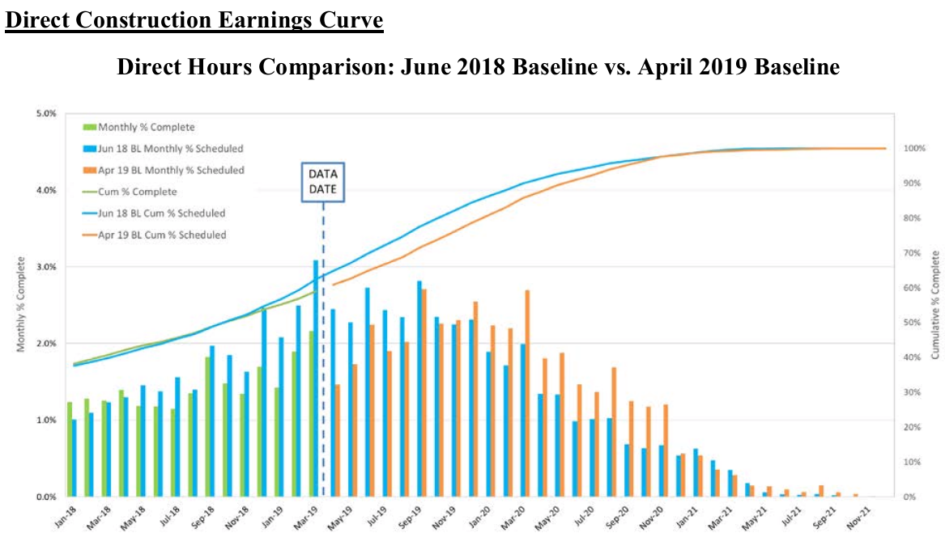

1. This is the total project capital costs for all owners (100%) and does not include financing costs.
2. Further delays would result in additional financing costs.
3. An EVMS represents the procedures and methods used by SNC to determine the actual progress of work compared to the forecast progress of work at any given time.
4. The Estimate at Completion is synonymous with the Project Cost forecast.
5. In this context contingency constitutes management reserves available to both SNC and Bechtel, and SNC Cost and Schedule contingency.
6. Staff has been raising issues with the project planning and schedules since at least VCM 6.
7. A ‘hammock” activity is one where the detail activities have yet to be scoped and loaded into the Schedule.
8. Nuclear Island, Annex Building, and Turbine Building.
9. Stacking of craft, congestion, occurs when more than one craft discipline requires access to an area to perform their respective work activity. Often it is not possible to have several craft working in the same area, or concurrently. Consequently, the work must be performed consecutively.
10. An exception refers to a scope of work that has been removed from a work package for completion at a later date.
11. Modifications, or Mods, are changes to systems, or partial systems, that typically isolate the area being tested. This isolation work may require cutting of pipe, installing temporary power, hooking up temporary water, etc.. necessary to perform the test.
12. The term legacy work refers to work that should have been performed, but was not, prior to SNC’s takeover of the Project.